License management
On any mSupply server, you have concurrent user licenses. When a user logs in, they take one of these licenses, when they logout the license is returned. These licenses sit in a single pool, to be used by all users who login to that server.
Sometimes, it can be helpful to split this single pool up into multiple smaller pools. This would be the case when, for example, different organisations use the same server and buy licenses separately for use by their organisations. It is then important that one organisation does not start to use the other's licenses.
To help manage this kind of situation, mSupply has the concept of user license categories. Each of these categories has a maximum allowed number of users logged in at the same time. Each time a user logs in, mSupply checks whether they belong to a license category and, if so, whether there is already the maximum number of users for that category logged in. If so, then the user is shown a warning message and not allowed to login, otherwise they are logged in as usual.
Please note that user license categories are still subject to the concurrent user limit (set by the number of licenses you have purchased), they do not override it. So, if you have 10 concurrent user licenses on your server and you have one or more user license categories with a total maximum number of logged in users set at 20, only 10 users will still be able to log in to your server at any one time. This functionality is not a free way to get yourself extra mSupply licenses, rather it's a way of helping you manage access to the licenses you have purchased!
User license categories only apply to an mSupply server so you won't be able to set them on a single user copy of mSupply (including single user satellite copies in a sync system). There's no point since only a single user can log in at a time to these versions of mSupply!
It is also important that you understand that each mSupply server has its own pool of concurrent user licenses so, if you have more than one mSupply server in your system, you can set user license categories on each server. You cannot set user license categories that affect more than one mSupply server.

Viewing existing user license categories
Choose Special > Show user license categories… from the menus. The following window will open showing a list of all the user license categories you have setup in your datafile:
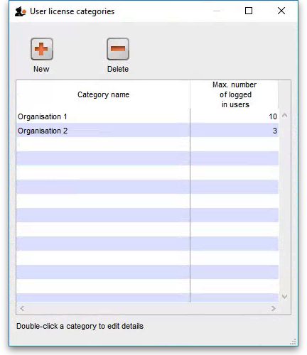

Creating a new user license category
To create a new license category, click on the New button in the window displayed above and a new window will open:
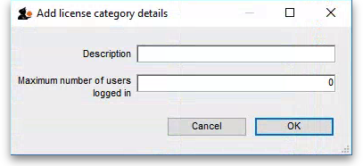
Enter the details of the new license category:
- Description: the name the category will be known as throughout mSupply
- Maximum number of users logged in: the maximum number of users that belong to this group that are allowed to login to this mSupply server at the same time
Click on the OK button when you're finished and you'll be taken back to the license category list window, which will now include your new license category.

Editing an existing user license category
To edit an existing user license category, view the list of existing ones by choosing the Special > Show user license categories… menu.
Now double-click on the license category you want to edit in the list and, in the window that opens, edit the category's description or maximum number of logged in users and click on the OK button to save your changes. You will be returned to the list of user license categories which will show the changes you just made.
Changing the maximum number of logged in users of a license category will not affect any users already logged in who belong to the category (even if there are more than that number already logged in) since the check against this number is only made when a user logs in. But it does mean that it will affect any users who login from that point forward. So, if there are more than the maximum number logged in after a change, then no more users belonging to that license category will be able to log in.

Deleting a user license category
To delete a user license category simply view the list of existing ones by choosing the Special > Show user license categories… menu, select the license category you want to delete in the list and click on the Delete button.
Note: you will only be able to delete a license category if it has no users assigned to it. If you receive a warning to that effect then edit all the users to remove them from the license category first (see below for details), then return here to delete the license category.

Assigning users to license categories
To complete the setup you must assign users to the different user license categories you have created.
You do this by selecting the user license category the user should belong to in the License category drop down list on the General tab of the user's details window. See Managing users for more details on how to set this.
Any users not assigned to a user license category will always be able to login (as long as there is a concurrent user license available in the server's pool). So be careful when using user license categories - leaving many users not assigned to license categories can undermine what you are trying to achieve.
Normally, you will assign more users to a user license category than the maximum number of users logged in setting for the category. Otherwise, the user license category check on login will have no effect!
Previous: Show Connected Users Next: Printer Installation

