25.16. Show connected users
Note: Not applicable when running mSupply in single user mode
To display a list of users currently logged on to mSupply, select Special > Show connected users (Ctrl + Shift + U). The window below is displayed.
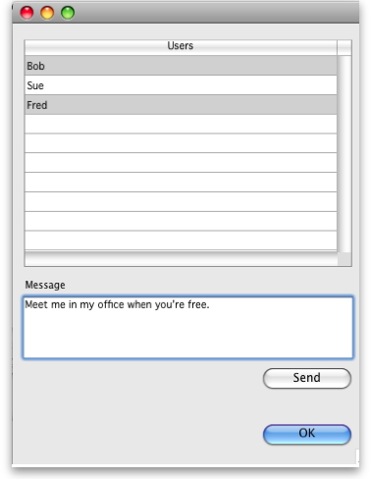

Messaging other users
By highlighting one or more users (use control on Windows/ command on Mac to highlight multiple users), a message typed into the Message box will immediately appear on the selected user(s) mSupply window when you click on the Send button.
Such messages are not stored on the system.

Previous: 25.15. Managing users | | Next: 25.17. License management

