12/04/2019 : This feature is currently not present in the current mSupply Mobile App but will come soon.

17.03. mSupply Mobile Demo
We now have a server setup for users to try out the mSupply mobile module.
Firstly Download and install Mobile App from here : Mobile App
The mSupply Mobile demo site is now hosted on : https://demo.msupply.org

Request a Demo Store
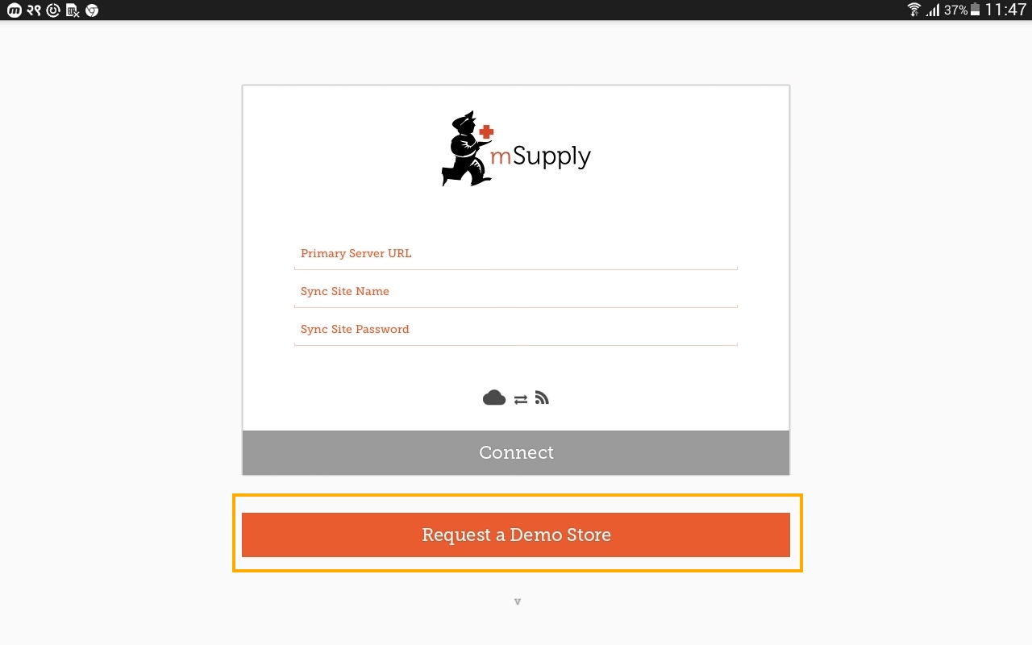
After starting mSupply mobile on the Android tablet, you will see a screen like above for the first time. Click on the “Request a Demo Store” button to request a credential for the new store.

Enter your details
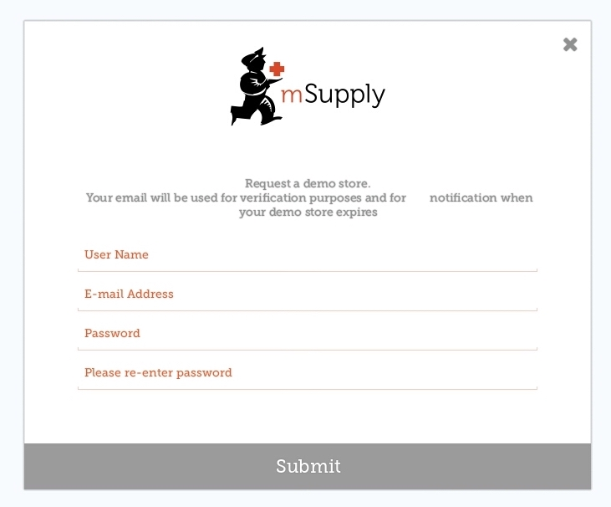
On the above screen you are expected to a unique user name, a valid e-mail address and password. Please note down the password as this will be needed later.
- For user name : If your same is James Brown , you could choose to type JamesBrown or BrownJames
If you have successfully entered the details then you will see a screen as below.
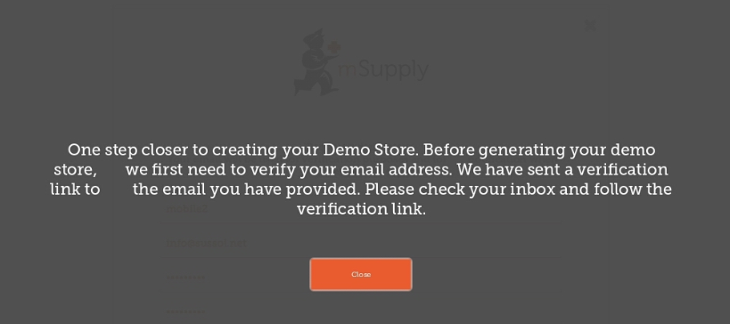

Check your e-mail
The mSupply Demo server will e-mail you and expect you to click the link to activate your Mobile store.
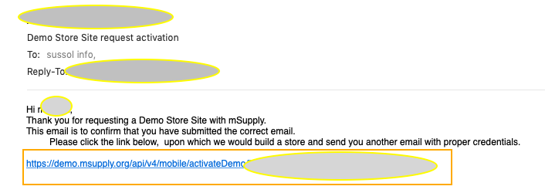
Please check your junk e-mail if you do not see the e-mail.

Setup your Mobile Store
You should now be able to setup your store.
- Your store name will be in the format : UserName_store, so depending on what you typed, it could be “JamesBrown_store”. Note that the demo server adds the “_store” to signify store setup.
- The password for the store credential will be in the format : “JamesBrown_store_Site”, that is if you typed “JamesBrown” as username. Note the capital letter in the text “Site”.
- The URL must be : https://demo.msupply.org
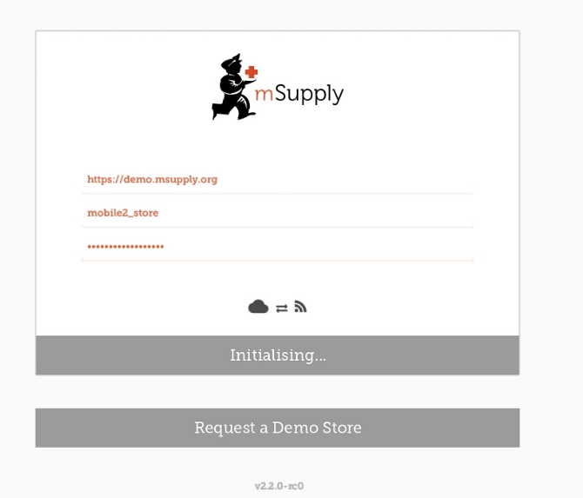
If the credential of your mobile store has been entered properly then your table will start to retrieve data from Demo server. Please wait until the procedure is finished. We expect this to take no more than 5 minutes.

Login as a User
You may login as a user once the store setup has been completed. You will be shown a login window.
- This time the User name is what you initially typed. So just UserName. In our case it may be “JamesBrown”
- Password is what you originally typed when requesting for a Demo site.
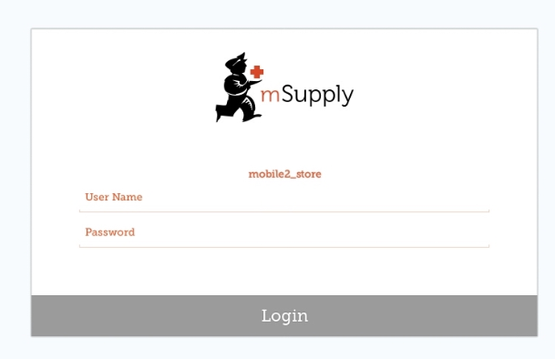
Good Luck and now carry out a stock take and start pretending to be a store.

Previous: 17.02 Setting up mSupply Mobile | | Next: 18. Remote User Web Interface

