15.02. Adding barcodes to items
Added: Version 4.01
In a synchronising system (29.01. Introduction to synchronisation) barcodes:
- can be added to items at any site and they will then synchronise to all other sites.
- that are created as a duplicate of one that already exists elsewhere in the system will be automatically merged into the existing barcode. This will be completely invisible to the user.
- can only be edited on the primary server.
Assigning barcodes to items is an important setup activity. It is this step that enables mSupply to recognise which item a particular barcode belongs to. Note: this is strictly assigning the GTIN to an item, not the rest of the barcode which includes things like batch, expiry, serial number etc.
You can add barcodes to items before or during the goods receipt process. The process described here is used for both - to see how the goods receipt process fits in, see Barcode scanning and receiving goods.
To start the process, view the details page of the item you want to add barcodes to (go to Item > Show items…, click on the OK button, double-click on the item you want in the list). Then click on the Barcodes tab on the left hand side of the details window:
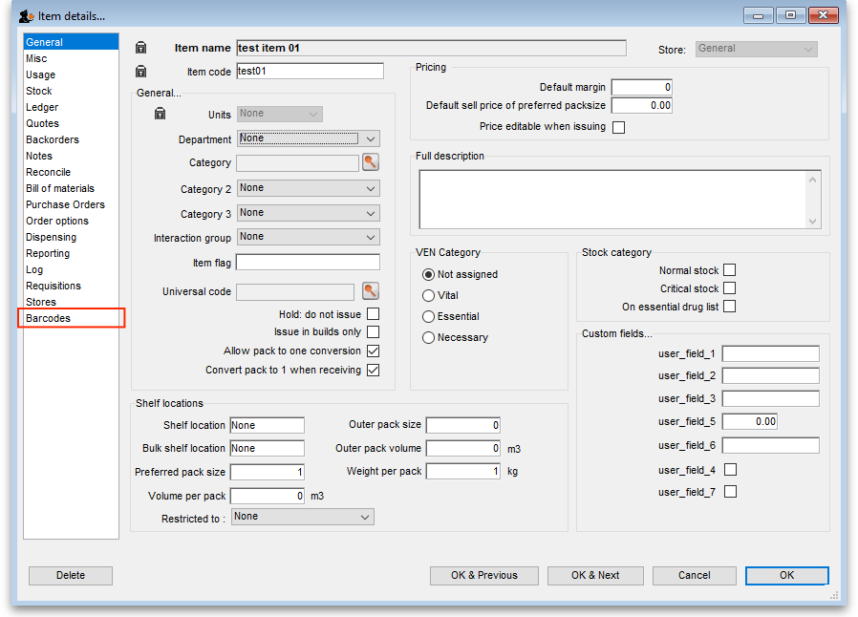
This will show you a list of the current barcodes assigned to the item:
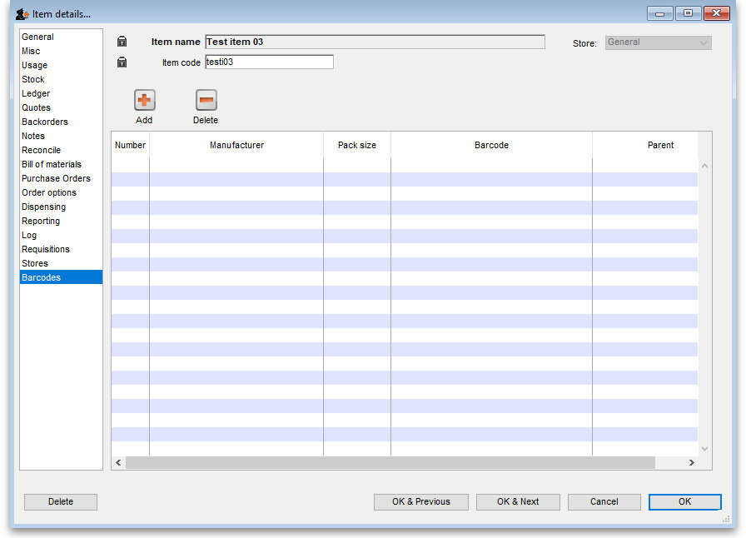
This item currently has no barcodes assigned to it but this is the information each column displays:
- Number: a sequential number for each barcode, starting at 1
- Manufacturer: the name of the manufacturer of the medicine
- Pack size: the number of individual items (tablets, bottles etc.) in the pack this barcode represents
- Barcode: the human readable form of the barcode, just the type identifier (01) and the 14 digit GTIN (it could be a 13 or 8 digit (or any valid length!) GTIN but it must be padded with leading zeros to 14 digits in total - this is part of the GS1 standard). A barcode that starts 0104 identifies an internal mSupply barcode (assigned because the manufacturer didn't put one on the item's packaging). A barcode that starts with 01 followed by anything else is a global barcode not assigned by mSupply.
- Parent: the number (shown in the Number column) of the barcode that is the parent (i.e. has the next largest pack size) of this barcode

Deleting a barcode
To delete a barcode, click on it in the table to select it and click on the Delete button. You will be asked to confirm the deletion. But please note, you will not be able to delete any barcode that has been assigned to a line of stock.

Editing a barcode
To edit a barcode, simply double-click it in the table. This will open the 'add a barcode' window shown in the Adding a barcode section below but the window will be populated with the barcode's details. Simply edit the details as described in the Adding a barcode section. Please note that, if a barcode has already been assigned to stock, you will not be able to edit the pack size or the barcode itself.

Adding a barcode
To add a barcode to the item, click on the Add button. This window appears:
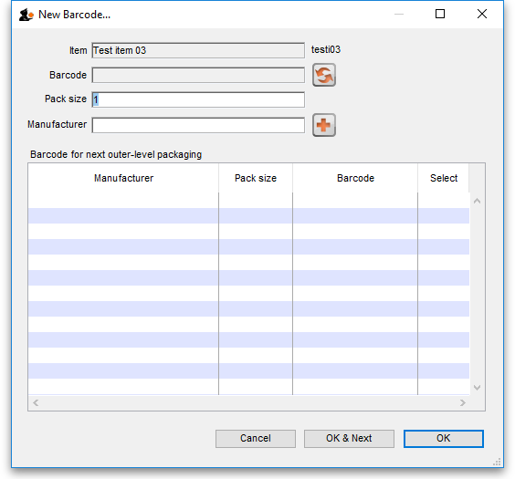
Item: this is the name of the item you're adding a barcode to, followed by its code. It is non-editable
Barcode: the human-readable form of the barcode; the 2 or 3 digit type identifier followed by the 14 digit GTIN only (it could be a 13 or 8 digit (or any length!) GTIN but it must be padded with leading zeros to 14 digits in total). You can't type anything in here, you have two options:
- Scan the item's barcode with a barcode scanner - the barcode's identifier and GTIN will appear in the textbox. If the barcode is not GS1 compliant you will see a warning message and you will not be able to save the barcode (just in case you've scanned the wrong thing. Why would anyone go wild with a scanner and start scanning anything they can find? )
- Click on the icon next to the Barcode field to have mSupply supply its own unique, internal GS1 compliant barcode. Each time you click on the icon, mSupply will supply a new barcode.
Pack size: the pack size (number of individual items in one pack) that this barcode belongs to.
Manufacturer: the manufacturer that this barcode belongs to. Type the first few characters of the manufacturer's name and press the Tab key to select it from a list of matching names. If the manufacturer you want doesn't exist in mSupply, click on the button next to the manufacturer field to add it.
Barcode for next outer-level packaging table: this is where you select the barcode that is the 'parent' of this one i.e. the one with the next biggest pack size. Selecting one is optional but it allows mSupply to identify barcodes that should go on tertiary level packaging (they can have different printing requirements). The table will show all the other barcodes entered for this item. To select the parent, simply click on the checkbox in the Select column to check it.
GS1 barcodes are unique to the combination of item, pack size and manufacturer. So you won't be able to add 2 barcodes to the same item with the same pack size and manufacturer.
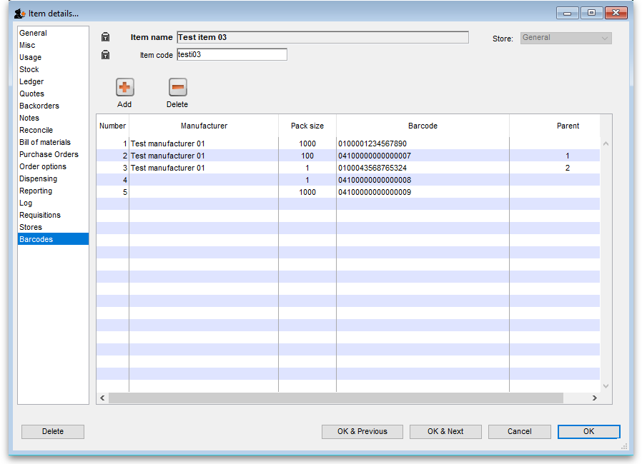
Here is an example of an item with several barcodes added:

Previous: 15.01. Barcode scanning | | Next: 15.03. Barcode scanning and receiving goods

