Barcode label printing
Added: Version 4.01
You might want to print barcode labels for your stock if an existing label is damaged, if you break a box down into smaller pack sizes and the contents don't have individual GS1 barcodes or if some stock comes into your warehouses and it doesn't have valid GS1 barcodes on it.
There are several places in mSupply where you can print barcode labels for your stock.

Item details page
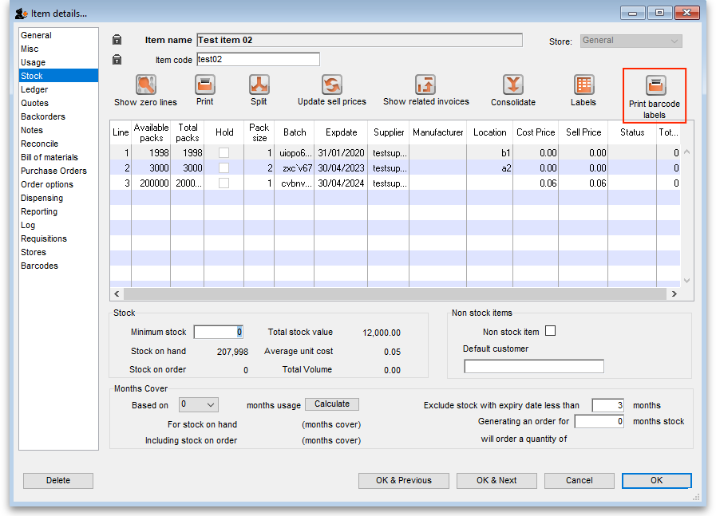
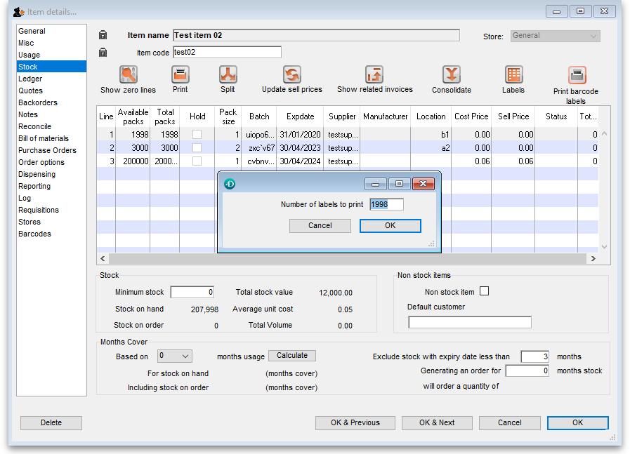

Supplier invoice
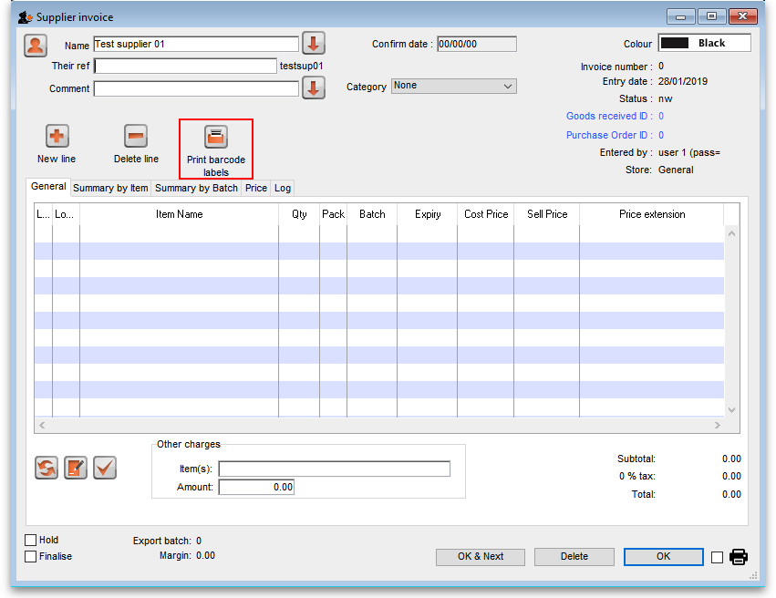
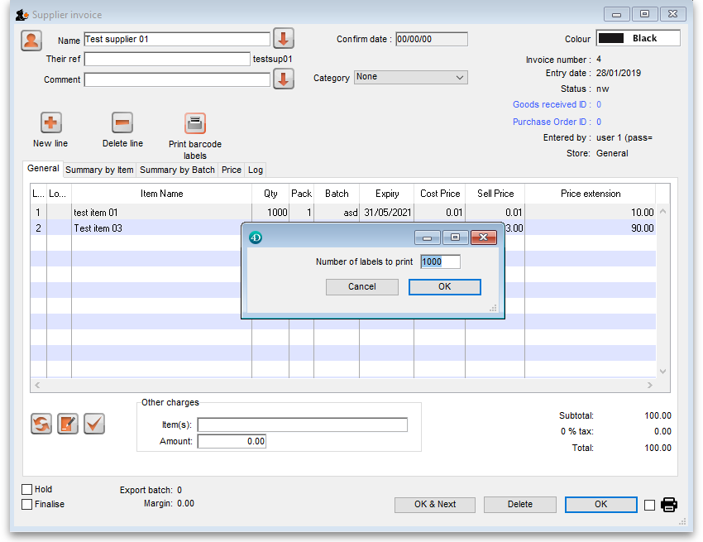
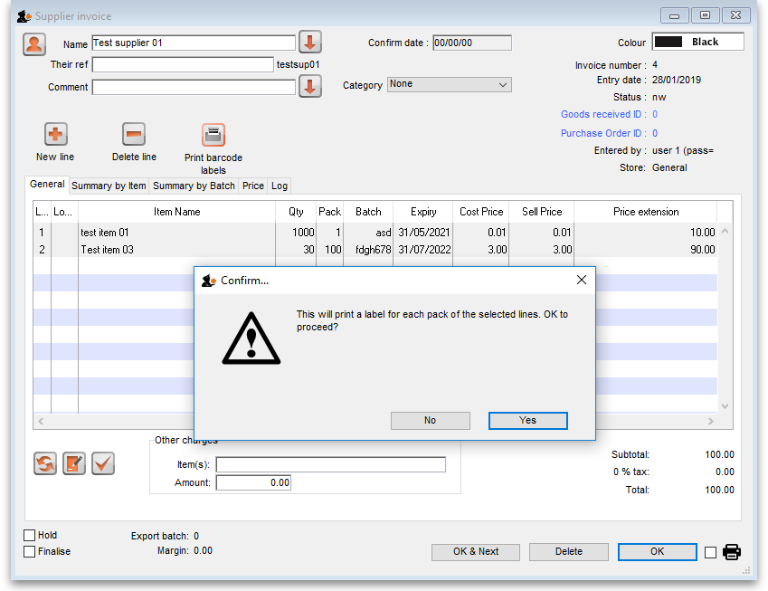

Stock list
Previous: Pick list checking Next: Why an HIS module for mSupply?

