15.07. Barcode scanning and prescriptions
Added: Version 5.01
If you have turned on bacrode scanning for prescriptions (see the 15.09. Barcode scanning preferences page for details) then, when you print out a prescription label, a second label containing a barcode will be printed with it. The label will look something like this:
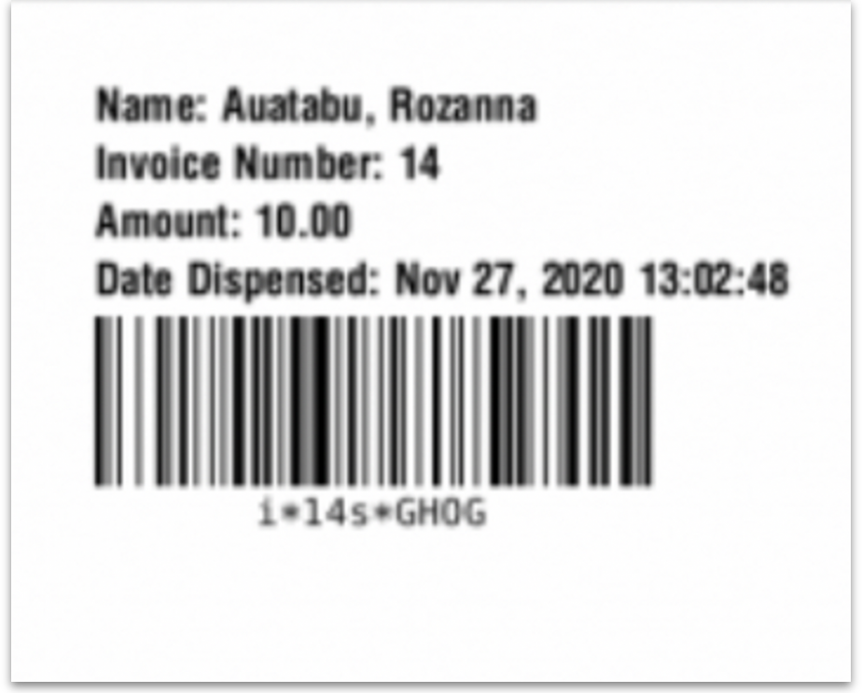
When you scan this label from the prescription search window (choose Patient > Show patients in the menus) with a barcode scanner, it will open the prescription at the Payment tab ready for payment to be entered. See the 11.03. Prescription payments and credits page for details on Prescription payments.

Previous: 15.06. Barcode label printing | | Next: 15.08. Barcode scanning with handheld computers (The Zapp App)

