28.16. Microsoft Print To PDF Issue
The recent windows 11 update, especially, 24H2 and 25H2 has a known bug where the “microsoft print to pdf” printer driver stopped working, which as a result affected the print preview and creation pdf documents from within mSupply.
mSupply reports and print form could no longer be generated due to `Microsoft Print To PDF` not functioning as before.

Affected versions both windows and mSupply
- Windows 11 24H2 and 25H2
- mSupply Version prior to v8.08.18
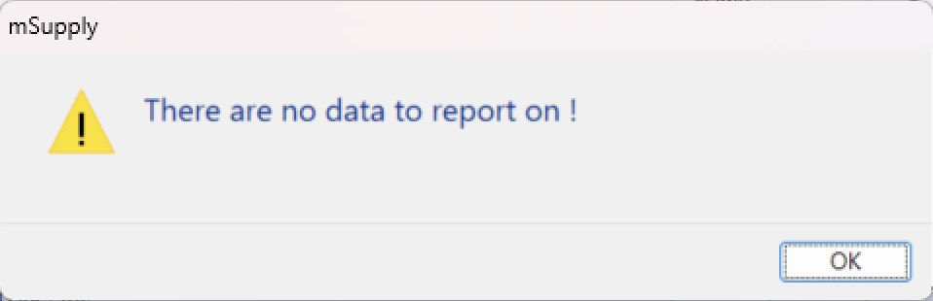
Below is the sample Image of the Issue:

Resolution
- Upgrade the mSupply to the version v8.08.18 or later
- This version allows the use of printer preview.
- Remove the `Microsoft to PDF` driver
Method 1 : Convert the `Microsoft Print to PDF` to a “Microsoft XPS Class Driver”
- Go to Printer and scanner setting
- Click on Microsoft Print to PDF → Go to Printer Properties → Advances
- Click on the `Drivers` list and choose Microsoft XPS Class Driver
  - - Or click on the `New Driver…` button and Choose Microsoft → Microsoft XPS Class Driver
- Click Apply and Ok
- See that the print driver name changes to “Microsoft XPS Class Driver”, the `Microsoft Print to PDF` driver now no longer exist !
- Test mSupply to see that the print preview and PDF creation works.
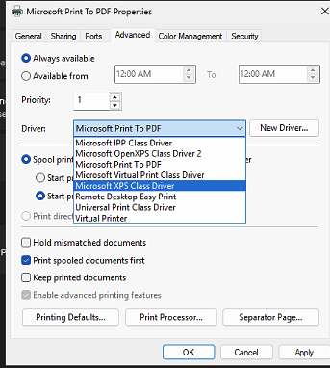
Check if “Microsoft XPS Class Driver” exists (Settings → Bluetooth & Scanner → Printer & Scanner). If not,
Method 2 : Manual add via Printer Setting
- Go to Settings → Bluetooth & Scanner → Printers & Scanners
- Click Add Device and Add a new device manually
- select Add a local printer or network printer with manual setting
- Choose Use an Existing port (LPT1: Printer Port)
- Choose Microsoft → Microsoft XPS Class Driver
Method 3 : Add Via Optional Feature
- Press windows+R and type - optionalfeatures - and enter.
- Look for “Microsoft XPS Class Driver” in the list
- Check Ok
- Make sure “Microsoft Print to PDF” is un-checked
- Restart your PC.
In all instances we must make sure that the `Microsoft Print to PDF` driver no longer exist.

