4.01.05. Items - Stock tab
Back to Item Details window
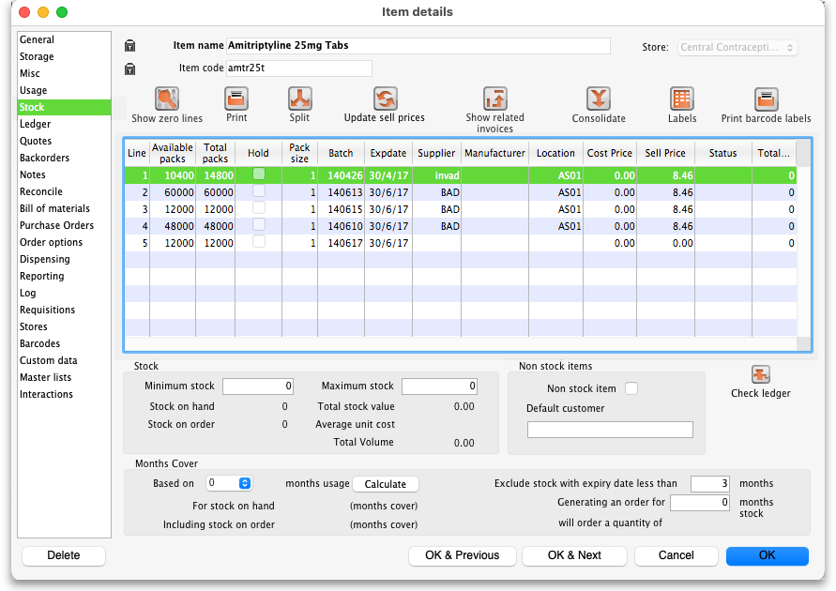
The “Stock” window shows the lines of stock for this item together with the stock on hand. mSupply® will calculate how many days this stock will last, based on your usage over a number of months - you can specify how many months.
If you have turned on any of the custom stock fields in store preferences they will be displayed as columns (between the Supplier and Manufacturer columns) in the list of stock lines on this tab and the information you entered for these fields when the stock was received will be shown in the appropriate cells.
Show zero lines: This button will show all the lines that are still in your data file, but which have no stock on hand. If you can think of a use for this information, please let us know! When you click the button the button title changes to “hide zero lines”, which allows you to get back to the info you really wanted.
Splitting: There may be occasions when you need to split your stock- e.g. if you are moving it, say, from a store to a dispensary or clinic, or when you are repacking some stock; select the line to be split, and click on the Split icon to show a window allowing you to enter the quantity to be split, the new location, and - if applicable - the new pack size.
In the example shown, 2 packs of 1,000 Erythromycin tablets are being transferred to a new location, and the `outer' of 1,000 ( actually 10 x100 shrink wrapped together) is being opened to yield 10 individual packs of 100.
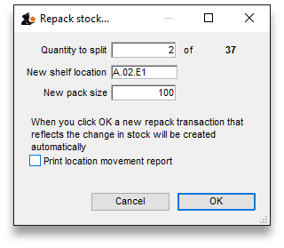
Update sell prices: Clicking on this icon will update the selling prices of the highlighted line(s). mSupply® will use the figure entered in the Default sell price of preferred packsize field in the General tab, which must show the updated price before this will take effect. If you make use of the Default margin field, and you update this figure, then Supply® will calculate the updated sell price using it. Note that mSupply® looks first in the Default sell price … field, and any figure entered there takes precedence.
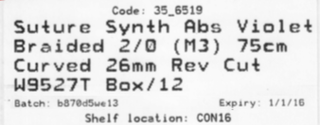
Labels: Clicking this button will print shelf labels for the highlighted stock line(s). The shelf label includes the location, the item name and code, and the batch and expiry. Here's a (bad) example

Show related invoices
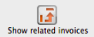 Highlight a line then click on this button to display a list of transactions which used this particular line.

Consolidate
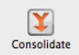 You can consolidate (join 2 stock lines together) if they have
- The same batch #
- The same expiry
- The same pack size
- Are at the same location
If 2 stock lines you want to consolidate are at different locations, edit one of the stock lines to move it to the location of the other stock line, then consolidate. This reflects what you would have had to do physically anyhow!
- Hold down the control key (command on Mac)
- Click on the two lines you want to consolidate
- Click consolidate
- If the two stock lines are at different locations you'll be warned and asked if you want to continue.
- You're shown this window
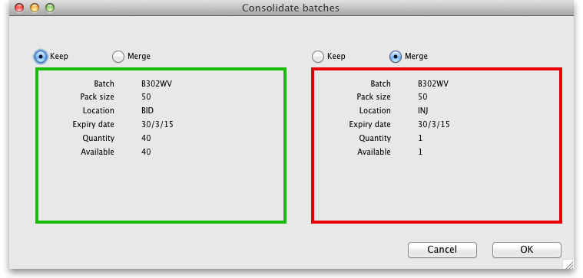
- Choose which stock line to keep.
- Click OK
An example:
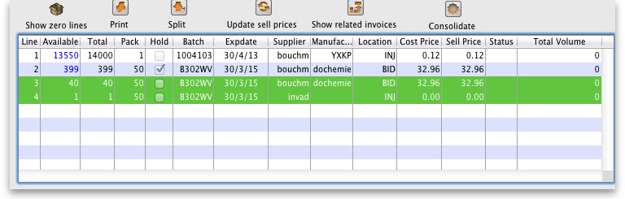
- Before:
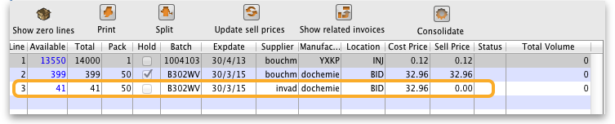
- After:

Other information on the stock details page
Stock
Minimum stock: The minimum stock you wish to keep on hand. Note that you do not need to enter a quantity here for mSupply®'s ordering system to work. In fact, it is better in most cases to leave this number set to zero. This field should only be filled in if you absolutely must keep a minimum on hand. For example, if you stock naloxone for narcotic over dosage reduction, and even if you only use 1 vial every year, you have decided you need to keep five vials on hand, you would enter “5” as the minimum quantity for naloxone.
Stock on hand: The total stock of this item on hand.
Stock on order: The total quantity of stock of this item on order from suppliers
Non-stock items
If this is a non-stock item, you can check this check box. If there is one, you can specify the default customer for the item, otherwise leave this box blank. For more on this topic see section 4.10. Non-stock items.
Months Cover
You can use this calculator to estimate the time left until the stock of this item runs out. The values which appear estimating the time it takes to use the stock on hand (and on order) are calculated from the average usage of the last few months. You can choose the number (from 1 to 24) of months used to calculate this in the drop down list.
You can also exclude stock that will expire soon. Enter a number of months and any stock that expires before your chosen time frame will be excluded from the calculation.
If you would like to know how much stock to order so that you have enough for the next few months, enter the number of months you would like stock for. After entering or changing any or all of these values, click Calculate to see the results.

Editing a stock line or viewing more stock line details
To edit the cost price and selling price for an item line, double-click the line you wish to edit.
The Item stock line details window is displayed:
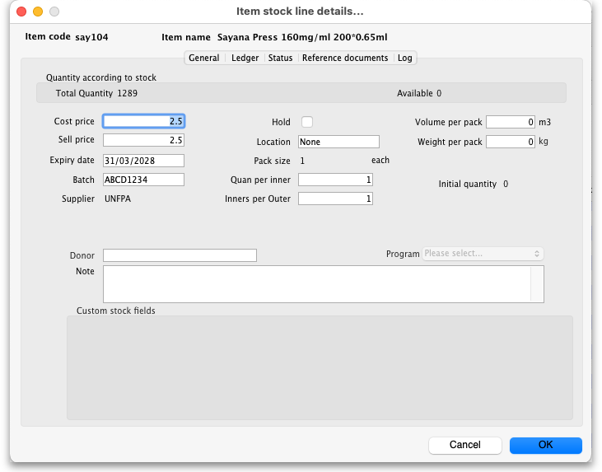

General tab
This tab shows the details of a stock line.It also gives you total and available quantity of that stock line.

Hold checkbox
To hold a stock line, check the Hold check-box. Once an stock line is held, it cannot be issued. It will still appear in the available stock window, but held stock lines will have a check box in the hold column, and if a user attempts to issue from the stock line they will be informed that the stock line is on hold.
The Hold: do not issue option in the Item details > General tab takes precedence. If that option is checked, then no stock of the item may be issued, regardless of the stock line's Hold checkbox setting.
Please note: if you are using barcode scanning then there will be an additional Barcode drop down list underneath the

Ledger tab
This tab shows a list of transactions (supplier and customer invoices, inventory adjustments etc.) for the item being viewed. You can use this window to see a list of customers who have been supplied with this particular item:
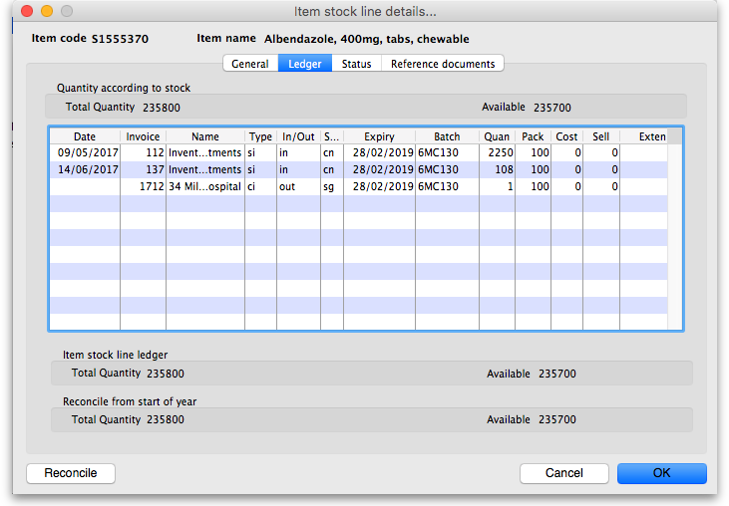
The In/Out column tells you whether the transaction on that line brought stock in to, or took stock out of, mSupply.

Status tab (vaccine vial monitoring)
A window appears with 4 columns:
- Date
- VVM status
- Entered by
- Comment
There are two buttons:
- New
- Delete.
This has been specifically designed to use the Vaccine Vial Monitoring (VVM) feature. All vaccines requiring cold storage bear a VVM label which registers cumulative heat exposure over time; the combined effects of heat and time cause the inner square of the label to darken gradually and irreversibly. A comprehensive description of VVM is available in WHO's pdf document accessible. Stock lines of vaccines should have their status VVM labels regularly checked, and assigned to the relevant status; Clicking on the New button allows the details to be recorded.
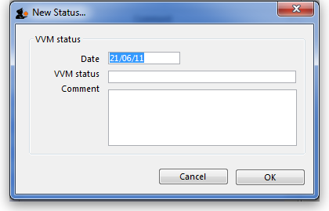
Should a stock line of vaccines have the status 3 (or 4), the Hold checkbox under the General tab should be checked.

Reference documents tab
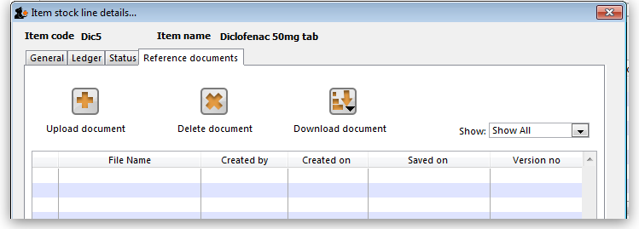
The standard Document Management window appears. See section 18.05. Tender reference documents for more information on the use of such documents.

Log tab
This tab will show any logs that have been recorded against this stock line (e.g. for changes made during a stocktake that weren't included on any inventory adjustment). These logs will also be visible in 25.19. The system log.
Previous: 4.01.04. Items - Usage tab | | Next: 4.01.06. Items - Ledger tab

