ARV regimen data recording
*
The ARV regimen data recording module was built for the MOH in Zanzibar/Tanzania. To date this module is not available as part of the standard mSupply package. We are willing to make this module available if our clients feel the need. Please keep in touch.
mSupply allows you to record ARV regimen data; you can record for each customer how many patients are following particular regimens, how many have defaulted on their regimen, and how many have died while on different regimens. There is a fixed list of regimens which applies to all customers.

Viewing/editing recorded regimen data
To view regimen records click on the Customer > Show regimen records menu item. The following window will be displayed:
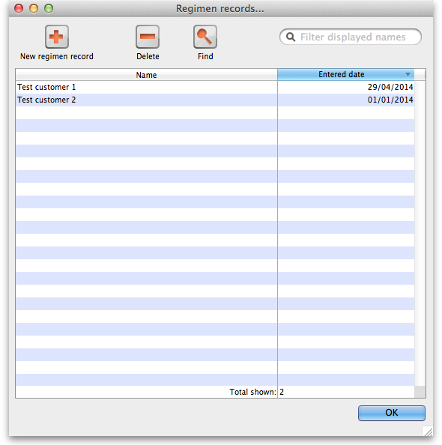
The window, when it first opens, lists all the regimen records entered for the current year (i.e. all those which have an entered date which falls in the current year) sorted by entered date, most recent at the top. The various items in the window do the following:
- New regimen record button: Clicking this button opens the editing window shown below in the Adding/editing a regimen record section with all fields empty, waiting to be filled in.
- Delete button: Click on this to delete the records you select in the list. You will be asked to confirm the deletion first.
- Find button: Opens the search window shown below in the Searching for regimen records section to enable you to find and display other regimen records.
- Search bar: The list of displayed regimens will be filtered to show only those for customers with names which begin with the letters entered in here. Useful for removing the clutter and seeing records for a single or small number of customers.
- OK button: Closes the window without doing anything.
You can edit the contents of any regimen record by double-clicking on it in the list. This will open the editing window shown below in the Adding/editing a regimen record section but loaded with all the information for the selected record. All the information is editable.

Searching for regimen records
To search for regimen records, click on the Find button on the regimen record list window shown above. This window will be displayed:
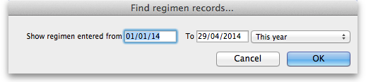
You can either enter the from and to dates manually or use the quick-pick drop down list on the right hand side to quickly set the dates based on common selections (e.g. This year, Last year). Click on the OK button and mSupply will search through all the regimen records and display in the list all those which have an 'Entered for date' (see the Adding/editing a regimen record section below for a description of this field) which falls between the dates you have entered.

Adding/editing a regimen record
When adding a new regimen record or editing an existing one, you will be shown this window:
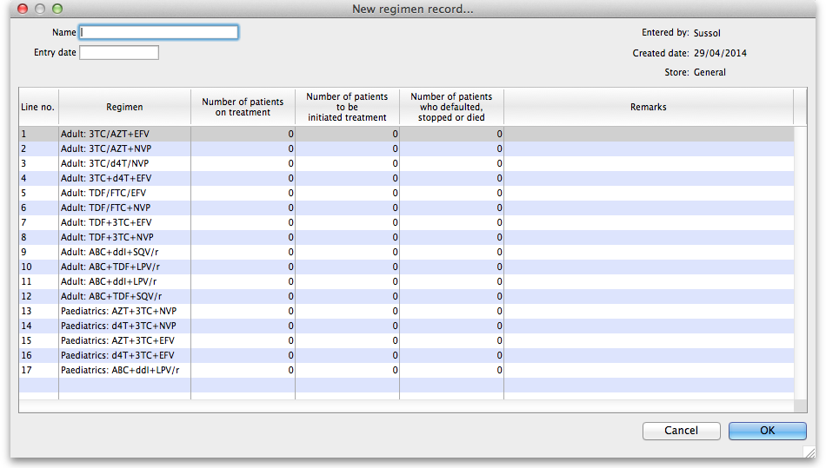
The window is shown as it looks when adding a new record. When editing an existing record it looks the same but all the information entered for the record is displayed, all of which is editable. Enter information in the various fields as follows:
- Name: The name of the customer to which this record belongs. Type the first few characters of the customer's name and press the Tab key to choose the customer from a list of names starting with the characters you typed. Much quicker than typing the whole thing!
- Entry date: The date this record is entered for. mSupply matches this date against against dates you enter when searching for regimen records and also for deciding which regimen records to include in a report. It will be different from the current date if, for instance, you want the record included in a different reporting period than the current date falls.
- Number of patients… columns: Each cell in these columns is editable. Each row represents the figures for that particular regimen. Click once to select a cell and once more to begin editing it. Tip: when you have finished editing a particular cell you can use the Tab key to edit the next cell or shift+Tab to edit the previous cell - this can really speed up entering a whole new regimen record.
- Remarks: Same as the Number of patients… columns, the cells in this column are all editable. Click once on a cell to select it and once again to start editing it. You can enter any text you need which pertains to that particular regimen and its figures.
When you have finished entering or editing information click on the OK button to save your work and close the window.

Reporting on regimen data
A single report is available for regimen data and it is accessed from the menu item Report > Regimen report. You must select the regimen records which are to be included in the report. You do this by giving the dates between which a record's entered date must fall to be included in the report in this window:
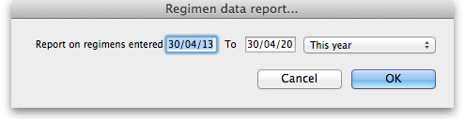
You can either enter the from and to dates manually or use the quick-pick drop down list on the right hand side to quickly set the dates based on common selections (e.g. This year, Last year). Finally, click on the OK button and mSupply will generate your report.
Previous: Asset Management Next: Backup

