Bulk Store Preferences Editor
The Bulk Store Preferences Editor allows changing preferences for many (or all) stores at once.
Launch from Special menu → Bulk edit store preferences…
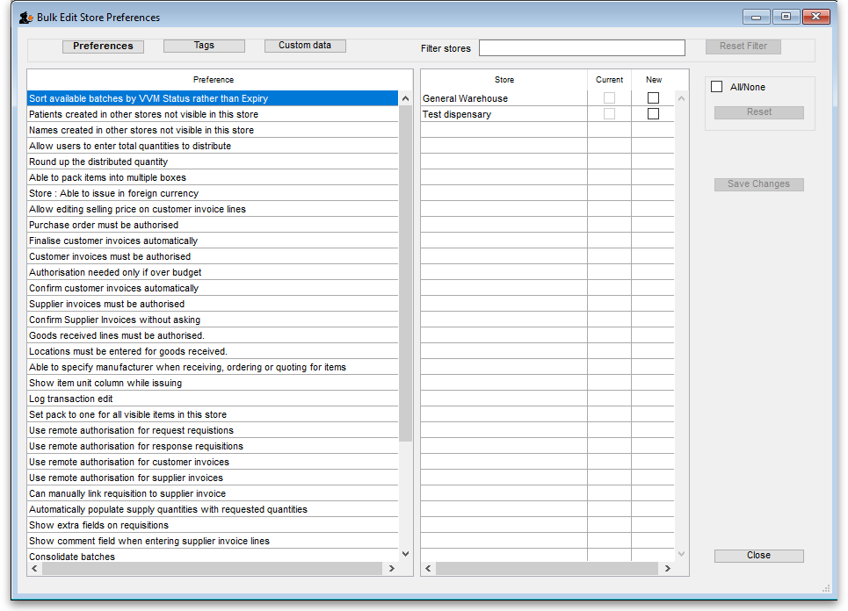

Types of Preferences
The editor allows editing of basic Preferences, Custom Data1) and Tags1). Select the preference type you wish to work with from the buttons in the top panel:

The Preference and Stores List
The list in the left-hand panel shows all the available preferences (of the type specified above). The list in the right-hand panel shows all the Stores you have available to edit.
When you select a Preference, the Stores list shows the settings for each of the stores in the Current column.

Editing preferences
To change a selected preference, tick the checkbox ☑️ in the New column to switch the preference on/off.
You can apply a setting to all displayed stores with the All/None checkbox on the far-right panel. Once you're done making changes for this preference, click the Save Changes button to write your preference settings to the database. The Current column will be updated with the new settings to reflect the saved changes.
Please note: You must save changes before switching to another Preference, or your changes will be lost.

Filtering stores
If you only wish to make changes to a subset of stores, you can filter the Stores list with the Filter bar in the top panel:
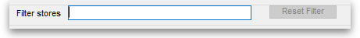
In the current implementation, when you click the text entry field, you will be presented with a simple Query editor:
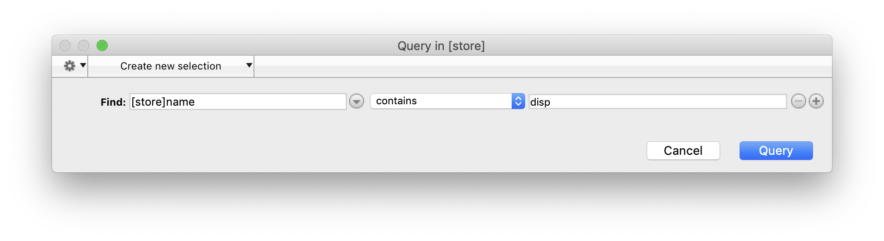
Submitting this query will update the list of Stores accordingly. Restore the full list of Stores with the Reset Filter button.

1)Not yet implemented

