26.15. Remote authorisation
Function added in version 4.01, overhauled to current form in version 5.05
mSupply has features to allow various types of transactions to be authorised within the application before they affect stock so that supervisors can make sure the transactions are correct (see the 26.14. Authorisation page for details).
Remote authorisation allows supervisors to authorise Response requisitions via a web app, so that they can participate in the authorisation process without having to login to mSupply. The process described below uses a supplier and customer store in the same mSupply installation but it can work with stores in different mSupply installations using mSupply Link.
Only response requisitions (those made in response to request requisitions, called internal orders (see the 6.04. Ordering from one store to another page for details), can be remotely authorised). Other requisition types or response requisitions made manually can not be remotely authorised.
When an authorisation request is made, authorisers receive an email containing a link to the web app. When the authoriser logs in, they are shown all pending authorisations which they can then do any of:
- Approve
- Edit and approve
- Deny

Authorisation by masterlist/vertical program or by store/facility
In the remote authorisation module authorisers can be set to authorise requisition lines which belong to items on the master list they are able to authorise for or which come from a particular store or facility. Or a combination of both!
A masterlist can be used to represent a vertical program so this method can also be thought of as authorisation by vertical program.
Authorisers can also be set up with auto-authorisation, where transactions will automatically be authorised if the user has not approved or denied the transaction before the set auto-authorise period has elapsed.

Setup

Turn on remote authorisation

For the store receiving requisitions that must be authorised
Remote authorisation must be turned on for each store separately. This means that, in the same datafile, some stores can use it while others do not. You turn it on for a store in the store's preferences:
1. Choose Special > Show stores from the menus.
2. Double click the store to edit.
3. Click on the Preferences tab.
4. Check the Use remote authorisation for response requisitions checkbox to turn remote authorisation on for that store.
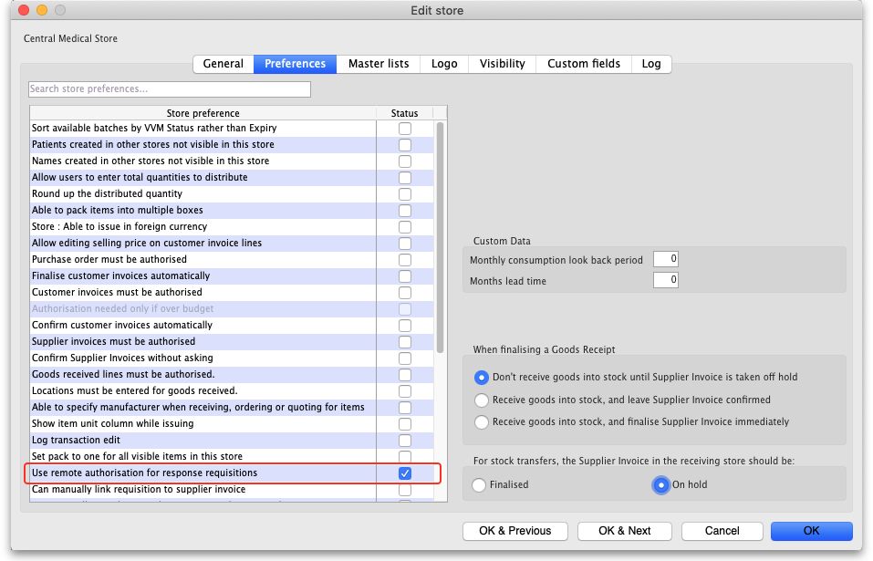
5. Click the OK button to save the changes.

For the store placing a requisition that must be authorised
1. Choose Special > Show stores from the menus.
2. Double click the store to edit.
3. Click on the Preferences tab.
4. Check the Include requisitions from this store in suppliers' remote authorisation processes checkbox to turn remote authorisation on for that store.
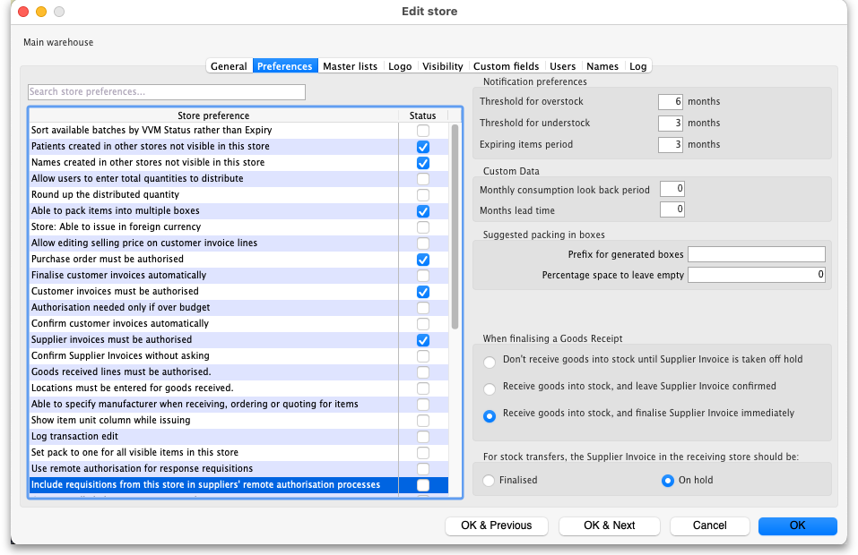
5. Click the OK button to save the changes.
From now on, response requisitions produced from internal orders from this store must be authorised before being confirmed.

Set up authorisers

Set up the user accounts and details
All authorisers must have an account in mSupply. See the 25.15. Managing users page for details about adding and editing users.
To allow a user to login to the remote authorisation web app as an authoriser you must check their Use web authorisation system checkbox on the General tab of their details window:
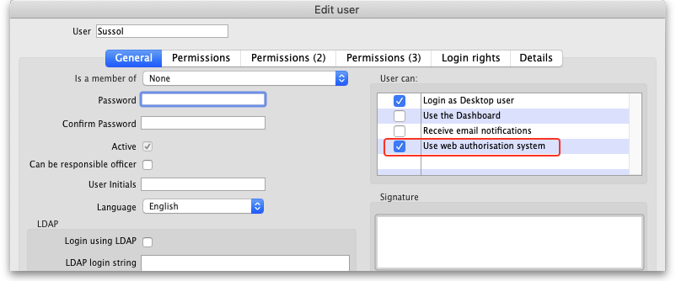
You must also enter their email address on the Details tab of their details window:
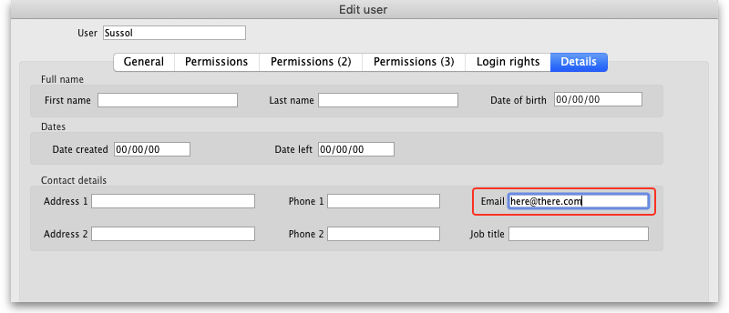
This will enable them to receive emails when a requisition is awaiting their approval.
The user must also be assigned to one store as a `default` login. This is needed for the login to the web portal to work.
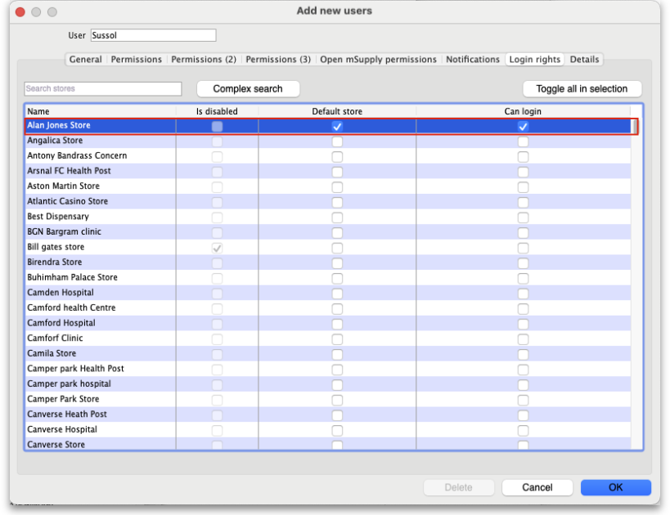

Assign the users as authorisers
After the user accounts have been setup, you can assign them as authorisers. To do this choose Special > Show authorisers from the menus. This window will open:
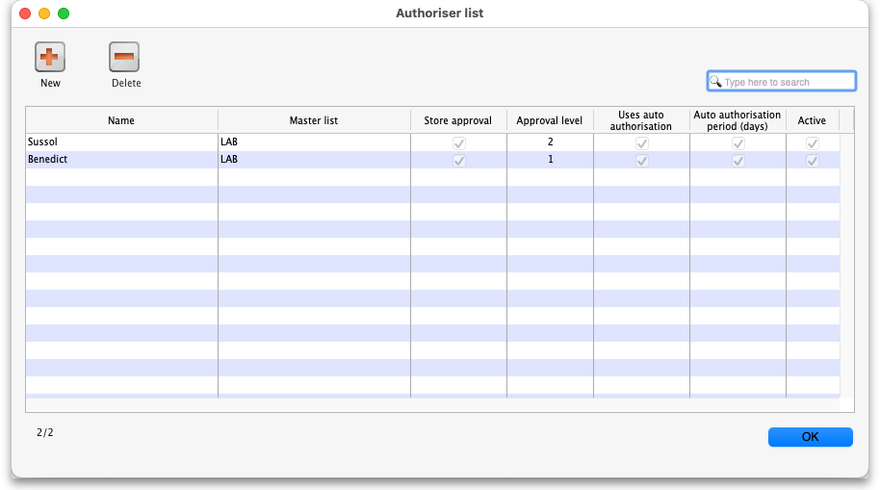
The window shows a list of the users who are currently setup as authorisers in the system; if none have been set up then the list will be empty.
Delete button: Select an authoriser in the list and click the Delete button to remove the user as an authoriser. This does not remove or disable their user account or prevent the user from logging into the authorisation web app, it only removes their ability to act as an authoriser.
New button: Click on the New button to assign a user as an authoriser. This window will open:
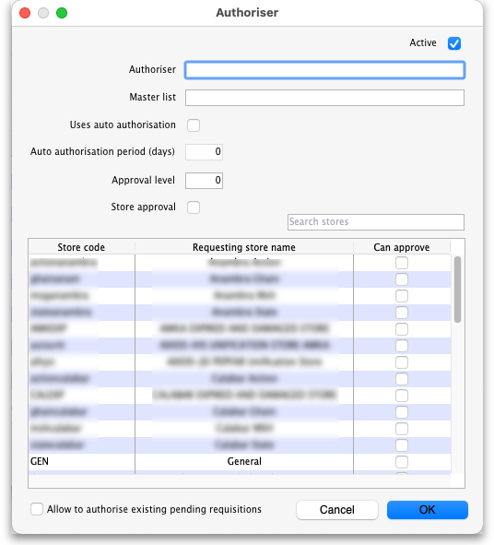
- Active: This is checked by default. If this is checked then the user's assignment is active and they can act as an authoriser. If it is not checked then the user cannot act as an authoriser. This is useful when an authoriser is to be removed as an authoriser for a period of time and then added back in again e.g. when they go away on holiday.
- Authoriser: Enter the name of the user here. Type the first few characters of their username and press the Tab key on the keyboard to select the user from a list of users with usernames that start with what you have typed.
- Master list: Enter the name of the master list containing the items that the user can authorise. Type the first few characters of the master list's name and press the Tab key on the keyboard to select it from a list with names that start with what you have typed. The user will only be able to authorise lines on requisitions for items that appear on the master list you select here.
- Uses auto-authorisation: If this is checked then, after the number of days set in the Auto-authorisation period (days) field, any requisition lines that are waiting for authorisation by this user will be automatically authorised.
  - Auto-authorisation period (days): The number of days after which any requisition lines waiting for authorisation by this user will be automatically authorised by the system.
- Approval level: A whole number starting from 1. Level 1 authorisers will approve first. When they have approved then level 2 approvers can see and approve or reject a requisition. When they have approved a requisition then level 3 authorisers will be able to see and choose whether to approve or reject the requisition. The lines from the requisition on an assigned master list will only be authorised when a highest level authoriser has authorised them. There can be as many authorisation levels as required. A higher level authoriser will not be able to see requisitions awaiting approval unitl a lower level authoriser has approved it.
- Store approval: This is not checked by default. If this is checked it means that the user will only be asked to approve a requisition if the request comes from the stores selected in the table. If store approval and no masterlist is set, then all items for requisitions from the selected stores need approval. If a masterlist and store approval are both set then approval is only required for requisitions which contain any of the items on the masterlist and that come from the selected stores. A requisition from a facility (not a store) can also be included in the list by adding a tag “remoteAuthorisation” set to True to the name record (see the 5.01. Names: using, adding and editing page for details on doing that).
  - Allow to authorise existing pending requisitions: If checked then the user can authrosie requidsitions that are already exist and are pending authorisation. If not checked then the user will only be able to authorise requisitions that are created after this time.
Click on the OK button to save the new assignment or the Cancel button to cancel it.
Editing an authoriser assignment: Double-clicking one of the users in the list will allow you to edit the assignment; the 'Add assignment' window shown above will open, populated with the current settings for the user. Edit the settings to be what you wish and click on the OK button to save your changes..
There is a preference to allow authorising an item only once, even if it is part of two or more master lists. Pref > Misc > If an item belongs to multiple master lists and authorisers, only one authorisation is required.

Enable emailing of authorisers
When a requisition is created that requires one or more lines to be authorised, the appropriate authorisers are emailed to tell them that a requisition requires their attention in the authorisation web app.
To set up the emailing:
- Set up the email server in the preferences. This is done on the Email tab of File > Preferences. See the 15.01. General preferences page for details on that.
- Tell mSupply what the URL of the remote authorisation web app is. You do that on the Server tab of File > Preferences. See the 15.01. General preferences page for details.
The email address to send the emails to is taken from that given in the Details tab of the user's details page (see the Setup the user accounts and details section above).

Using the remote authorisation system

Requesting authorisation
You do not need to request the authoristion of a requisition. When the remote authorisation system is turned on as described above, when a requisition that requires authorisation is confirmed, an authorisation request is automatically emailed to all active authorisers who are assigned to authorise a master list containing any of the items on the requisition, and/or which is from the stores or facilities selected in their settings.
The only types of requisition that can be authorised using remote authorisation are response requisitions created automatically in the supplying store in response to an internal order (internal orders are also called request requisitions). See the 6.04. Ordering from one store to another page for details on internal orders.
To action an authorisation request they have received by email, an authoriser logs into the remote authorisation web app.

The authorisation statuses of requisitions
When the remote authorisation system is turned on, the list of customer requisitions, displayed by choosing Customer > Show requisitions from the menus, has an extra Authorisation status column and some additional filter options:
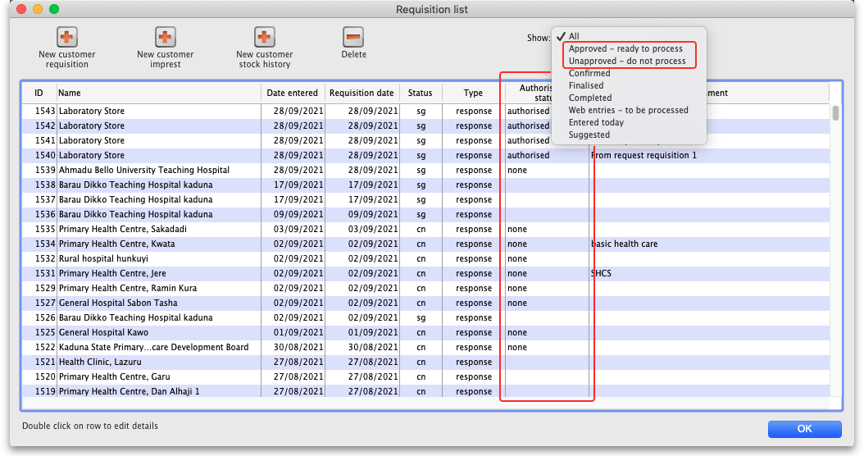
If you open a response requisition when the remote authorisation system is turned on, you will see the requisition's authorisation status and two additional columns:
- Approved quantity: the quantity that was approved by the authoriser. The authoriser can change the quantity allowed on the requisition so the approved quantity might be different from the requested or calculated quantites.
- Authoriser comment: any comment that the authoriser added to the requisition line.
This screenshot shows where you can find them:
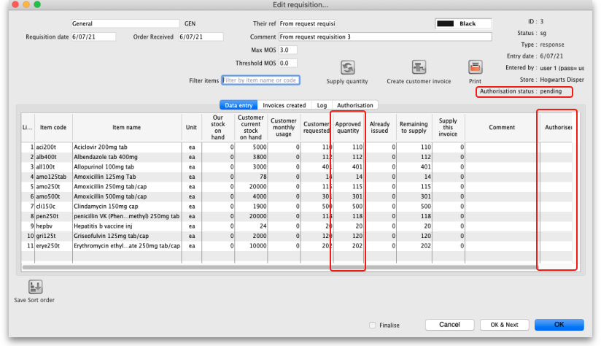
There is also an additional Authorisation tab on these requisitions, which shows the authorisation history of the requisition:
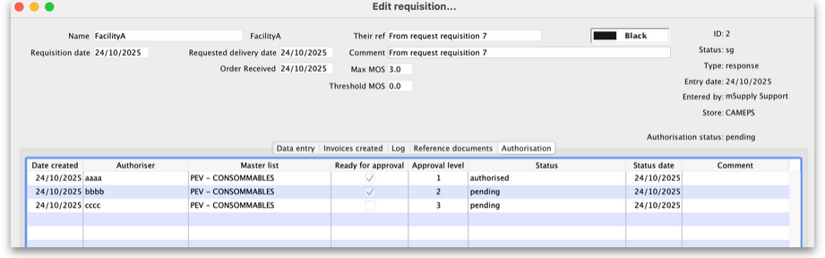
This particular screenshot shows that three authorisers at different levels have been requested to authorise lines on this requisition. The level 1 authoriser (user aaaa) has authorised the requisition, it is available and waiting for authorisation by user bbbb (level 2). If they also authorised it then it will become available for user cccc (level 3) to authorise, bnut it is niot yet available to them. If emails have been sent to multiple authorisers at any level they will also be shown in the list.
The authorisation status can have a few different values:
- None: the requisition does not need authorisation and is not subject to the remote authorisation system. This is true for all manually created response requisitions and any requisitions of other types (customer stock history, imprest or request). All requisitions with this status can be edited normally and customer invoices can be created from them as normal.
- Pending: the requisition is awaiting authorisation of one or more of its lines. A requisition with this status cannot be edited and you cannot create customer invoices from it.
- Authorised: all lines that were waiting for authorisation have been authorised (with or without adjustments). The comments and quantity to supply can be edited and customer invoices can be created from requisitions that are authorised.
- Denied: the authoriser has reviewed the requisition and the lines have all been denied. Like the Pending status, a requisition with this status cannot be edited and you cannot create customer invoices from it.

Authorising using the web app
When an internal order is finalised and contains items in master lists that are assigned to users for authorisation then an email is sent to all the users who are set as authorisers for those items. The email looks like this:
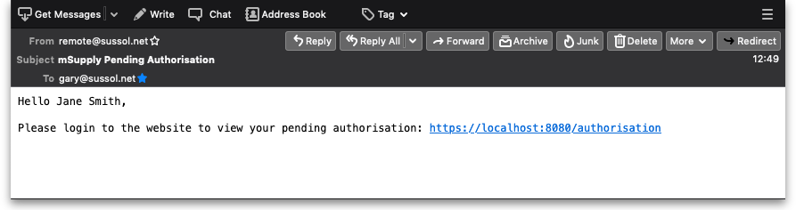
The link in the email is to the web app they need to log in to action the authorisation request. The URL is in the format server:port/authorisation; for example, https://demo.msupply.org:2048/authorisation.
When they click on the link (or paste it into their browser), authorisers are shown the login page where they login using their mSupply username and password:
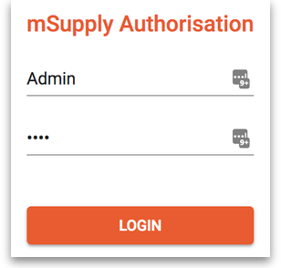
Once logged in, the authoriser can see all pending (and previous) authorisation requests.
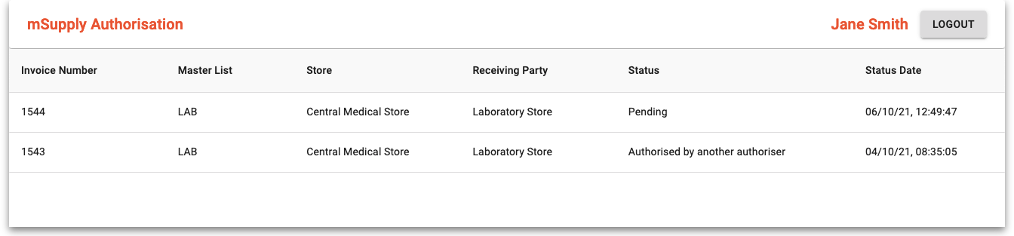
Note that only requisitions with a staus of Pending are editable in the web app. Any other status means that the requisition has already been processed, either by you, another authoriser or automatically by the system if the auto-authorise period for an authoriser has passed, and it is no longer editable.
To finish the authorising session and logout, click on the Logout button. This will log the user out and return them to the login window.
To view a requisition, click on it in the list. The requisition details window will open:
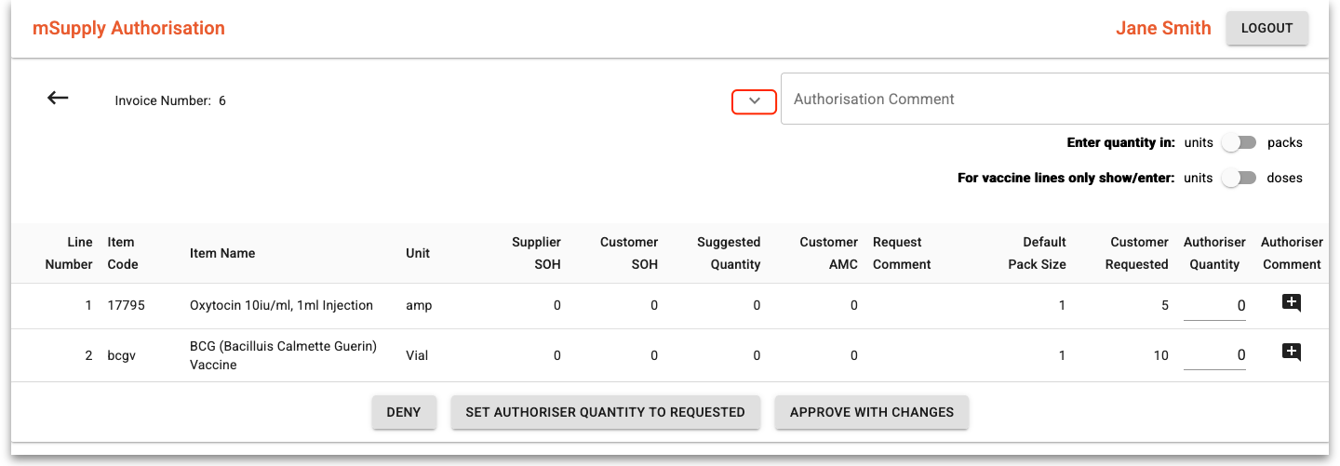
This is a simplified view to make reviewing easier. To see all the details of the requisition, click on the down arrow highlighted in red and more details will be shown like this:
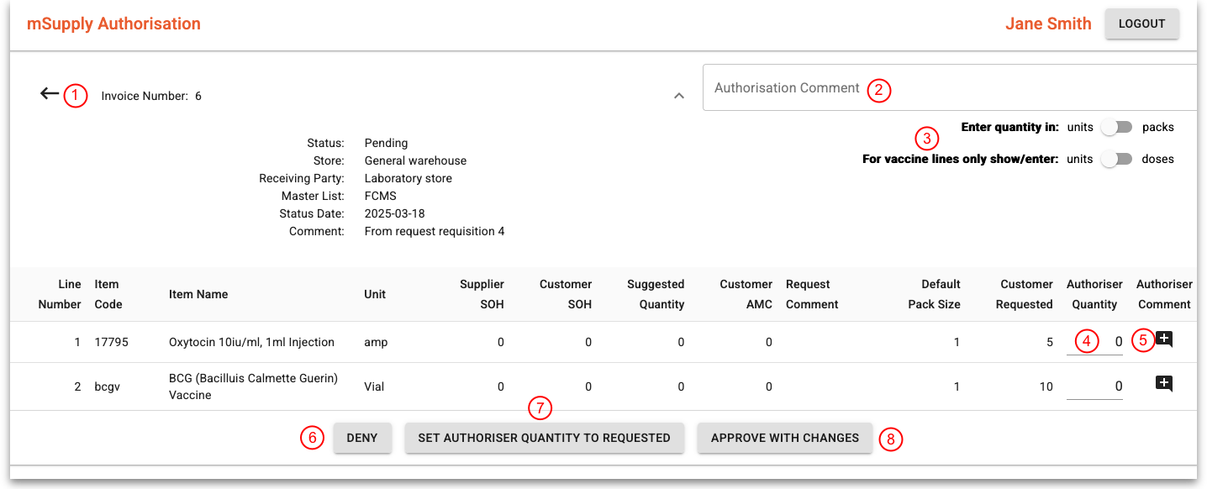
- Click on this arrow to go back to the list of requisitions.
- Enter any authorisation comment for the whole transaction. When saved, this comment will appear in the Comment column of the Authorisation tab on the requisition in mSupply.
- Click on the Enter quantity in units/packs slider to choose whether you enter the Authorised Quantity column values in units or default pack size packs. The For vaccine lines only show/enter units/doses slider only shows if a vaccine item is on the requistion for approval. The position of this slider affects all vaccine item lines on the requisition ONLY. The units/packs side of the slider will show what is selected in the Enter quantity in slider. If the slider is in the doses position then all vaccine lines will show quantities in doses in the Supplier SOH, Customer SOH, Suggested quantity, Customer AMC, Default pack size, Customer requested and Authoriser quantity columns. If it is in the units/packs position then it will show units or packs in those columns, just the same as the non-vaccine lines.
- Edit the quantities for each line that you are able to authorise in these cells. Note that not all lines of the requisition are displayed in this window. Only the lines that the user can authorise are shown (i.e. those that are for items that appear in the master list the user can authorise for). The quantities you enter in this column will be taken as units, packs or doses, depending on the positions of the sliders in 3.
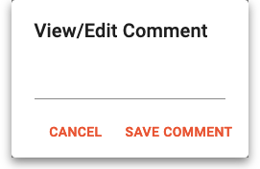
- Click on this icon to view, add or edit the line authorisation comment. When you click on it, this window will open: If there is a comment for the line already, it will be populated for you. You can edit the comment (or add one) and click on the Save comment button to save your changes. Click on the Cancel button to close this small window without saving any changes. Any comment that is saved here will appear in the Authoriser comment column on the requisition details window in mSupply.
- Click on this button to deny approval of all the requisition lines shown. This will deny the whole requisition and will mean that it cannot be processed in mSupply. This and the Approve with changes button will be disabled when the changes have been saved.
- Click on this button to quickly set all the Authoriser quantity column values to what was requested i.e. the Customer Requested column values. A handy shortcut to speed up the authorisation process if all or most of the lines are to be approved with what was requested.
- Click on this button to approve all the requisition lines shown. This will save any changes you have made to the approved quantities. This and the Deny button will be disabled when the changes have been saved.
If a requisition is open in mSupply, it is locked and changes cannot be saved. If you click on the Approve with changes or Deny buttons and the buttons do not become disabled then the changes were NOT saved. You will need to wait until the requisitions have been closed in mSupply before you can save your changes.
When a requisition has been approved or denied by an authoriser, its details and authorisation status will be updated in mSupply. If all the lines awaiting authorisation have been authorised then the requisitions's status will be updated to Authorised and the requisition will be able to be processed as normal.
Previous: 26.14. Authorisation | | Next: 26.16. Misc labels

