15.05. Dashboard set up (prior to mSupply v4.0)
The following instructions are for setting up dashboards for mSupply versions prior to v4.0.
For mSupply v4.0 and later please refer to the Dashboard set up chapter of this user guide.
Before you set the dashboard up you must:
- know what ports are already in use on the server
- have an appropriate SSL Certificate set up.
- make sure your webserver is currently running.
Sustainable Solutions can help with these.
To setup the dashboard (refer figure below):
- Open File > Preferences > Dashboard
- Check the “We use the web dashboard” checkbox.
- In the Dashboard web URL field enter the base URL to reach the dashboard, e.g. http://yoursystem.msupply.org:2048/.
Don't forget the trailing slash (/) otherwise it won't work!
If you are running from localhost, use your IP address, e.g. http://127.0.0.1:8080/ rather than http://localhost/.
- The URL users type in to the address bar of their browser to access the dashboard will be this base URL with dashboard on the end, e.g. https://yoursystem.msupply.org:2048/dashboard/
- Tick the reports in the Is active column to select them for display on your dashboard.
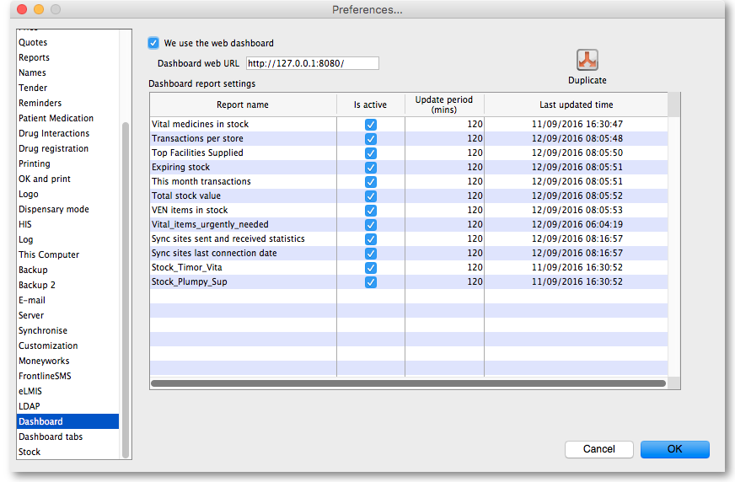
- You can choose how often these reports are updated by clicking in the Update Period (mins) column and entering a number of minutes.
- Setup which reports appear on which tabs - refer Dashboard tabs.
- Setup which dashboard reports each user can access - refer The dashboard.

Editing dashboard reports
Double-click a report in the list shown above and the following window will open:
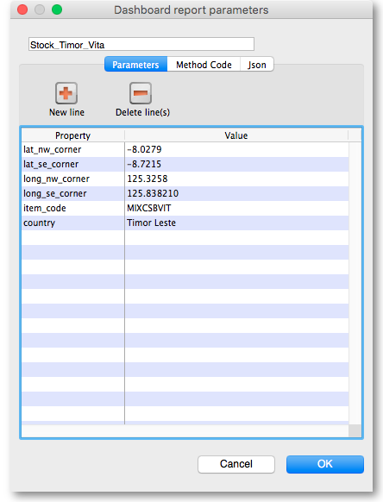
If there are any properties shown in the list, these can be edited to change what is displayed.
To edit a property or value, click once to select the row, and then click again in the appropriate cell to edit it.
To add or delete a row use the New line and Delete line(s) buttons at the top of the window.
In the example shown in the screenshot above (a map report), the coordinates of two of the map corners and the item code of the item whose stocks will be shown on the map have been entered. Note that if you add extra properties to the default reports they'll be ignored.
See the section below for details of the various dashboard reports available and the settings that can be edited.

What the dashboards show and what can be edited
There are several built-in dashboard reports that everyone can use. Here's what they show and what properties can be edited to change what they show:
Report name | Property | Value
VEN items in stock: Shows stock on hand of each items that belongs to the VEN (Vital, Essential, Necessary) category.(Method: dashboard_rep_item_ven) Report format : Table
 | store_code | store code if empty then default store is chosen
 | ven_category | V,E,N or E,N or V ..etc will filter the VEN items. If blank all visible items for the store are chosen
Total stock value: A single figure in your default currency, showing the total value of the stock you have in the store you are viewing the dashboard for. (Method: dashboard_rep_total_stock_value)
 | None | None
This month's transactions: Shows a bar chart of the number of purchase orders, goods receipts, supplier and customer invoices created this month. (Method: dashboard_rep_month_transacs)
 | None | None
Expiring stock: Shows the cumulative and monthly number of all items expiring within the year, split into columns by month of expiry. (Method: dashboard_rep_expiring_stock)
 | None | None
Top facilities supplied: The 10 customers in your store to which you have sent the greatest value of stock in the past 90 days. Shows the value of stock for each customer. (Method: dashboard_rep_top_facilities)
 | None | None
Transactions per store: Shows a table of all transactions per store within the past 7 and 30 days (Method: dashboard_rep_month_transacs)
 | store_tags | A comma-separated list of tags - or omit this parameter if you want to show stock for all stores.
Vital items in stock: Shows a bar graph of the percentage of medicines of the chosen category in stock at each facility. (Method: dashboard_store_stock_percent)
 | ven_category | v or e or n if you want to include items that are Vital or Essential or Necessary
 | user_field_4 | TRUE if you want to include items with this field checked
 | user_field_7 | TRUE if you want to include items with this field checked  Note that the labels for fields 4 and 7 may be different, as they are set up in the mSupply preferences (misc tab)
 | critical_stock | TRUE if you want to include items with this field checked, false for all items
 | store_tags | entering healthcentre will only include stores with the “healthcentre” tag
Map stock on hand: Shows a map of the area specified, with an “X” if the facility is out of stock of the item, or a dot representing the amount of stock on hand. (Method: dashboard_map_stock_on_hand)
 | lat_nw_corner | the latitude of the North-West corner of the map
 | long_nw_corner | the longitude of the North-East corner of the map
 | lat_se_corner | the latitude of the South-East corner of the map
 | long_se_corner | the longitude of the North-East corner of the map
 | item_code | the item code of the item to display
 | country | compulsory parameter
 | store_tags | A comma-separated list of tags - or omit this parameter if you want to show stock for all stores
Sync sites last connection date: Shows the last connection date and current mSupply version of each sync site. (Method: dashboard_report_last_sync_date)
 | None | None
Sync sites sent and received statistics: Shows number of records sent and received by each syc site within the last day. (Method: dashboard_report_sync_stat)
 | None | None
Stock_for_category_1_stores_by_item_list: Shows… (Method: -)
 | None | None
Trends in critical stock: Shows the historical stock on hand using parameters to filter store and/or items. Will show the current percentage, and percentages from the last day of each month for the prior six months. (Method: dashboard_rep_in_stock_trends)
 | store_id | the ID of the store you're interested in, or no value for all stores
 | critical_stock | TRUE if you want to include items with this field checked, false for all items
 | Output: use the type “time_series_chart”
Reports Monthly Transactions Shows how many transactions of each type the chose store has processed this month (Method: dashboard_rep_month_transacs)
 | store_name | the name of the store which you are interested in, or no value if you want all stores
Items Issued This Month: Shows items issued by the facility within the last 30 days. (Method: dashboard_itemRow_storeCol_usage)
 | store_tag | include stores with this tag
 | master_list | include items on this master list
 | period | 30 ( currently only 30 days is supported)
Stock each item in each store: Shows a table of items in rows and stores in columns, with the stock on hand for that item in that store in each cell. (Method: dashboard_rep_stk_StoreCols_Itm)
 | store_code | store code attached to the store. multiple stores can be specified by adding more parameters that begin with store_code (e.g. store_code2). The item_code parameter must be specified if using store_code
 | item_code | items whose code matches this code (append “@” for a “starts with” search)
 | master_list | selected master list of items. Category1_description must be specified if using a master_list
 | Category1_description | Items with this category1
Unfinalised Stock Transfers: Table of unfinalised stock transfers (between mSupply stores) for each facility. (Method: dashboardReportUnfinalisedStock)
 | store_tags | (optional) A comma-separated list of tags - or omit this parameter if you want to show transfers for all stores.
 | days_older_than | (optional) show only transactions that are older than this value (days).
If you can't make a dashboard report that does what you want then please speak to us, it's usually a fairly simple matter for us to create one for you.

Dashboard tabs
You set up Dashboard tabs which will display on your dashboard. Dashboard tabs are “containers” for one or more dashboard reports. To edit them go to File > Preferences and click on the Dashboard tabs tab on the left hand side:
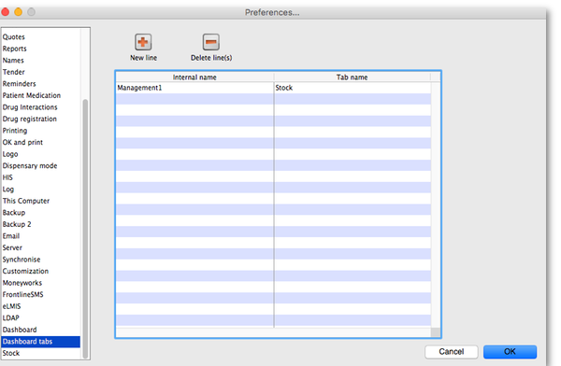
To add a tab click the Add button. To edit a tab, double-click it. You will be shown a window for editing a dashboard tab:
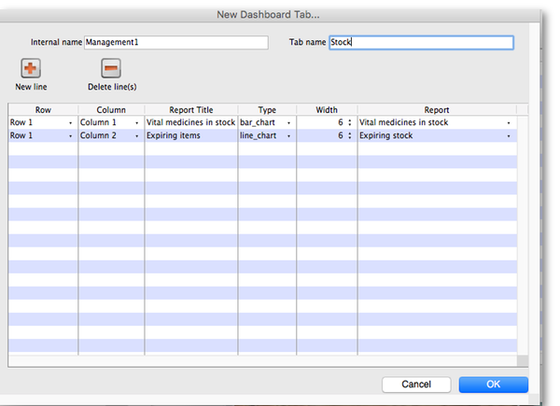
Now you add reports that will show on this tab.

Understanding rows and columns
Take this example dashboard tab:
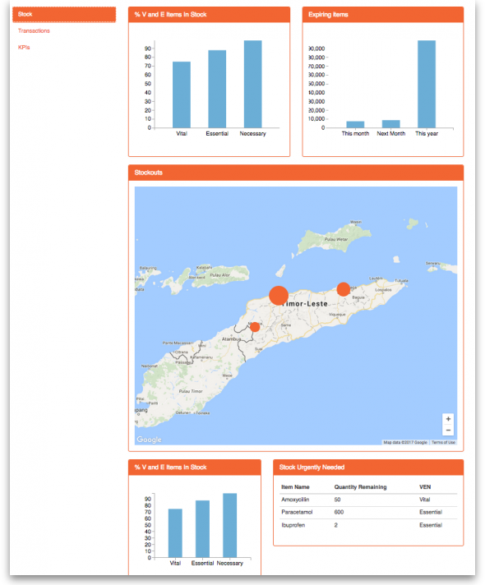
- The tabs themselves occupy their own space on the left of the window- they aren't considered when laying out the dashboard
- The first row has two reports- each report takes up half the row. So for the first report:
  - Row 1, Col 1, width 6 (“12” means it takes up the full width of the cell it is in- “4” would mean it would take up 1/3 of the width)
- For the report at the top right:
  - Row 1, Col 2, width 6
- For the map
  - Row 2, Col 1, width 12
- The next two reports are on the same row, but are divided into 5/12 and 7/12 of the width of the window, so we put them in the same cell but change the width settings:
  - Row 3, Col 1, width 5
  - Row 3, Col 1, width 7

To add a report to a dashboard tab
Click New Line to add a new report to the tab. Then edit the values in each column
- Row: The row it will be in
- Column: The column within the row- set to “1” if you don't have multiple reports on this row.
- Report tite: The title that will show in the Orange heading bar for the report. Note that the same report can display different information depending on the parameters you set for that report- hence the need for the ability to customise report names
- Type: You'll need to know the appropriate type for the report you're displaying. The options are
  - bar_chart
  - table
  - pie_chart
  - time_series
  - map
  - line_chart
- Width: The fraction of the cell width in “twelfths” that this report will take up (“6” will make it take up half the cell width)
- Report: Choose the report name from the drop-down list of available reports

Add a dashboard tab to a user's dashboard
This is the final step in setting up dashboards: once the tabs have been setup you have to choose which users will see which tabs. You do this in individual users' settings. See managing users for instructions on how to do this.
Some of these dashboard reports can be used for mSupply Mobile. Users do not need to be set up to have access to mSupply Mobile dashboards. The mSupply Mobile store will see the dashboard reports provided that on the mSupply central server:
- The mobile: Uses dashboard module store preference is turned on for the store
- The report has been configured for display on mSupply Mobile stores

Previous: 16.04. Printing preferences | | Next: 16.06. Entering a new logo

