6.05. Ordering from multiple suppliers
The multi-store purchase order will enable you to create a purchase order that includes lines for many stores at once.

Limitations
- You can only create a multi-store purchase order in supervisor mode.
- You can only create a multi-store purchase order as a blank purchase order. You cannot create a calculated multi-store purchase order (yet;-)).
- You cannot use multi-store purchase orders to order from another store in the mSupply system.
- For a specific item, you cannot order different pack sizes for different stores. For any item, all stores must have receive the stock in the same pack size.

Set up
To make a store available for multi-store purchasing, you will need to go into the store preferences and add a custom field labelled canBeIncludedInMultiStorePOs with its value set to true:
- Log into any store
- Special > Show stores…
- Double click on the store name in the list
- Go to the Custom fields tab
- Add a new line that looks like this (be VERY careful to get the spelling of canBeIncludedInMultiStorePOs correct. It is case sensitive):

How it works

Permissions
To be able to create a multi-store purchase order the user must have permissions to:
- Log in to Supervisor - All stores
- Create a purchase order in Supervisor - All stores - refer The permission tabs

Creating a new purchase order
To create a new multi-store purchase order, login to supervisor mode, choose Supplier > New blank Purchase Order as for a normal blank purchase order. Like a normal purchase order only one supplier can be chosen, but in the case of multi-store purchase orders this supplier cannot be a store. When entering a new line, you will be presented with this window.
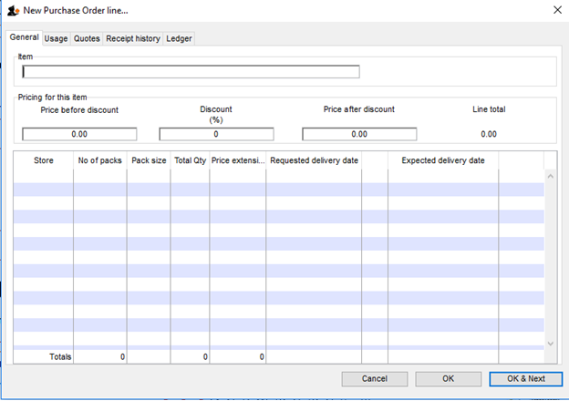
You can choose an item by typing the first few letters of its name or item code in the “Item” field box and press the Tab key. You will be presented with a list of items corresponding to the letters you have entered. Note that since the stock available of all stores could not be displayed at the same time in supervisor mode the quantities shown in the Stock on Hand Column have been set to 0. After choosing an item, a line will appear in the table for each of the stores that you have setup to be included in multi-store purchase orders (see Setup (make the word Setup a link to the section) above) will be displayed, along with the default pack size for that item and the current date as the requested delivery date. If the chosen item has been designated as a non-stock item in a particular store, that store’s line will be disabled.
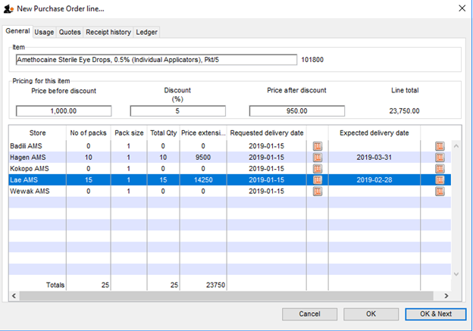
For each store, you can specify the number of packs to order. The total quantity will be automatically calculated. If you put a price per pack and a discount, the discounted price per pack will be calculated and applied to each line. You can change the requested delivery date and add an expected delivery date either manually or through the calendar icon on the column to the right. When you click OK, only the lines for which the number of packs is not 0 will be included in the purchase order line.
The other tabs are the same as normal purchase orders with two exceptions. Firstly, when adding a line for a normal purchase order, the usage is calculated for the current store only. For multi-store purchasing there is now a dropdown list that lets you choose for which store you want the usage to be calculated.
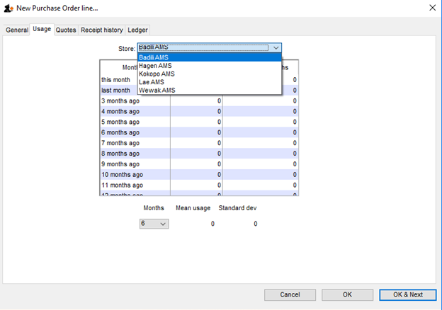
Secondly, there is also a dropdown list in the ledger tabs, where you can select the store for which you want the ledger to be displayed.

Editing a new purchase order
To edit a multi-store purchase order line, you must login to supervisor mode. When you have done so, open the purchase order and double-click on the line you want to edit. All the lines pertaining to the same item will be loaded. Here’s an example of a multi-store purchase order opened in supervisor mode:

If you click on the first line of the “Acryliser, Electric”, all five stores’ order lines for that item will be loaded.
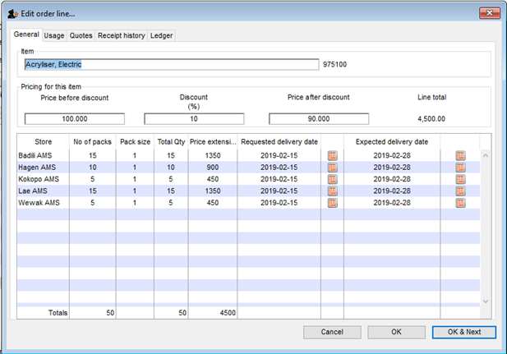
You can change the pack size, the price, the discount and the requested and expected delivery dates. If you put 0 as the number of packs for a line that had previously contained a quantity, this line will be deleted when the user clicks the OK or OK & Next button.
As with normal purchase orders, when a purchase order has been confirmed it is no longer possible to go back and edit the order lines.

Viewing multi-store POs
Multi-store purchase orders can be identified by an asterisk after the supplier name in the purchase order display list.
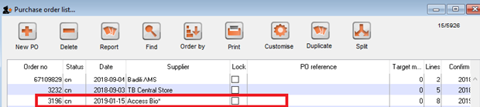
A multi-store purchase order appears in the purchase order list of each store for which goods have been ordered. When viewed in a particular store, only the lines that belong to that store will be displayed. The screenshot below shows an example:

Furthermore, the displayed lines will not be editable unless you are accessing it in supervisor mode.

Goods receipt
Good receipt will function as normal (see the link to Goods Receipt here) but only the lines pertaining to the store you are currently logged in will be available.
Previous: 6.04. Ordering from one store to another | | Next: 7. Receiving Goods

