2.02. Installation
We are assuming you have obtained mSupply from the mSupply Downloads web page.
If you are using a Windows machine, you have downloaded the file you need, and you have saved it to your desktop, it is important that you saved the file with an .exe extension or it will not run. You can rename a file by right-clicking on it. The name of the file should be something like mSupply_Single_User_V4-07-09.
It is strongly recommended that users who are not familiar with program installation adhere to these directions.
- Double-click the installer and it will automatically run the mSupply installer.
- The installer will do the following:
  - Create a folder on your chosen drive called “mSupply”
  - In Windows XP & 2000, create in the mSupply folder a sub folder called “Database” containing an example data file.
  - In Windows Vista and Windows 7, the example data file is installed in the My Documents/mSupply/Example sub folder.
    - NOTE: You can use this data file for practice. (Or use the tutorial at the start of the manual to learn the basics quickly)
  - Install the “mSupply.exe” application and associated files. Double-clicking this file will do the same as double-clicking the “start mSupply” icon on your desktop.
  - Install “readme.txt” - information on licensing and using mSupply.
  - Install “mSupply manual….pdf” - this document (CD version only).
  - Create two shortcuts on your desktop: “ start mSupply” and “ mSupply manual” (CD version only)
  - Create a “mSupply folder” entry in the “programs” section of your “start” menu.
Now you are ready to begin! Proceed to the section below on starting the example database.

Example data file
The mSupply installer treats Example data files in a special way. Re-installing mSupply on a previous installation will replace all the files except the Example data file. This is to prevent valuable data from being deleted as users may have started entering actual stock into the Example data file.
To install a fresh copy of the Example data file on Windows you can carry out one of the options described below:
- Un-install mSupply using the Windows menu Start > Program Files > mSupply > Uninstall mSupply . This will remove all installed files of mSupply which includes the Example data files. Re-installing mSupply now will install a fresh copy of the Example data file.
- You can manually delete the Example data file and re-install mSupply. The mSupply installer will install a fresh copy of the example database as the previously installed file has been deleted.
On Macintosh machines, simply replace the Example folder from the mSupply installer image.

Notes for Windows users

Date format
- In the regional settings in Control Panel, we recommend that the short date format is set to display only 2 digits for the year (YY, not YYYY).mSupply lists are set up to allow only enough space for 4 digits with most font sizes, but occasionally 4 digit years may be truncated. Having the wrong setting here will only affect display, not the actual data. It does not matter if you use DD/MM/YY or MM/DD/YY or YY/MM/DD
- If the display of lists in mSupply overlaps the separator lines, turn off large font in the display control panel.

Region / Language
After installation, if mSupply fails to start, then it's quite possible that the Language setting needs to be changed. Not all Windows OS languages are supported by the 4D database that mSupply is built on. Unfortunately, 4D does not maintain a list of unsupported languages.
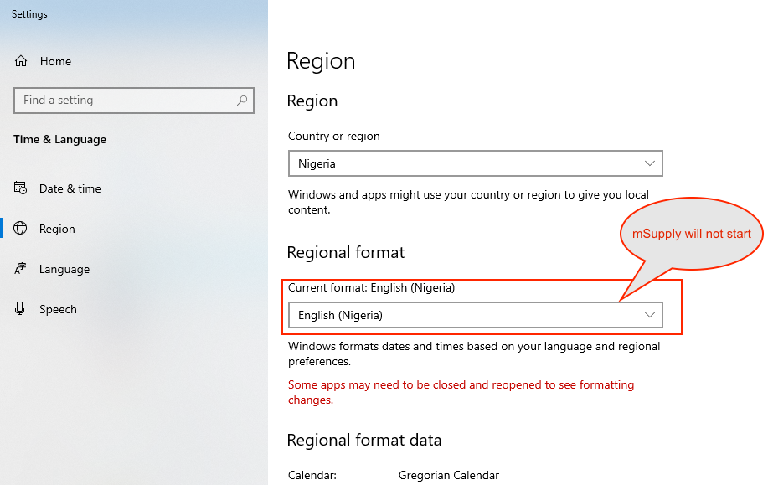
For example with regional format setting of English (Nigeria) it is known that mSupply will not start.
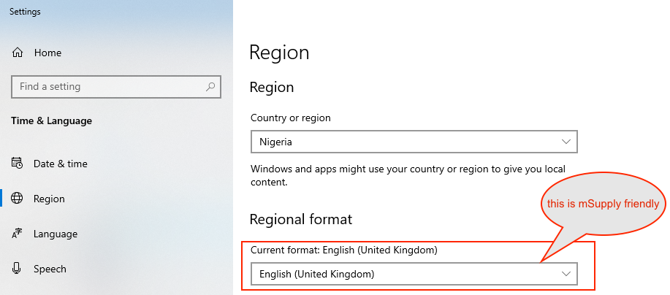
The solution is to change the regional format setting to something more common like English (United Kingdom) or English (US):

Known unsupported languages include:
- English (Nigeria) (2019-08-28)
- English (Papua New Guinea) (Win10 1903)
If you discover other unsupported languages, please let us know, and we'll update this list!

Previous: 2.01. Requirements | | Next: 2.03. Starting mSupply for the first time

