12.03. Supplying a mSupply Link site
An order from a mSupply Link customer will appear in your mSupply instance as a customer requisition. The responsible officer for the store will get a reminder to process the requisition when they login:
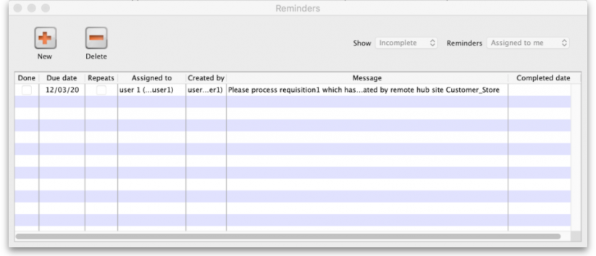
Douible-clicking on the reminder will show the detail:
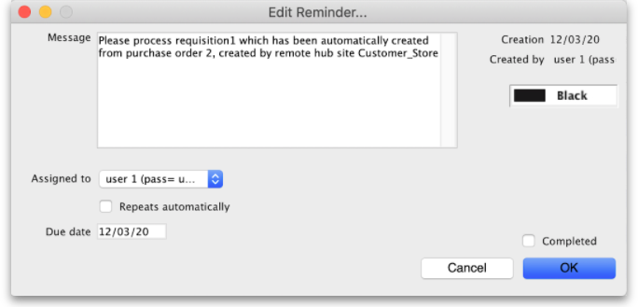
See the 26.02. Reminders page for more detail about reminders.
The customer requisition can be processed as usual; see the 8.07. Stock control methods for your customers (requisitions) page for information about this but please note this:
- The customer site will only receive notification of the stock being sent to them once you finalise the customer invoice created from the customer requisition.
- Once the customer receives the goods, the customer invoice you created from the customer requisition in the step above will be updated with details of the goods they received, including when they were received.
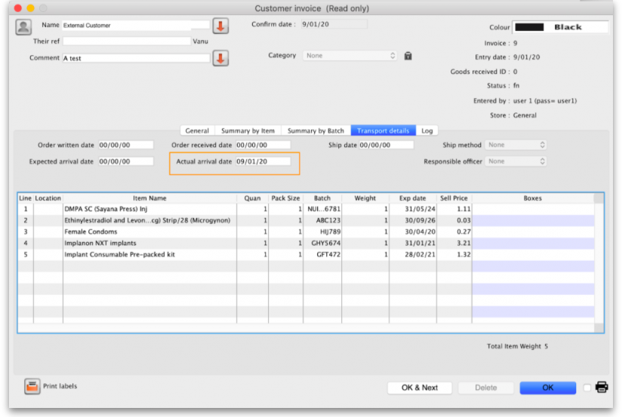
- The actual arrival date of the goods in the customer's store (the date they confirmed the supplier invoice) can be seen on the Transport Details tab of the customer invoice:
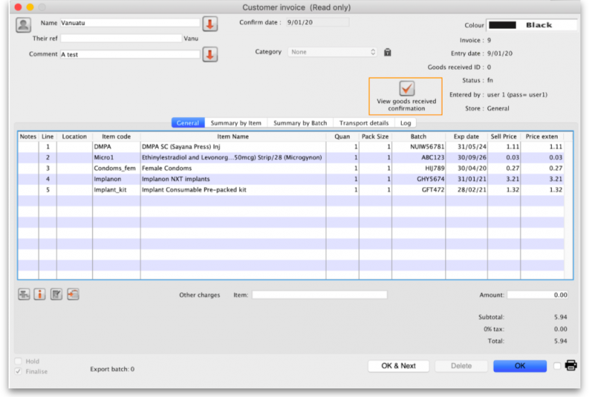
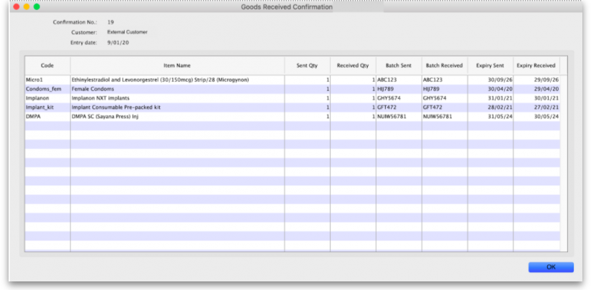
- The details of the items and batches received can be seen by clicking on the View Goods Received Confirmation button (which is only displayed on mSupply Link related customer invoices): This window will open to show you the details:

Previous: 12.02. Ordering Process with mSupply Link | | Next: 12.04. Receiving goods

