18.10. Supplier instructions for submitting tenders via Excel
As a supplier, you may be invited to participate in a tender managed using mSupply. The client may send you a tender template Excel document in xlsx format, which you are expected to complete and submit for evaluation.
You must use Microsoft Excel to view and edit the tender template. Microsoft Excel 2016 or newer has been tested to work with the tender template xlsx file. Theoretically Microsoft Excel 2007 should be fine, but this has not been tested.
The tender template will look something like this. You can also download a reference template from here: supplier_tender_reference_template.xlsx
The yellow section contains the item that you may bid for. Do not modify any contents of the yellow section.
The blue section is where you can enter the price for the items you wish to bid on.
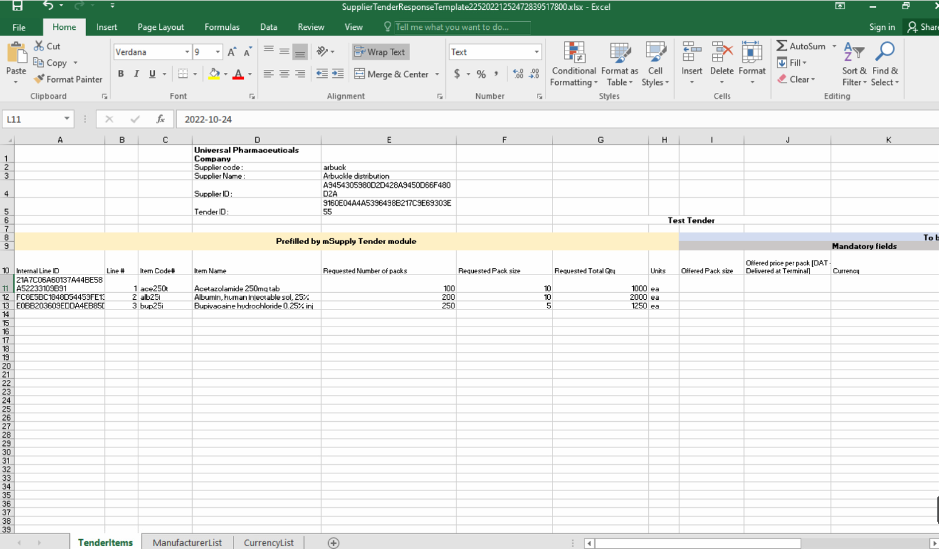
The currency and the manufacturer column should appear as a dropdown list. View currency pop down list If this doesn't work, please make sure you are using Microsoft Excel and that the version supports xlsx file format. Contact the client if you suspect that the xlsx file is wrong.
Do not change the cell format. If the cell is set to text or number, then it must be left as it is. Changing the cell to a different format will cause issues later with information potentially being lost.
The Excel file has the header row frozen, allowing you to scroll down the list and enter data while still being able to view the corresponding header.

The three worksheets
The Excel template contains three worksheets. Do not modify the name of the worksheets.
- TenderItems: Main worksheet containing the tender items.
- ManufacturerList: Contains the manufacturers that populate the manufacturer dropdown list in the main worksheet. Do not add to the list of manufacturers manually as this list needs to come from your client.
- CurrencyList: Contains the available currencies that populate the currency dropdown list in the main worksheet. Do not add to the list of currencies manually as this list needs to come from your client.

Supplier Tender Response file format
A more detailed information regarding the tender template columns and cells is described below.
Serial number | Column | Field | Description
1 | 1(D) | Organization name | Pre-filled. Displays the mSupply store's organization, cannot be changed.
2 | 2(D) | Supplier code | Pre-filled. Cannot be changed.
3 | 3(D) | Supplier Name | Pre-filled. Cannot be changed.
4 | 4(D) | Supplier ID | Pre-filled. Cannot be changed.
5 | 5(D) | Tender ID | Pre-filled. Cannot be changed.
6 | 10(A) | Internal Line ID | Pre-filled. Cannot be changed.
7 | 10(B) | Line # | Pre-filled. Cannot be changed.
8 | 10(C) | Item Code# | Pre-filled. Fixed by the tender, cannot be changed.
9 | 10(D) | Item Name | Pre-filled. Fixed by the tender, cannot be changed.
10 | 10(E) | Requested Number of Packs | Pre-filled. Cannot be changed. 30 alphanumeric characters.
11 | 10(F) | Requested Pack size | Pre-filled. Cannot be changed.
12 | 10(G) | Requested Total Qty | Pre-filled Cannot be changed.
13 | 10(H) | Units | Pre-filled. The unit the quantity is measured in e.g. tablet, mL, g, bottle, vial, ampoule
14 | 10(I) | Offered Pack Size | Mandatory. Number greater than zero (default = 1).  The pack size (number of units in one pack) you are offering.
15 | 10(J) | Offered Price per Pack  [DAT - Deliver at Terminal] | Mandatory. The price you are offering for each pack.
16 | 10(K) | Currency | Mandatory. The currency of the quoted price.  Choose the required currency from the dropdown list.  If the currency does not exist, enter the new currency here manually.
17 | 10(L) | Expiry Date | Mandatory. Expiry date of the quoted product, which can be a specific date or an expiry from delivery (e.g. 12 months). This field can be plain text.
18 | 10(M) | Delivery Time | Mandatory. Estimated time between the goods leaving the supplier’s premises and delivery to the customer (.e.g. 5 months).
19 | 10(N) | Supplier Item Code | Optional. Your supplier item code, if any.
20 | 10(O) | Manufacture Name | Optional. Choose the required manufacturer from the dropdown list.  If the currency does not exist, enter the new manufacturer here manually.
21 | 10(P) | Comments | Optional. Enter any comments that should be considered in the evaluation process (e.g. brand provided, quote only applicable if all needle sizes are awarded etc.).

Currency
This specifies the currency for your quote, which is set for each item. Select an available currency from the dropdown list.
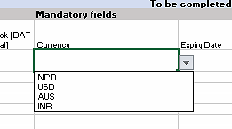
If the required currency is missing, it means the client has never handled this currency in mSupply before. You may enter the new currency in this column using the appropriate three letter abbreviation from this link:Currency Abbreviation.
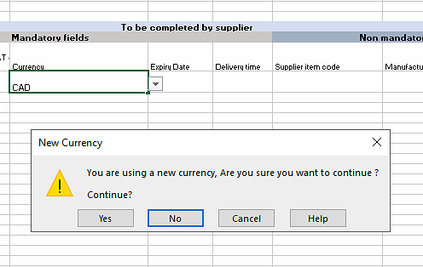
The example above shows Canadian Dollars (CAD) is being quoted for this item. Excel will alert you that this is a new currency. Click OK to continue with the new currency.
On your next tender with the same client, your currency of choice should already be present on the spreadsheet.

Manufacturer
The name of the manufacturer can be chosen from the drop-down list. Typing the first few characters of the manufacturer's name will show a list of matching manufacturers. Click to select one.
If the manufacturer drop down list shows, the it is a good sign that your Microsoft Excel is OK.
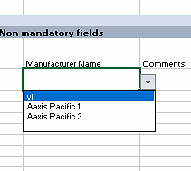
If the manufacturer does not exist, this means that the client has never processed drugs from the manufacturer that you wish to bid with. Similar to the currency column enter the new manufacturer name and the excel will confirm if you want to continue.
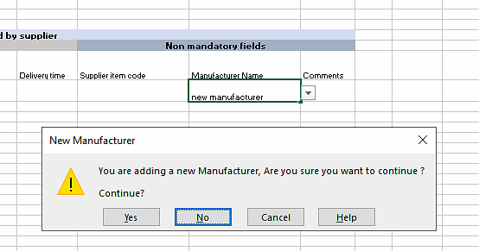
Chances are on your next tender with the same client, you manufacturer of choice will be present on the excel.

Entry rules
- Leave the row empty / unfilled if you choose not to bid for the item.
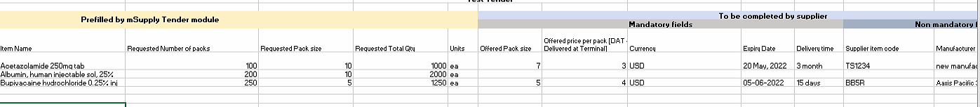
- Multiple bids for the same item is allowed by copying and pasting the entire row. The “Internal Line ID” must be part of the copy as it is very important.
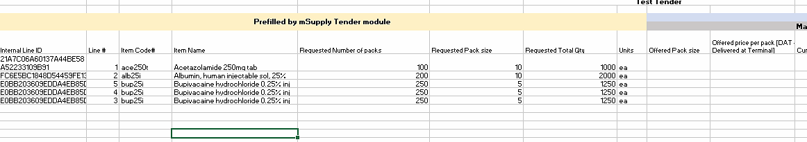
- Line number is not important and doesn't need to be in any order.
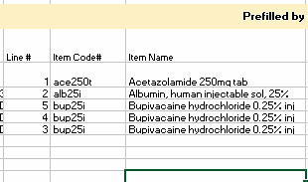

Tender Submission
Enter your bid, save it and email the xlsx file to the client as guided.

