Stock Web App
You can use the Stock Web App to look up the stock on hand of items, including batch and expiry information, from anywhere you have access to the internet. Very handy if you are away from the computer you normally use to access mSupply, or travelling overseas and still need to check the stock information in your store.
Users will be able to see the stock information for their default store only, and only on the Primary server in a synced system.
To access the Stock Web App, point your browser to https://yourserver.msupply.org:2048/stock where yourserver.msupply.org is the domain name and 2048 is the port for your mSupply web server (these details will be supplied to you by Sustainable Solutions if you are using this functionality). If you are going to use the App a lot, it would be a good idea to set its location as a bookmark or favourite in your browser.
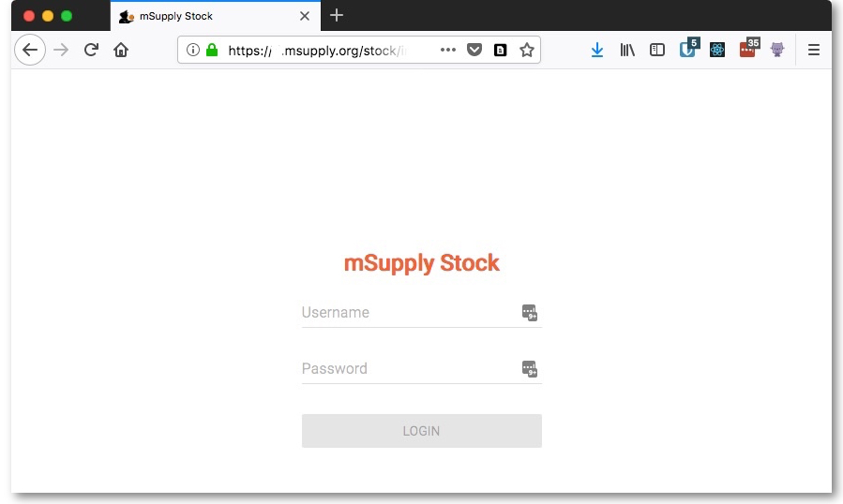
This is the screen you will see:
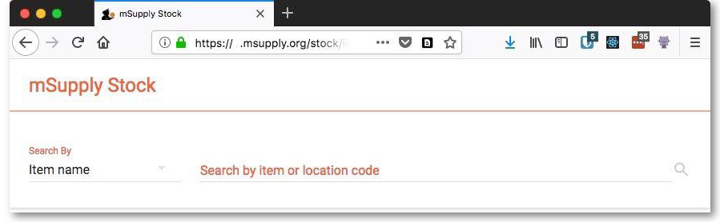
Type in your normal mSupply username and you normal mSupply password and click on the Login button to move to the search screen:
You can either search by item name or stock location code - select “Location code” instead of “Item name” in the screenshot above to search by location code. mSupply will search for stock belonging to items with names or in locations with codes that begin with what you type in the “Search by item or location code” field shown in the screenshot. When you have entered the text to search for, click on the magnifying glass icon to make the search. The results are displayed below the search filter, as shown in this screenshot:
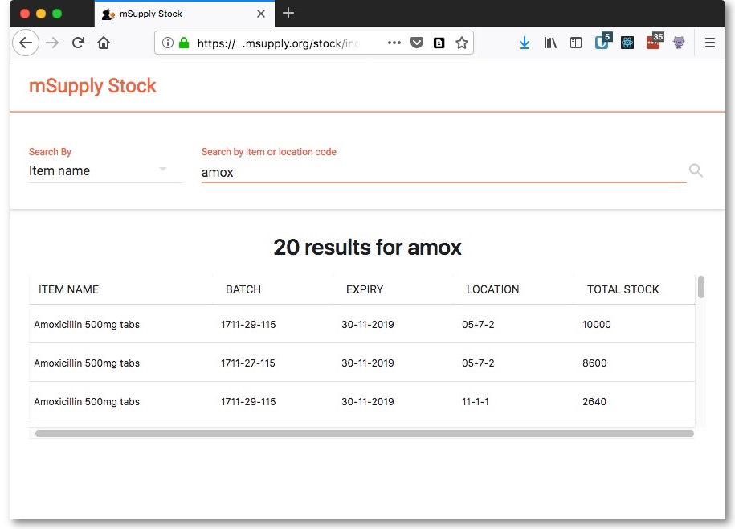
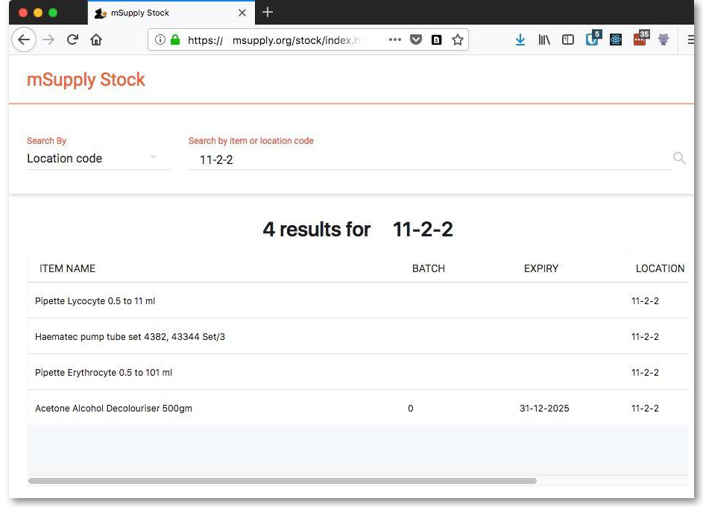
And this is an example of a search by stock location code:
Previous: mSupply mobile API Next: Miscellaneous topics

