Diagnostics
Note: This feature is primarily intended for use by our technical staff when there is reason to believe that there may be some errors in the database; it is unlikely to be of practical use to users of mSupply . A brief description follows.
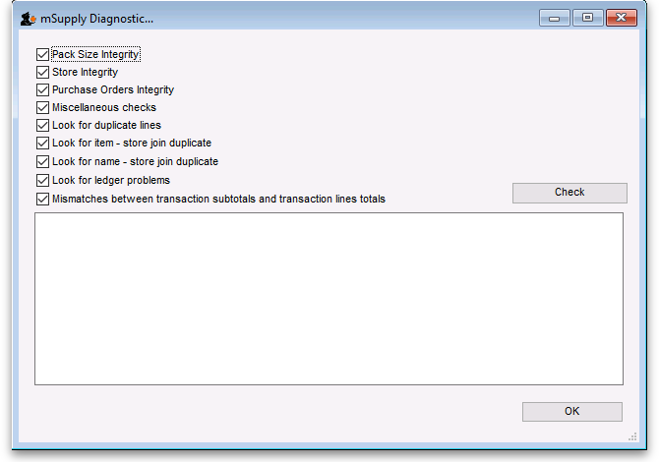
Pack size integrity: Each item's pack size is examined by batch number to confirm that stock in balances with stock out.
Store integrity: Each customer invoice is examined to confirm that each transaction has been applied to the appropriate store.
Purchase Order integrity: A check is performed to confirm that Purchase Order quantities and Goods Received quantities tally.
Miscellaneous check: This check is performed to confirm that any repacked items have not resulted in negative amounts being recorded
Look for ledger problems: This report presents you with a list of items whose ledger balances (total in minus total out) does not equal the difference between the opening stock and the actual stock on hand.
The report was originally created as a check that the stock on hand was being accurately updated with all the different transactions in mSupply. It has been left as a menu option as it is also useful to pinpoint unauthorized adjustment of stock values.
Previous: Change user Next: Field descriptions

