The Help Menu

Help > About mSupply
Choosing this item displays information about the version of mSupply in use, and provides details of the location and size of your data file.
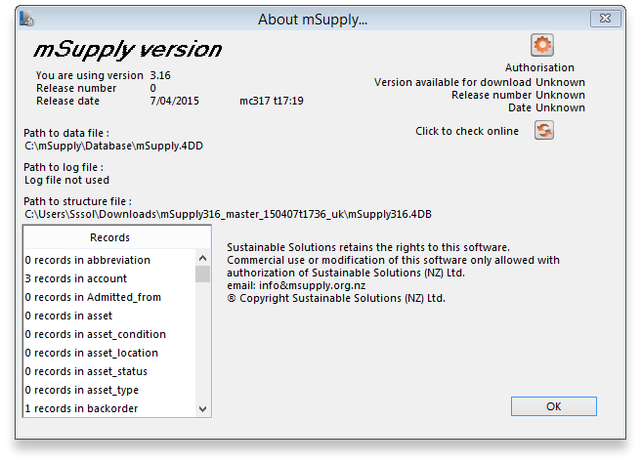
You can click the blue arrows icon to retrieve the current version number from the internet. (This will not download a new version- it will only advise whether a newer version is available for download).

Authorisation
The Authorisation button is provided largely for developers' use. Its purpose is to assist our technical staff to resolve clients' problems. It is recommended that you ignore it.

Updating mSupply
For single user versions of mSupply, you can see if you have the latest version by choosing Special > Check for updates
Choosing this item from the Special menu will connect to the mSupply web site and compare your current mSupply version with the version you are now using.
If an update is available, you will be shown a window where you can click to download the latest version.
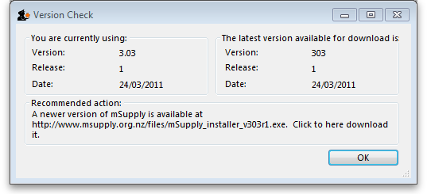
Previous: The Help Menu Next: FAQ: Why is my stock balance negative?

