15.03. Barcode scanning and receiving goods
Added: Version 4.01
You can use barcode scanning in two different ways when receiving goods, depending on how the preferences are set:
- Manually tell mSupply which barcode belongs to each line of stock (no scanning required but allows scanning to be used for the stock in other processes later e.g. stocktaking, picklist checking.
- Full scanning. Use this process to minimise manual data entry. This is using simple barcode scanners tethered to the computer running mSupply. For scanning using independant handheld computer barcode scanners, please see the details on the 15.08. Barcode scanning with handheld computers (The Zapp App) page.
Please see the 16.09. Barcode scanning preferences page for details on how to set the preferences for barcode scanning. If the Items, picklist checks and stocktakes checkbox is checked and the Receiving goods on a supplier invoice checkbox is NOT checked then process 1 (manually telling mSupply which barcode belings to each line of stock) is used.
If both the Items, picklist checks and stocktakes checkbox and the Receiving goods on a supplier invoice checkboxes are checked then process 2, full scanning, is used.
Both these processes are carried out on a supplier invoice. The supplier invoice can be created manually in the normal way (either manually (see Receiving goods - a supplier invoice or by finalising a goods received note (see Goods receipt notes)). When the We use barcode scanners preference is turned on (see Barcode scanning preferences), this is what a blank supplier invoice invoice window looks like:
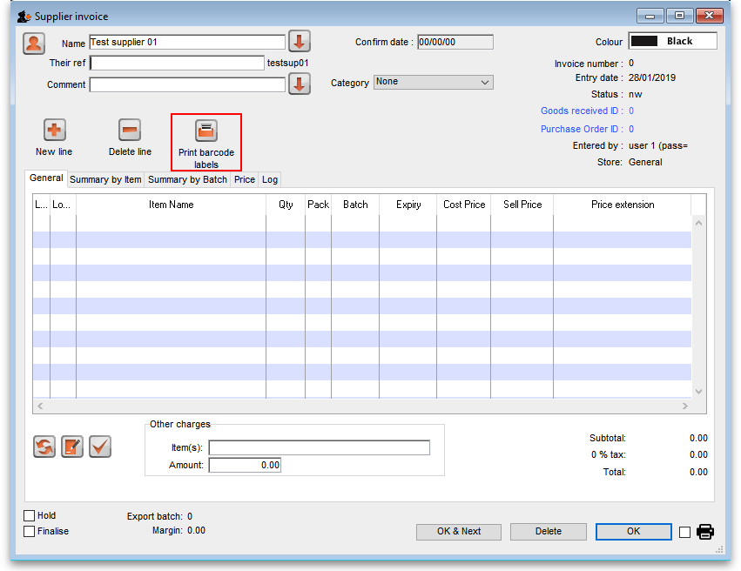
It is exactly the same as a standard supplier invoice, except for an additional Print barcode labels button (see Barcode label printing for details)
Clicking on the Add line button shows an extra Barcode field on the invoice line window:
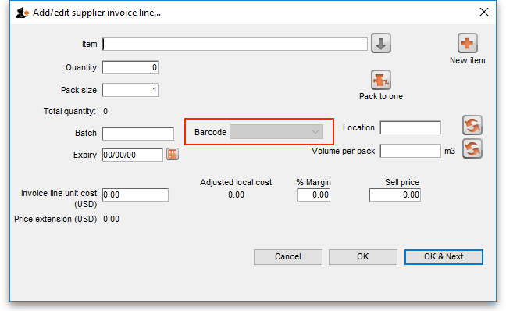
How this window behaves depends on whether you're using the manually barcode asignment or full barcode scanning processes described above.

Manually assigning barcodes
When the item has been selected in the usual way, the Barcode drop down list is filled with a list of all the barcodes already assigned to the item, showing the pack size and manufacturer for each:
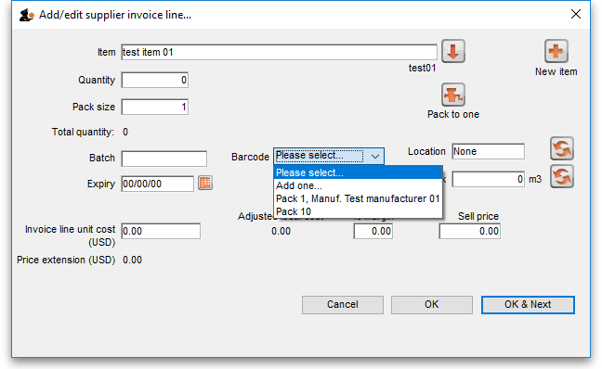
If one of the barcodes matches the stock that is being received, select it: this will set the Pack size field to match the pack size that belongs to the barcode. You can still manually edit the Pack size field but if it doesn't match the barcode you have selected when you click on the OK or OK & Next buttons, you will be warned and told to correct it (either select another barcode with a matching pack size or alter the pack size).
If none of the barcodes in the drop down list match the one on the stock, you can click on the Add one… option. This will immediately open the Add barcode window so you can add the new barcode. See Adding barcodes to items for details.
Note that once you have selected a barcode, the Please select… option in the Barcode drop down list becomes Remove barcode to show that selecting this option will remove the barcode from this line.
When you are using this process, you must select a barcode from the Barcode drop down list, you will not be allowed to add the line without it.

Full barcode scanning
When full barcode scanning is chosen, the barcode drop-down list is not shown on the supplier invoice line entry window, so it looks like this:
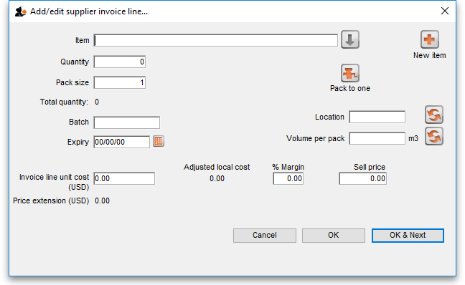
When you scan a GS1 barcode on the item to be received, mSupply will fill in as many of the fields as possible with information from the barcode, such as the:
- Item name
- Pack size
- Number of packs
- Expiry date
- Batch code
- Manufacturer
- Manufactured date
Only fields that are displayed will be filled in (some preferences can make other fields show). These values can be edited manually after scanning if desired. If you enter them before scanning, they will be overridden with the contents of the barcode if you then scan. Click the OK or OK & Next button to save the line as normal.

Manually assigning barcodes to existing stock lines
Sometimes it might be necessary to manually add or edit the barcode that belongs to an existing stock line. For example, any stock lines you have in mSupply before you turn on the barcode functionality will not have barcodes entered against them and they will need to be added manually. Or an incorrect scan may have been made at goods receipt and the barcode might need to be changed.
To do this, first choose Items > Show items from the menus, search for the item whose stock you wish to edit and open its details window by double-clicking on it. Then click on the Stock tab:
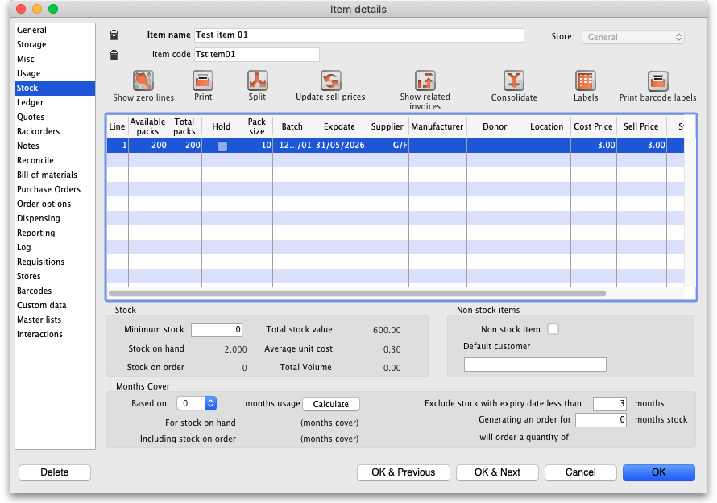
Now double-click on the stock line whose barcode you wish to change. This will open the stock line details window:
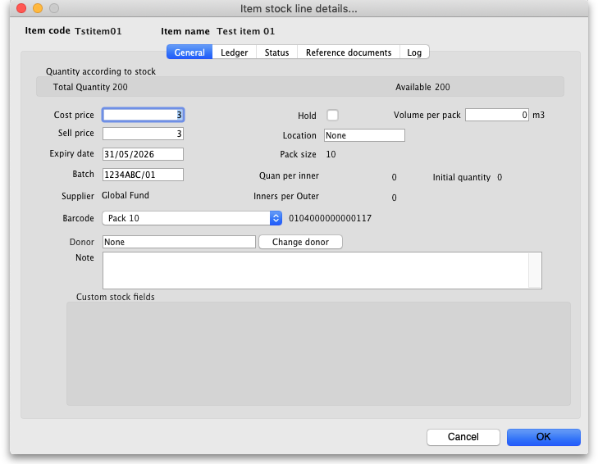
The Barcode drop down list displays the current barcode assigned to the stock line (it will say Please select… if it has no barcode assigned). The current barcode will also be shown to the right of the drop down list, as in the screenshot, if one is currently assigned.
Click on the drop down list and you will be shown a list of all the barcodes of the same packsize as this stock line for this item. You can select any one of these or the Add one… option to open a new window to add a new barcode (see the 14.02. Adding barcodes to items page for details on that window).
If a barcode is already assigned to the stock line, the first option in the Barcode drop down list will be Remove barcode - select this if you want to remove the barcode current assigned ot this stock line.

Previous: 15.02. Adding barcodes to items | | Next: 15.04. Barcode scanning and stocktaking

