9.06. Label printing preferences
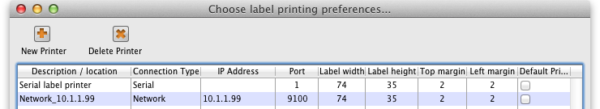
In mSupply the settings for label printer are set in the “Choose label printing preferences window”, which you open via the mSupply menu bar: Special > Printing preferences
This window will show you ALL mSupply printers that have been set up for your whole organisation.
Your mSupply printer descriptions must include your site name and make sure that you do not delete printers for other sites!!!

Changing your mSupply default printer
To change the mSupply default printer in the “Choose label printing preferences window” simply click the checkbox in the right-hand Default Printer column for the printer you wish to use.
Note this is different from your Windows default printer. You are setting the default printer for mSupply to use (the default printer you have set for Windows can be another printer altogether).
The mSupply printing preferences are stored for the computer you're setting it from (not the mSupply user or the mSupply site you're logged in to). When you change the mSupply default printer you are changing it for everyone who uses the computer.

Editing a printer
In the “Choose label printing preferences” window double-click the printer entry in the list. This will open the “Add label printing preferences” window - see below for info on each setting.

Adding a printer
If you are setting up up your label printer hardware for the first time, you will first need to follow the instructions here: 25.18. Label printer hardware setup.
When your printer hardware is connected and ready to be set up in mSupply open the “Choose label printing preferences” window and click the New Printer button. This will open the “Add label printing preferences” window - see below for info on each setting.

The printer preference settings
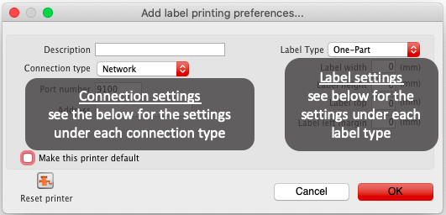
Description
Since the mSupply printing preferences window lists ALL the mSupply printers for your organisation it is vital that the Description includes the site name to avoid confusion.
e.g. Busby Pharmacy GK420t
Connection Type
If printer connected with a network cable (recommended) choose network
If printer connected with USB choose USB
If printer connected with a serial cable choose serial
Label Type
One-Part
Three-Part
Make this printer default
Checking this box means that mSupply on this computer will always print to this printer.\\Refer to the Changing your mSupply default printer section above to find out how this works.
Reset printer
You can use this button to send a command to the printer to reset it. Occasionally a printer may misbehave if it's memory is corrupted by an electricity spike or the like, and this button may help. If your printer is not behaving we recommend you contact Sustainable Solutions support@msupply.org.nz rather than charging ahead on your own.

Printer connection settings
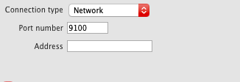
Network
Port number
For network connections this will usually be 9100
Address
The IP address of the printer
e.g. 10.1.1.253
For info on creating a static IP address for the printer refer to label_printer_hardware_setup
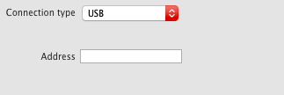
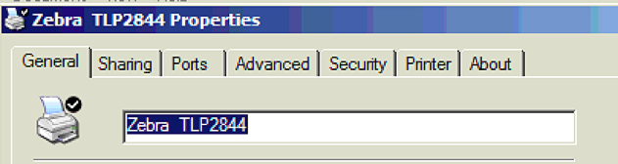
USB
Address
Enter the Windows name of the printer. It must be entered exactly.
To confirm the Windows printer name go to the Windows Control Panel > Printers and Scanners.
Right click on the printer and select properties.
The Windows printer name is recorded on the General tab.
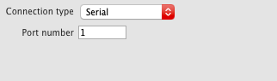
Serial
Port number
Enter the Windows serial port number for the printer.
To confirm the port number go to the Windows Control Panel > Printers and Scanners.
Right click on the printer and select properties.
The Windows port number is recorded on the Ports tab.

Printer label settings
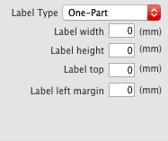
One-Part label
Label width: the physical width of the full label
Label height: the physical height of the full label
Label top: the height of margin wanted from the top of the label
Label left margin: the width of margin wanted from the left of the label
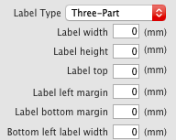
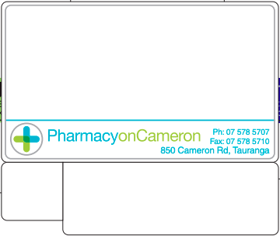
Three-Part label
Label width: the physical width of the full label
Label height: the physical height of the full label
Label top: the height of margin wanted from the top of the label
Label left margin: the width of margin wanted from the left of the label
Label bottom margin: the margin between the top label and lower labels.
Bottom left label width: the width of the bottom left label.

Previous: 9.05. Abbreviations for dispensing | | Next: 9.07. Warnings

