Warnings...
From the Special menu this command allows you to view and edit the standard list of warnings.
Once this list is created, you can apply one or more warnings to each item, and choose which warning will be automatically printed on labels.
To apply a warning to an item, see Adding a New item
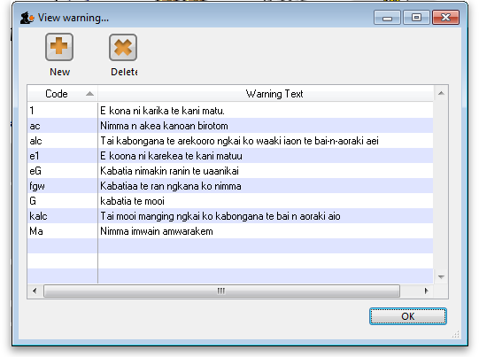
Double-click a warning in the list to edit its details.
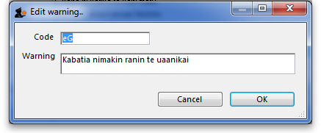
Click the “New” button to add a new warning.
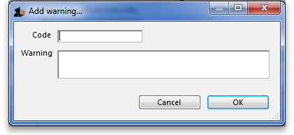
We suggest you use the standard set of warnings as specified by the pharmaceutical authorities in your country.

