28.14. Navigating inactive windows or form

The problem
Cursor on mSupply changed from arrow to window and user can't click anything resulting in inactive windows/form.
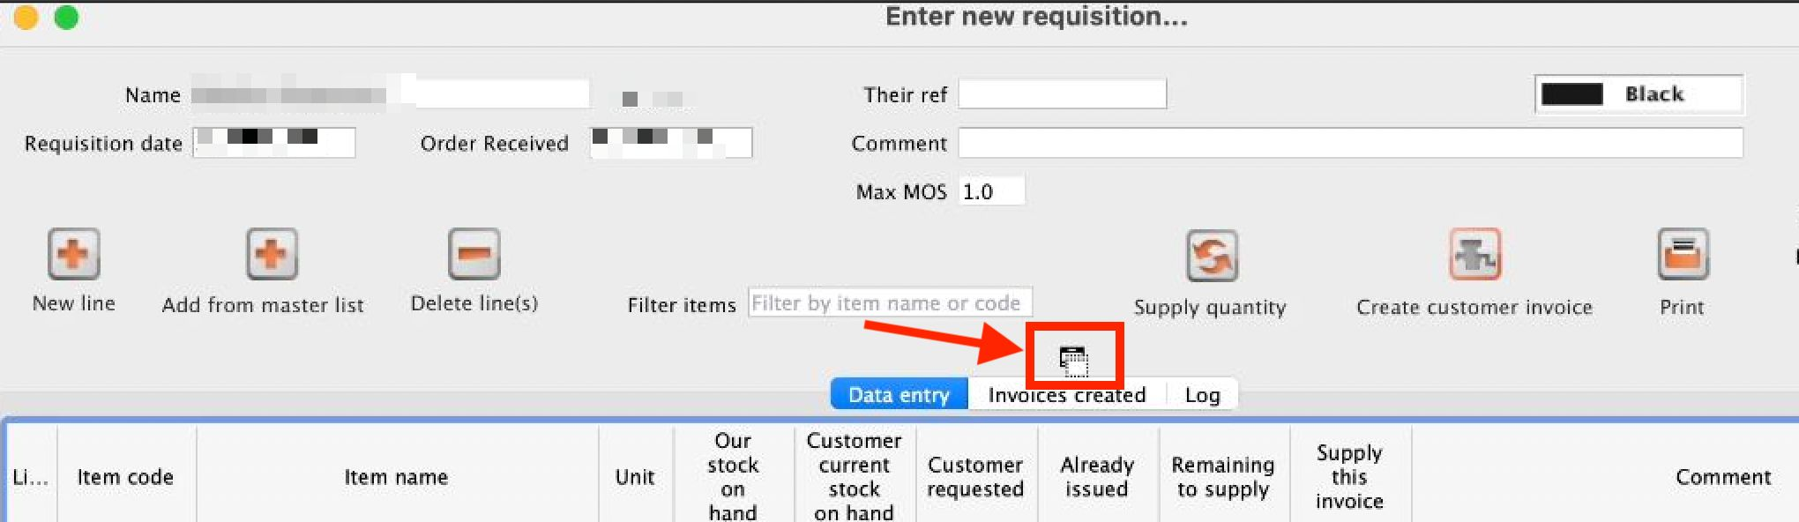

Active window
- They may have active window that has been pushed behind the current shown window.
- They may have minimised the active window unknowingly.
There may be an alert window that has been pushed back by the user clicking the inactive window.

Fixes
- Drag the Top most window to the side and check if there is another active window or an alert behind it.
OR
- Hit the “Enter” key and mSupply should bring the active window to the front.

