17.06. Importing customer budgets
You can set up budgets for customers manually if you wish (see here) but if you have to set budgets for many customers at a time then this feature will save you a lot of time. As with the other import features of mSupply, this import uses a tab delimited text file (easily produced by exporting a spreadsheet from Excel or other spreadsheet programme). The columns that must be present in the file and their contents are as follows:
Column number | Column letter | Field | Description
1 | A | budget description | The description for the budget, as it will appear in the list of budgets for a customer.
2 | B | customer code | The customer's code as entered in mSupply. If this code does not match a customer in mSupply an error will be generated.
3 | C | customer name | For your reference only. This column is ignored during the import and can be left empty, but it must be present.
4 | D | budget period start date | The start date for the period to which the budget belongs in the format dd/mm/yyyy or mm/dd/yyyy (whichever your copy of mSupply is using).
5 | E | budget period end date | The end date for the period to which the budget belongs in the format dd/mm/yyyy or mm/dd/yyyy (whichever your copy of mSupply is using). The budget period start and end dates must match an existing budget period period in mSupply (set up using Budgets), otherwise an error will be generated.
6 | F | budget amount | The amount of the budget. Must be a positive number with or without a decimal point.
7 | G | additional budget | Whether the budget amount is to be considered an additional budget. A “T” or “Y” is interpreted as true, anything else is interpreted as false.
8 | H | effective budget date | The effective date for an additional budget in the format dd/mm/yyyy or mm/dd/yyyy (whichever your copy of mSupply is using). Ignored if the budget is not additional. If this field is left blank and the budget is additional then the current date is used.
When you have created the import text file go to File > Import > Import customer budgets and select your text file. You will be show the following window:
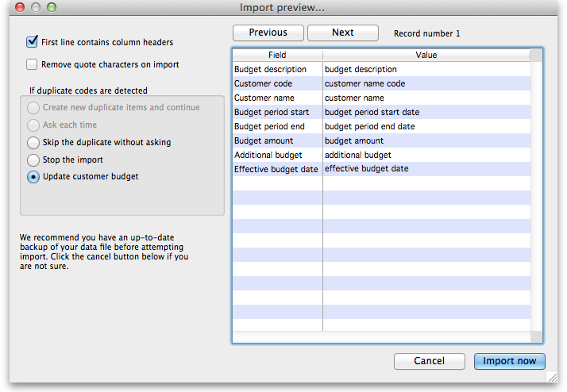
Now choose the import settings to match your file:
- First line contains column headers: check this if the first row in your text file contains the column descriptions. If checked, mSupply will ignore the first line of the file.
- Remove quote characters on import: check this if fields in your file is surrounded by quote (“ or ') characters. If checked, mSupply will attempt to remove them from each field.
And select how duplicates are to be handled (a duplicate is a row which matches another line in the file or a budget already in mSupply):
- Skip the duplicate without asking: The duplicate record is ignored completely
- Stop the import: mSupply will stop importing from the file if it detects a duplicate. Any budgets already imported will be kept but no further lines in the file will be processed.
- Update customer budget: The budget already in mSupply will be updated with the new details found in the file and the import will continue.
You can also click the Next and Previous buttons to see a preview of what mSupply will import on each row from your file. This can be useful for showing differences in the contents of your file and what mSupply is expecting.
When you're ready to carry out the import, click on the OK button. mSupply will carry out the import and tell you how many lines were imported, how many budgets already in mSupply were modified and if there were any errors. You can see more details by viewing the log (see The log).

Previous: 17.05. Importing abbreviations | | Next: 17.07. Importing locations

