4.20. Forecasting
In mSupply, 'consumption' is defined as stock that is issued. Stock lost due to damage, expiry, etc. (managed through Inventory Adjustments) are not included in 'consumption'. During the later quantification calculation, there are options to include or exclude Stock Transfers and Builds in the consumption calculation.
By default, mSupply uses the assumption that future consumption will continue at the same level as consumption over a given historic period. Our experience is that in almost all situations, this method, combined with a conservative provision for buffer stock, yields very good to excellent results. However, in certain situations you may want to provide your own forecasts. Reasons for this could include factors such as:
- Excessive, sudden population increase
- An epidemic causing increased demand
- Historical usage being inaccurate due to operator error or out of stocks.
- A change to Standard Treatment Guidelines meaning a new treatment is being introduced, and there is no historical data
- Morbidity and mortality data has been obtained and used to calculate requirements.
mSupply provides a number of alternative methods for making a forecast of future consumption. These other methods are detailed below.
If a user has the View items permission but not the Edit items permission, they are still able to use the functionality described here to set forecasts for items in 'this' store (that they are logged in to) since this makes no changes to the properties of the item itself.
mSupply allows you to choose to use from a range of forecasting methods on a per item basis. To choose a different forecasting method for any given item, find the item you are interested in, then open it's details view, and choose the Usage tab:
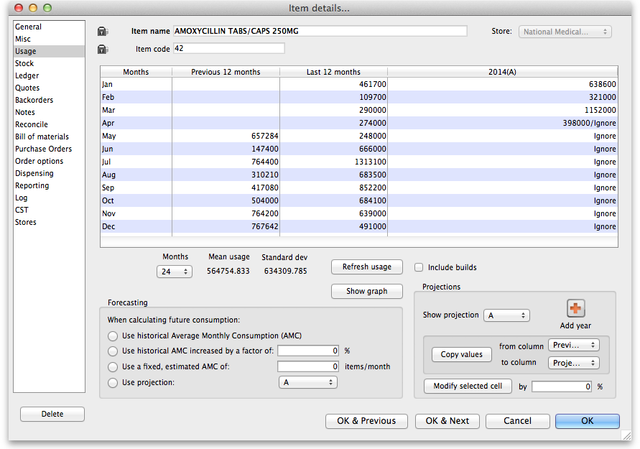
In the Forecasting section of the window shown above there are four options:

Use historic AMC
This is the default option, and is the recommended method. During the later quantification stage (creating a new tender, creating a new purchase order or the suggested order report), there is an opportunity to provide the number of months of historical data to use to calculate the forecast.
For our worked example, we will use the Historic AMC method, based on 12 months of historic data.

Use historic AMC increased by a factor of X %
Using this option, mSupply will still calculate requirements based on historical AMC, but increased by the percentage you have entered.
BEWARE! Once set, this option will continue to govern for every forecast generated by mSupply for this item until you re-set forecasting to the default (use of historical AMC).

Use a fixed, estimated AMC
This option allows you to specify a particular amount that will be applied to all future months. For example, you might have caluclated a target consumption for an oral contraceptive based on fixed population and coverage targets.
BEWARE! Once set, this option will continue to govern for every forecast generated by mSupply for this item until you re-set forecasting to the default (use of historical AMC).

Use projection (A or B)
With this option, mSupply allows you to maintain an A and a B projection, and easily swap between them. Of course you must enter projections for this to be of any use!

Entering projections
You can enter projections in a number of ways

Manually entering projections
If you click once on a cell that contains a projection (as opposed to a cell containing historical data), then you can click again to edit the cell's value.
Don't double-click: you need to click once, wait for a second or two, then click again

Copying a projection
You might want to copy historical data as a starting point for your projection. You can do this by choosing a column for from column and to column in the Projections section, then clicking Copy values.

Modifying a projection
You can use the Modify selected cell button to increase or decrease a column or some cells in a column by a certain percentage.
For example, you might have entered values for 2016, and then decide your 2017 values should by the 2016 values plus 8%. To do this
- Fill in your 2016 column values
- Add a column for 2017 if one doesn't already exist
- Use the Copy values button to copy 2016 to 2017
- Drag to highlight all rows in the 2017 column
- Enter 8 in the percentage field, then use the Modify selected cell button to increase the 2017 values by 8%.
If you are using projections, you are responsible to fill in future values for the period to be covered by your ordering. Leaving future projections at zero will have potentially serious consequences.
BEWARE! Once set, this option will continue to govern for every forecast generated by mSupply for this item until you re-set forecasting to the default (use of historical AMC).

Where does mSupply use forecasts?
Any time mSupply produces a suggested order quantity, it will consider each item and use the forecast options for that item to produce a forecast. This includes:
- Creating a new tender
- The suggested order report
- Creating a new purchase order

Previous: 4.20. Units | | Next: 5. Customers and Suppliers

