4.01.08. Items - Backorders tab
Back to Item Details window
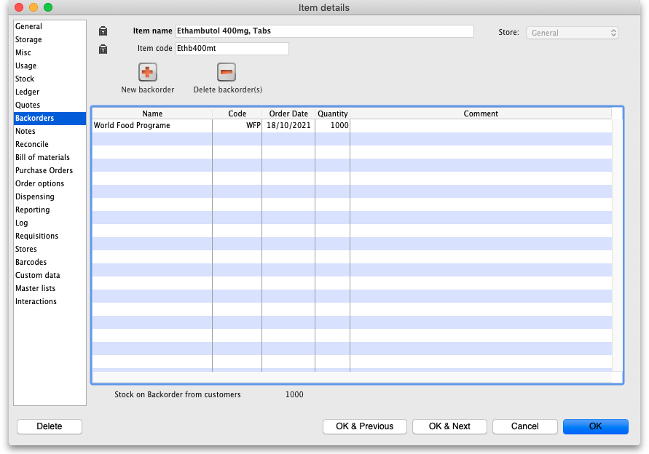
You can view the backorders for an item here. These are the backorders that have been created manually in this window or during the process of issuing goods to customers when you do not have enough stock to send to them and the We run a backorder system preference is turned on (see the 16.03. Invoice preferences page for details).
To edit a backorder, double-click the line you wish to edit and this window will open:
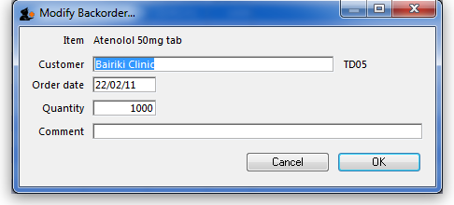
To add a new backorder for this item, click the New backorder button. This window will be shown:
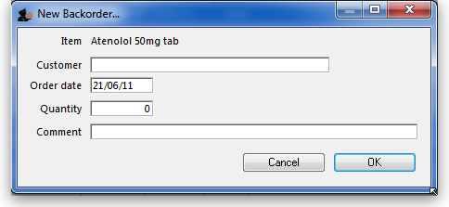
- Enter part of the customer name, then press Tab to search for the customer.
- Enter the order date, quantity and any comment, then click OK to save the new backorder entry.
To delete a backorder, select the line you wish to delete by clicking on it, then click the Delete backorder(s) button. You can also select several at once (using ctrl/cmd+click and shift+click) or all the backorders in the list using ctrl/cmd+a and delete them at once.
The total stock on backorder is shown below the list.
Previous: 4.01.07. Items - Quotes tab | | Next: 4.01.09. Items - Notes tab

