4.01.01. Items - General tab
Back to Item Details window
What are those lock icons? To minimise the chance of accidental amendment, some critical fields have a lock icon to the left of it. To change any of these fields, you must click on the lock icon first, and then enter the new value in the field.
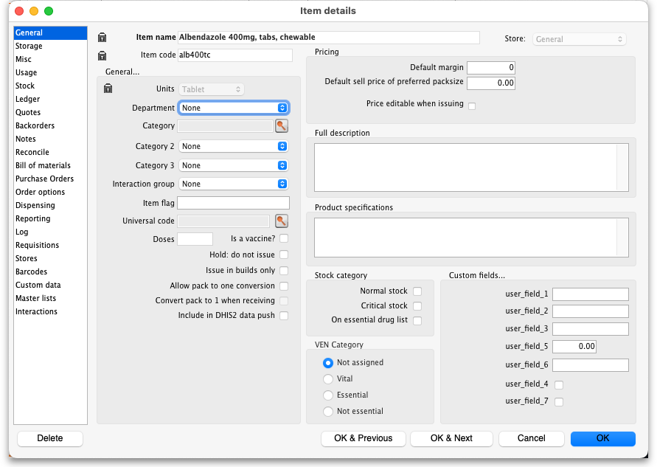

Item name
This is the name by which mSupply will refer to the item.
- You should avoid changing the name of an item to that of another item. If you have accidentally created two copies of the same item, these should be merged - refer Merging two items.
- Historical records will still record the original name, but future invoices and invoices in process will pick up the new name when you add or edit an invoice line.
- Any non-printable characters entered before or after the name will be removed. Any entered in the name will be replaced with an underscore (_).

Item code
This is the code assigned to the item. This should be a unique code, and ideally, should not be a part of another code. For example, 1034 is unique, but is a part of 1034a, and so these two codes should ideally not coexist in an mSupply system. Any non-printable characters entered before or after the code will be removed. Any entered in the code (including spaces) will be replaced with an underscore (_).

Store
The store which you are using is displayed here. For mSupply systems that are only using a single store, this field is not relevant. For users managing more than one store, the desired store may be selected from the drop down menu. For users having access to all stores, and wishing to work with the cumulative data from them all, one of the options displayed will be “Supervisor - All stores” - refer Miscellaneous topics, Supervisor Mode.

General
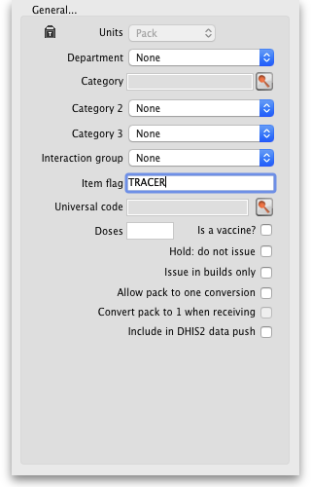

Units
Choose the unit you use for this item. It is useful to distinguish items you issue by pack (eg eye drops) from items you issue by volume (eg oral liquids)

Department
You can assign each item to a department by choosing from the list of departments here. To set up departments, refer Managing Item Access....

Category
Provided that you have defined item categories, the appropriate category should be selected using the drop down list which displays your defined categories - refer Item categories.

Interaction group
Here you can choose the interaction group for the item - refer Manage drug interaction groups.

Item Flag
The item flag field is designed for bulk editing, where you use the list view to update many items at once. You can enter or edit an individual item's flag(s) here, though it can be easier to do so using The list view.

Universal Code
mSupply has the ability to look up and store a Universal Code for each item. Click on the select button to look up a universal code. This window will open:
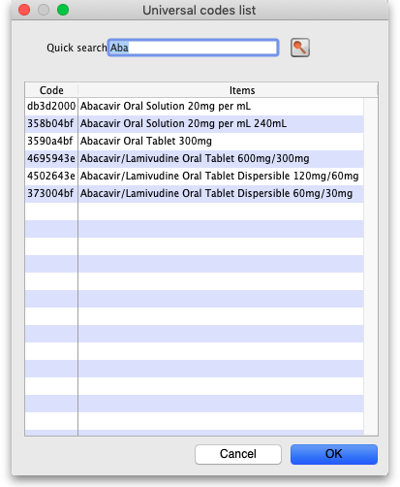
The search is automatically made on the first 3 characters of the item's name and the results shown in the list. If you see the matching item, double-click on it to select that universal code. If you don't see the correct item in the list, change the search term in the Quick search field and click on the button to search again.
When you select a universal code the ATC category, item strength, DDD value, interactions with other medicines and other item properties will also be populated from the universal code server (only those that have been set for the item on the universal code server will be populated of course!). You can see them on the Reporting tab where they are added as properties of the item - see the 4.01.15. Items - Reporting tab page for details. The interactions can be seen on the Interactions tab - see the 4.01.22. Items - Interactions tab page for details.
Make sure you carefully select the correct item from the list when using this feature.
If you want new universal codes added to the system send an email to support@msupply.org.nz
You can also search for universal codes manually from a web browser at https://universalcodes.msupply.org.nz/ (old version) or https://codes.msupply.foundation (new version)

Doses
Enter the number of doses a single unit of this item provides. Used for vaccines and is only enterable if the Is a vaccine checkbox is checked.

Is a vaccine
Check this if this item is a vaccine and you want mSupply to include it in the vaccine functionality (including in mSupply mobile; see the mobile vaccine dispensing page for details). When checked, a default value of 1 is entered in the Doses field.

Hold: do not issue
If this box is checked, the item will not be available to be issued on invoices. It will still appear in lists, but you will get a warning if you choose it when issuing stock, and will be required to choose a different item.
Putting the Item on hold applies to all stock lines of the item in the store you are currently logged into. If you wish to hold selected stock lines only, you should do that by editing the individual stock lines using Show items with stock or by using the stock tab of the item's details window (see the 4.01.05. Items - Stock tab page for details).

Issue in builds only
Checking this box will mean that the item cannot be issued on customer invoices. This is useful in situations like where an item which by law can not be sold in an unprocessed state, but is used to 'build' (refer Building (Manufacturing) Items) another item which is legal for distribution.

Allow pack to one conversion
Checking this box allows stock of the item to be repacked to 1 for this item in this store.
For example: say you receive 50 x 100 boxes of paracetamol tablets, but you issue variable amounts of paracetamol tablets on invoices. If this option is checked, as you receive the stock on a supplier invoice, it will be converted to 5000 (quantity) x 1 (pack size). You will now be able to issue any quantity you like. The cost and sell price are automatically adjusted for the new pack size.
This preference, and it's companion Convert pack to one when receiving, below, can be set and cleared by the Set pack to one for all visible items in this store preference on the store Preferences tab. The store preference will set or clear these preferences for ALL items visible in the store. Whereas clearing and setting the preference here allows you to control it individually for each item and each store.

Convert pack to one when receiving
If this box is checked, when you receive stock of the item on a supplier invoice, the pack size will automatically be converted to 1 for this item in this store. This preference does NOT affect any existing stock; existing stock will remain in the pack size it was received in, regardless of the setting of this preference.
This preference, and it's companion Allow pack to one conversion, above, can be set and cleared by the Set pack to one for all visible items in this store preference on the store Preferences tab. The store preference will set or clear these preferences for ALL items visible in the store. Whereas clearing and setting the preference here allows you to control it individually for each item and each store.

Include in DHIS2 data push
If checked then data from this item will be included in information pushed to DHIS2 via the DHIS2 interface.

Pricing
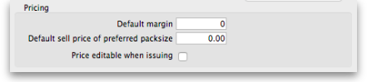

Default margin
This is the margin that will be applied to this item on supplier invoices to calculate the selling price. It can be set to a different value in different stores if required (which also means that you must set it to a value in every store you want it to have a value in - setting it in one will not set it in any others). Note that if a supplier margin is also set, there is a setting in the Preferences > Invoices 1 that determines which margin will be used. Note also that if a default selling price is set, this price will take priority and be used rather than the margin.

Default sell price of preferred pack size
Only enter a price here if you want a fixed selling price for this item. Enter the price for one preferred pack. A price entered here will override any margins you have specified for either the supplier or the item.

Price editable when issuing
If the Allow editing selling price on customer invoice lines store preference is turned on (see Virtual store preferences) and this checkbox is checked, when adding a line of this item to a customer invoice, an additional Sell price field will be available for the user to enter the sell price for that line of the customer invoice (see Issuing goods (customer invoices) for details).

Full description
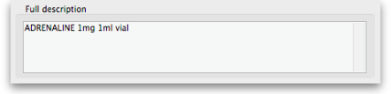
This field may be used for entering a fuller description of the item should the item name alone be insufficient.

Product specifications
Enter any specifications for the item that would be important in a tender. Anything entered in here will be included in a tender and automatically uploaded to the Health Supply Hub.

VEN category
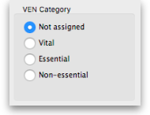
Like all categorisations, this one can be very helpful for reporting and ordering. VEN category options available are:
- Not assigned
- Vital
- Essential
- Not essential (or Necessary - see below)
Each item can be assigned only one of these VEN categories. Items will be Not assigned by default.
- Authorities, including the WHO, have been inconsistent on whether N should stand for Necessary or Not essential.
- In the past, there was a greater tendency towards N = Necessary. Therefore, mSupply 'hard wired' N = Necessary.
- There is an increasing trend towards N = Not essential.
- As of mSupply v5.04, you can choose which is used in your data in the preferences - see General preferences - Title for "N" classification.
  - For all pre-existing installations, N = Necessary unless you change it.
  - For all new implementations after v5.04, N = Not essential.

Stock category
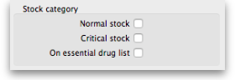
These categorisations are used for reporting and you can check as many as are appropriate. You don't have to check any, they are entirely optional.

Custom fields
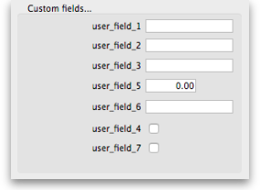
These are 7 fields available for users to store information appropriate to their operation. These fields may be queried when performing a search or producing a custom report. Their default names are user_field_1, user_field_2, etc.., but these labels may easily be edited to more descriptive ones as required..
Field types:
- Fields 1,2,3 & 6 are text fields
- Field 5 is a numerical field
- Fields 4 & 7 are boolean - True/False (Yes /No) entry.
To set the names of the user fields, refer General Preferences, Miscellaneous tab.
Previous: 4.01. About items | | Next: 4.01.03. Items - Misc(ellaneous) tab

