4.01.11. Purchase orders tab
Back to Item Details window
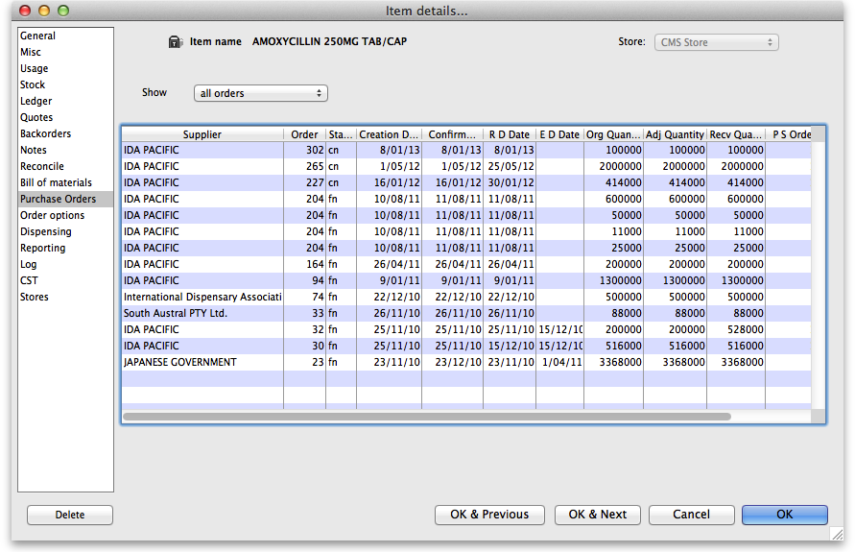
- The Show drop down list allows filtering the display of Purchase Orders according to their status - All, Suggested, etc. -
- If you double-click a row the Purchase order will be opened in a new window.
Previous: 4.01.11. Items - Bill of materials tab | | Next: 4.01.13. Items - Order options tab

