Asset Management
*
mSupply allows you to manage assets you may have in your facility such as computers and vehicles.
In order to use this function users will need to have assets enabled in page 3 of permissions. See Managing users
The functionality allows you to record
- The location of the asset
- It's current condition
- A unique ID you've given it (e.g. the license plate if a vehicle, or the serial number of a computer)

Showing the Asset list
Choose Special > Show Assets
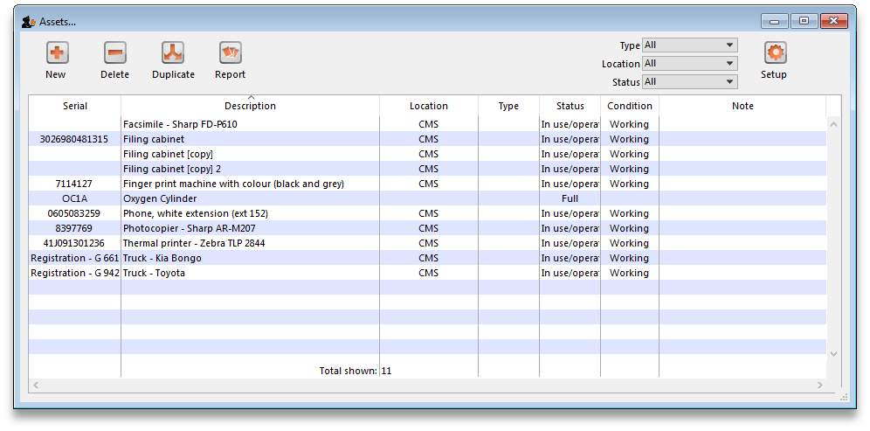

Setup
Before starting to track your items you may need to set up the kinds of data you are tracking. For instance. If you are tracking Oxygen cylinders you may want to keep records of whether they are full or empty. To do this we would set up a “Status” field.
To do this click on Setup
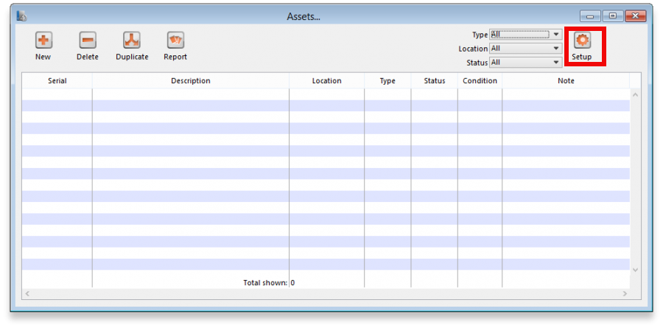
A new window will open:
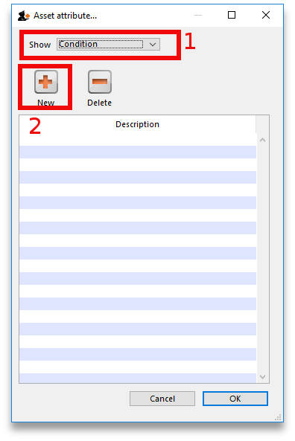
To setup tracking for our oxygen cylinders we would choose “Status” at the top field (1). Then click “New” (2). Type in Full and click OK. Repeat the process for “Empty”
Now you have two statuses set up that can be linked to an asset.
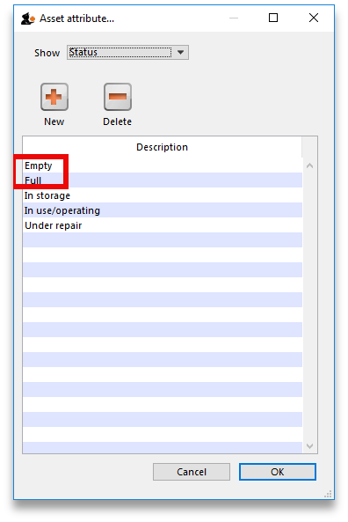
Let's create an asset to track.

New
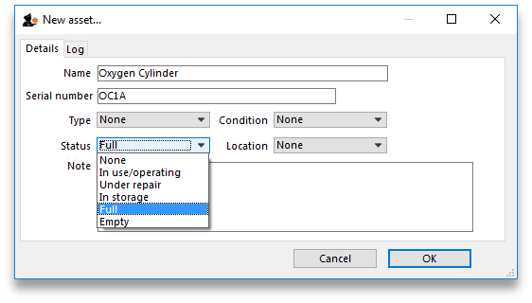
Clicking New Opens a window allowing you to enter new assets:
In this example I have created the Asset: Oxygen Cylinder. I have recorded its serial number and I have chosen the Status: Full.

Editing an Asset
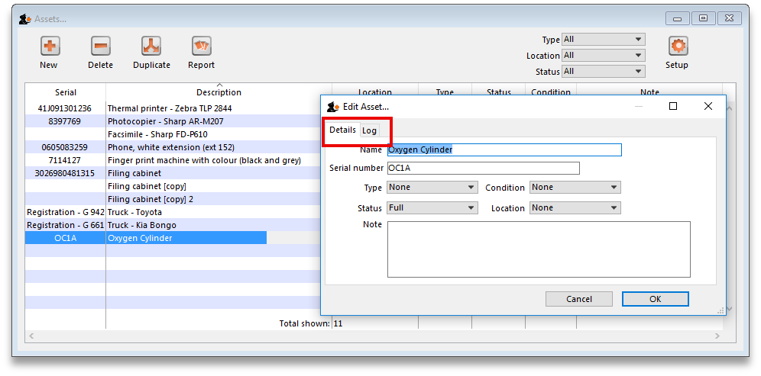
If you want to change one of the Conditions, Type, Status or Location of an asset you can do so by double clicking the asset from the Show Assets window.
You can switch between the Details and Log tabs to either edit the fields or view the log for this asset.
Previous: FrontlineSMS Integration Next: ARV regimen data recording

