26.15. Authorisation
Sometimes it is important that certain critical processes are not carried out until they have been authorised. mSupply allows authorisation to be set according to local needs for:
- Purchase orders
- Goods receipt
- Supplier invoices
- Customer invoices
Authorisation can either occur within mSupply or externally using the mSupply web authorisation system (see Remote authorisation).
Invoices can be edited after authorisation but goods receipt lines cannot be unauthorised to fix mistakes! Any authorised errors can only be fixed using stock adjustments.
When invoices have to be authorised, they cannot be confirmed until they are authorised. Until then:
- Unauthorised invoices are held at suggested (sg) status
- The official invoice cannot be printed
- Goods are not removed from or received into stock

Configuring mSupply for authorisation

Turning on authorisation
Authorisation must be set up for each store independently. For each store, you can decide which transaction types require authorisation.
1. Click the Special tab, then click Stores.
2. Double click the store to edit.
3. Click the Preferences tab.
4. Check the boxes to set compulsory authorisation for specific transaction types at that store.
5. Click OK.
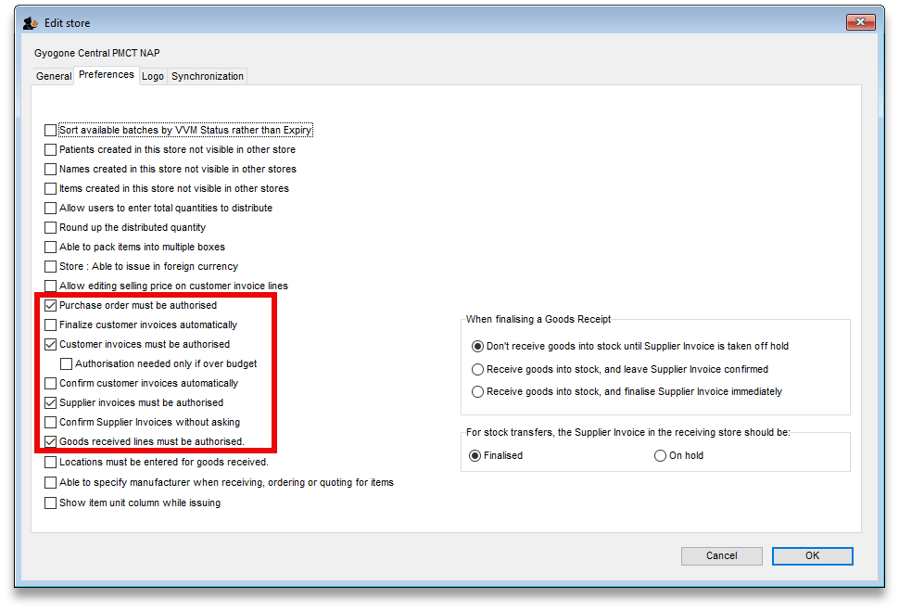
From now on, the transaction types you set the preferences for must be authorised before being confirmed.

Setting up authorisers
To use the authorisation module, certain users must be designated as Authorisers for each store and transaction type requiring authorisation.
Give the user permission to be an authoriser:
1. Click the Admin tab, then click Edit Users. Double click on the user to edit.
2. Go to the Permissions tab and the Permissions (2) tab and check the boxes that give the user permission to authorise specific transaction types.
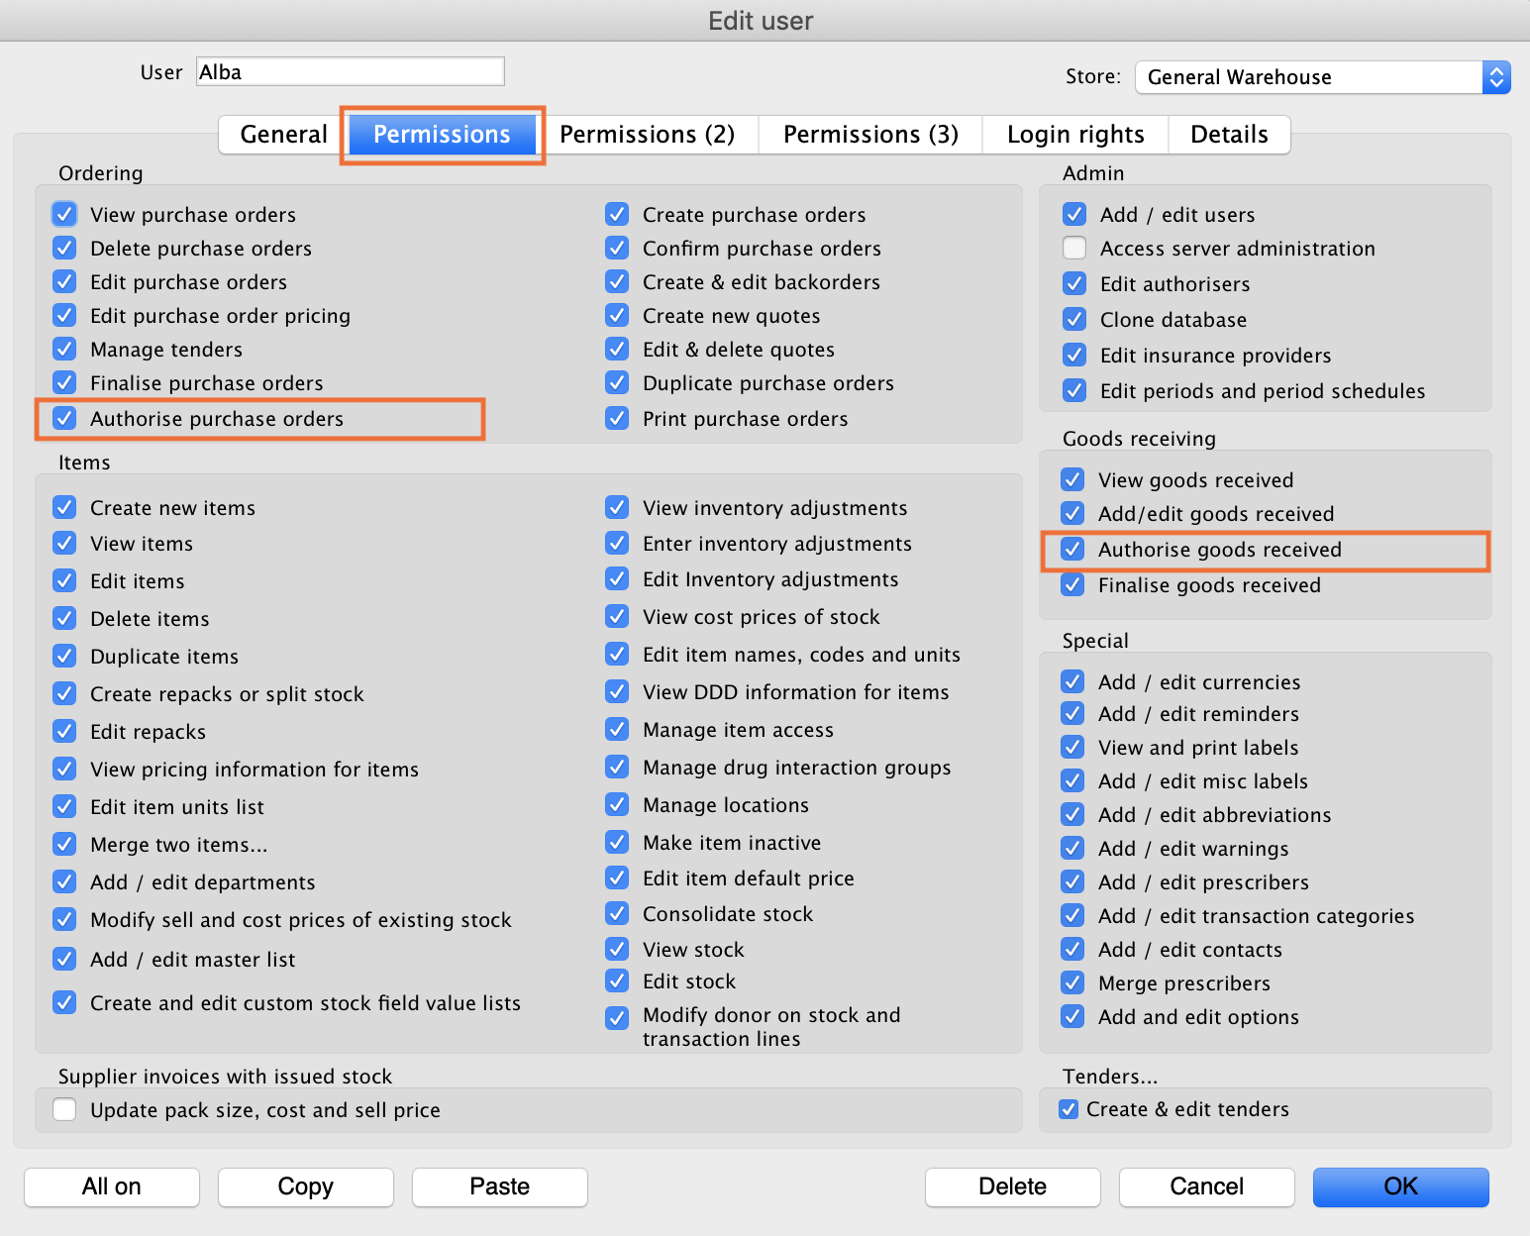
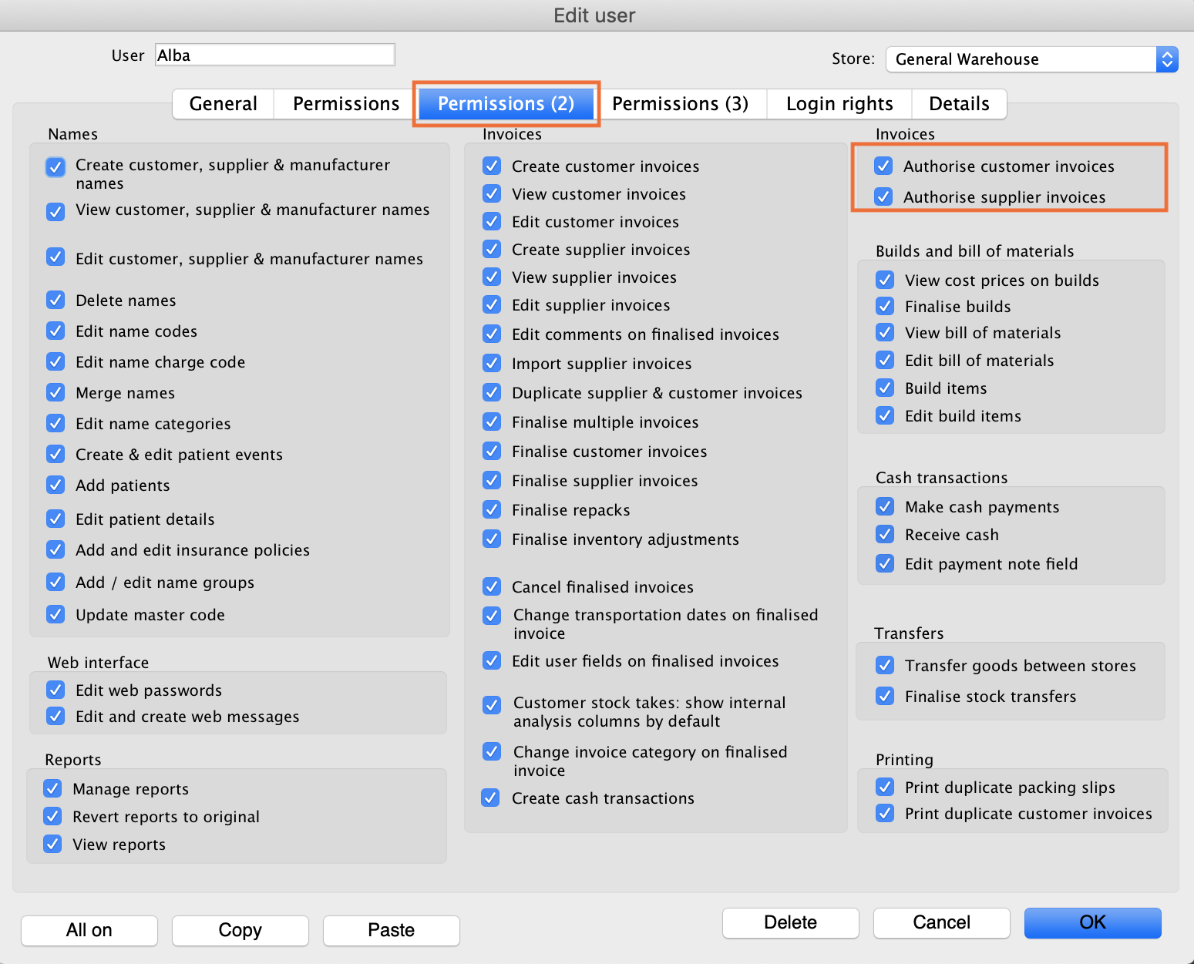
3. Click OK until you return to the navigator home page.
Allocate authorisers to tasks: (You only need to carry out these steps if you are using remote authorisation - see the 26.15. Remote authorisation section for details).
4. Click on Special > Show Authorisers.
5. Click the Plus button in the Store column.
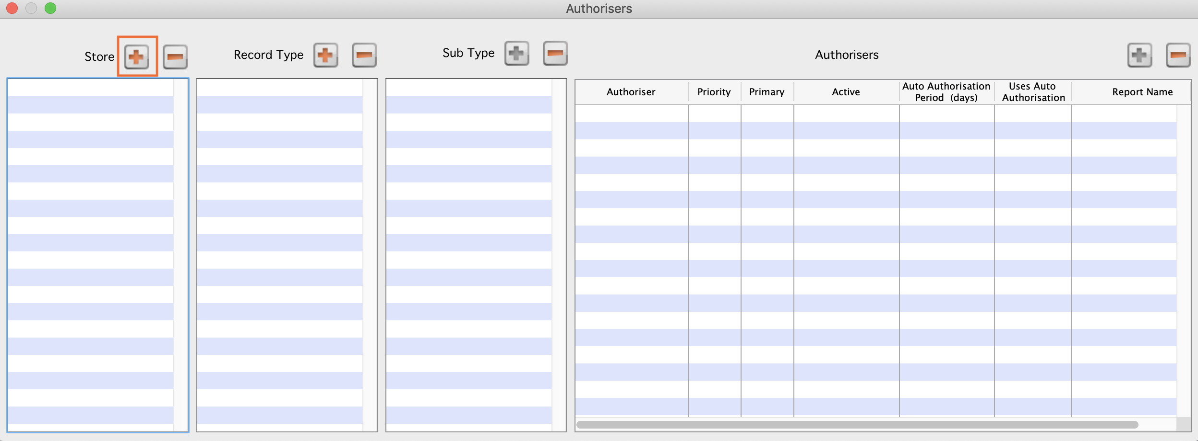
6. Choose the store to allocate authorisers to and click OK.
7. Select the store from the list, then click the Plus button in the Record Type column.
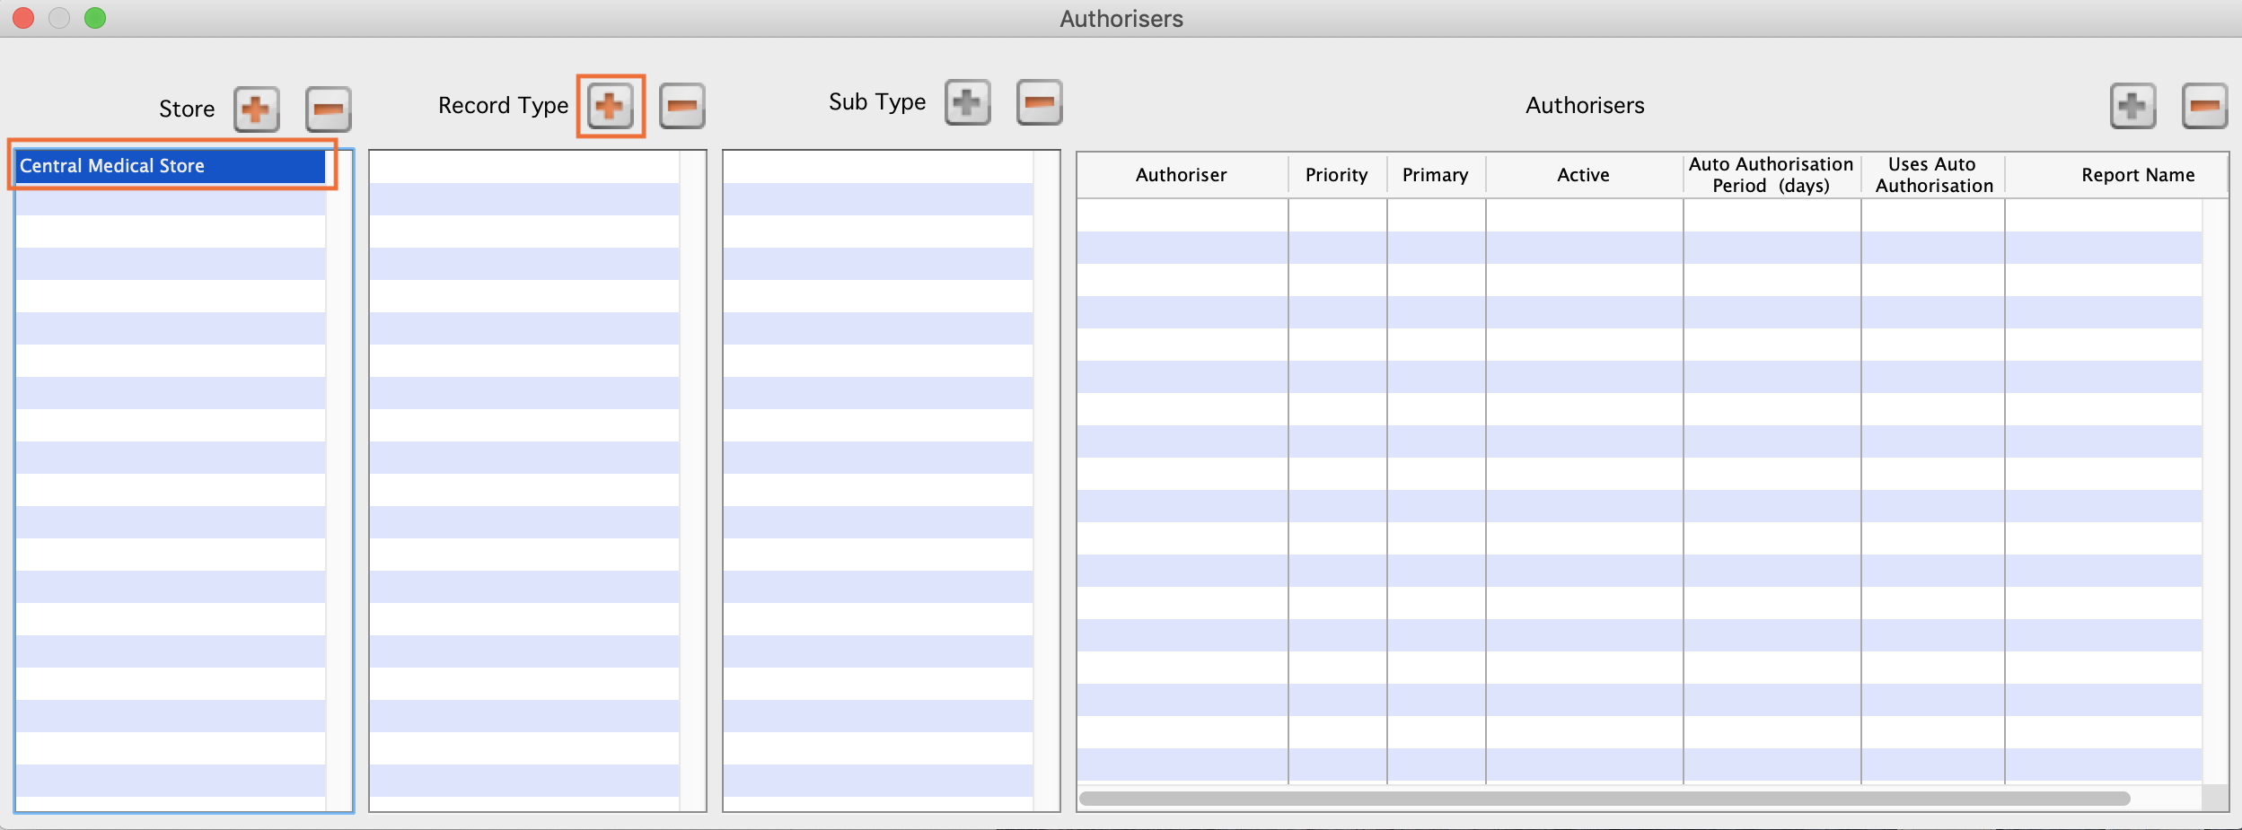
8. Choose the type of transaction to allocate authorisers. Select from Customer Invoices, Supplier Invoices, Request Requisitions or Response Requisitions and click OK.
9. Select the record type from the list, then click Default to allow authorisation for all sub types. Alternatively, click the Plus button in the Sub Type column to create further specifications (e.g. if certain users can authorise customer invoices for some facilities only).
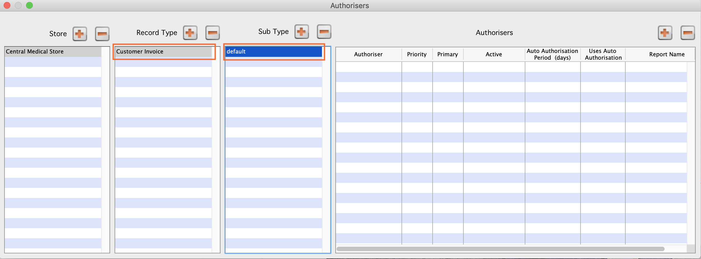
10. In the Authorisers section, click the Plus button to add authorisers for that specific transaction type (and sub type) in that specific store. You will only be able to allocate users that have permission to be authorisers (steps 1 - 3).
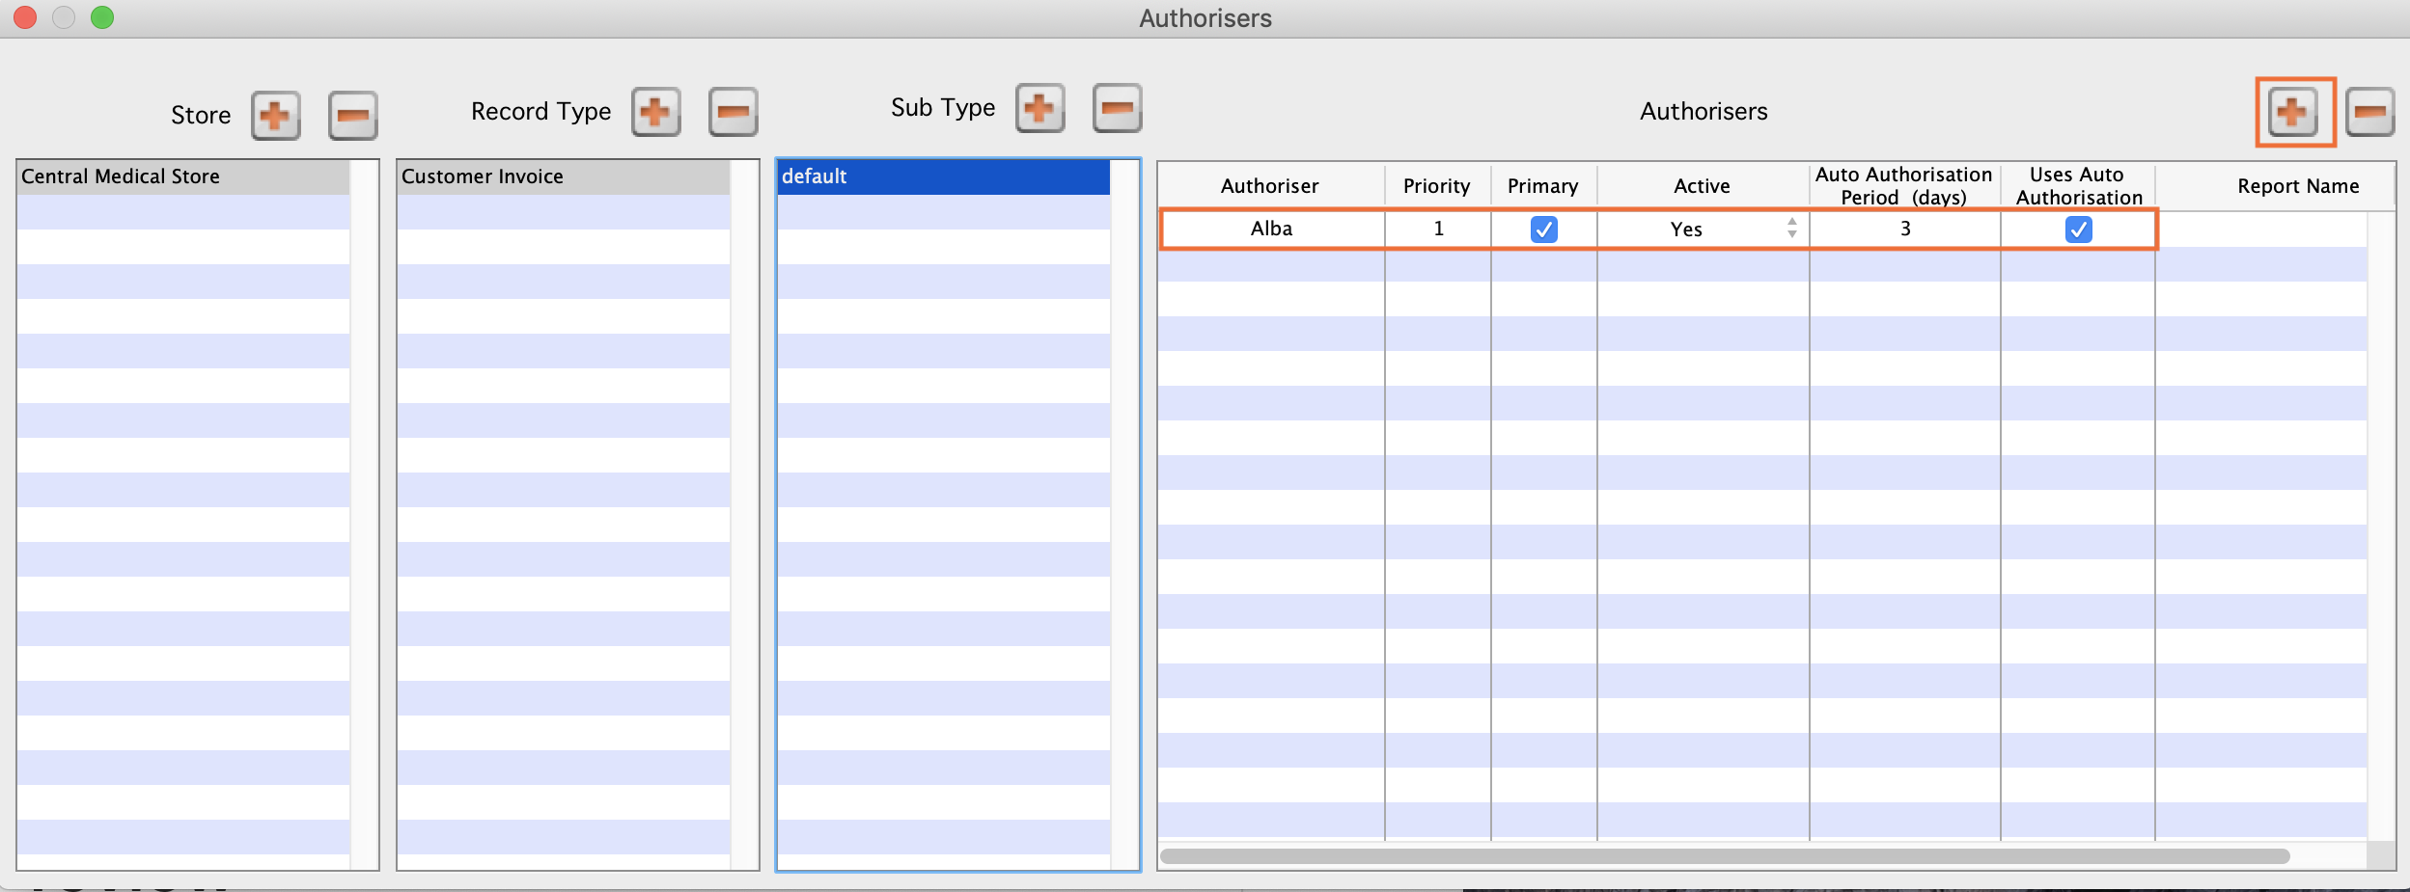

Supplier invoice authorisation
When the Supplier invoices must be authorised store preference is set, new supplier invoices will contain an Authorised checkbox.
An authoriser must check the Authorised box before the supplier invoice can be confirmed.
- The Authorised box will be disabled for users without permission to authorise.
- If the OK button is clicked while the Authorised box is unchecked, a warning message will appear stating that unauthorised invoices cannot be confirmed and nothing will happen.
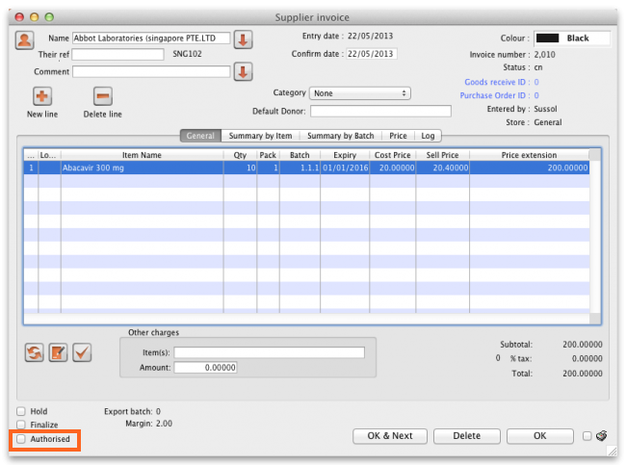
If you have permission to authorise a supplier invoice, you can also unauthorise it.
- If the invoice has a new (nw) status then it has not been entered into stock. If you unauthorise it, users can edit it and and you will still control the process of authorisation before the goods are entered into stock.
- However, if the invoice is confirmed (cn), the goods have already been entered into stock. If you unauthorise it, any changes users make will affect stock levels immediately, even though the invoice is not authorised.
- Therefore, only unauthorise a confirmed invoice to make immediate changes yourself, then immediately reauthorise it.
- Alternatively, if goods have not been issued, you can delete the lines off the invoice (and optionally delete the whole invoice) and require users to enter a new invoice to receive the stock. The normal authorisation process will then apply to the new invoice.

Customer invoice authorisation
When the Customer invoices must be authorised is set, new customer invoices will contain an Authorised checkbox.
An authoriser must check the Authorised box before the customer invoice can be confirmed.
- The Authorised box will be disabled for users without permission to authorise.
- If the OK button is clicked while the Authorised box is unchecked, a warning message will appear stating that unauthorised invoices cannot be confirmed and nothing will happen.
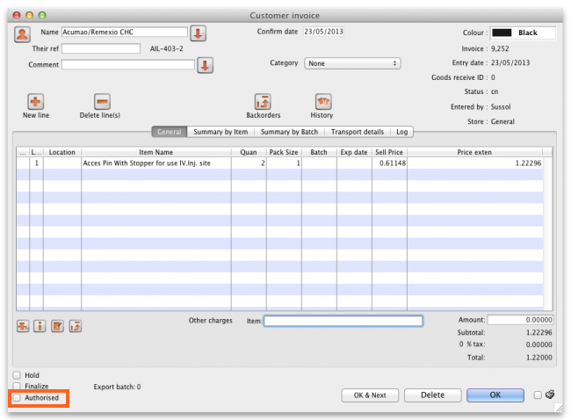

Goods receipt authorisation
When the Goods received lines must be authorised store preference is set, a new Authorised column will be displayed and will contain a checkbox for each goods receipt line. It looks like this:
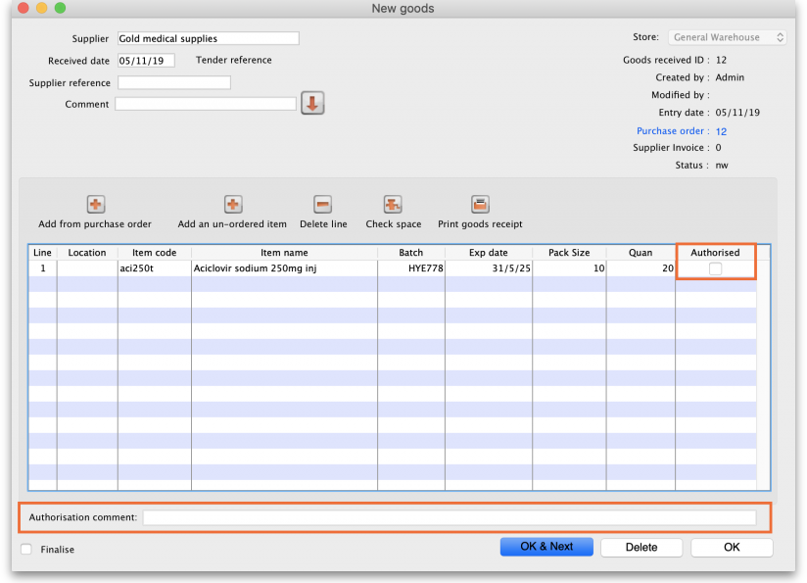
Users who have the Authorise goods received permission turned on can check the Authorised checkbox for each line that is authorised. When the goods received note is finalised, only lines that are authorised will be added to the supplier invoice to be received into stock. The unauthorised lines will remain on the finalised goods received note as a permanent record of what was actually received but not authorised.
Any unauthorised goods received note lines do not count towards stock received against purchase orders or on goods received notes so they can be received again at a later date if they are resent by your supplier.
Users who have the Authorise goods received permission turned on may also leave a comment in the Authorisation comment field to record anything that needs to be noted.

Purchase order authorisation
When the Purchase order must be authorised store preference is set, new purchase orders will contain an Authorised checkbox.
An unauthorised purchase order can still be confirmed and have goods receipted against it so it is not as restrictive as, for example, a customer invoice or supplier invoice.
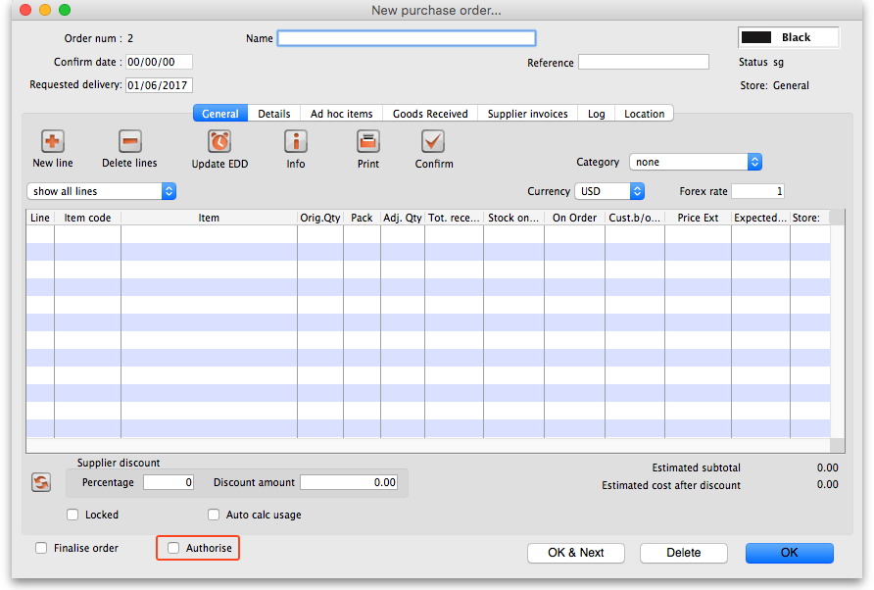
However, an unauthorised purchase order will print with an Unauthorised watermark across it. An authorised purchase order will print without the watermark.

Monitoring authorisations

Printing unauthorised invoices
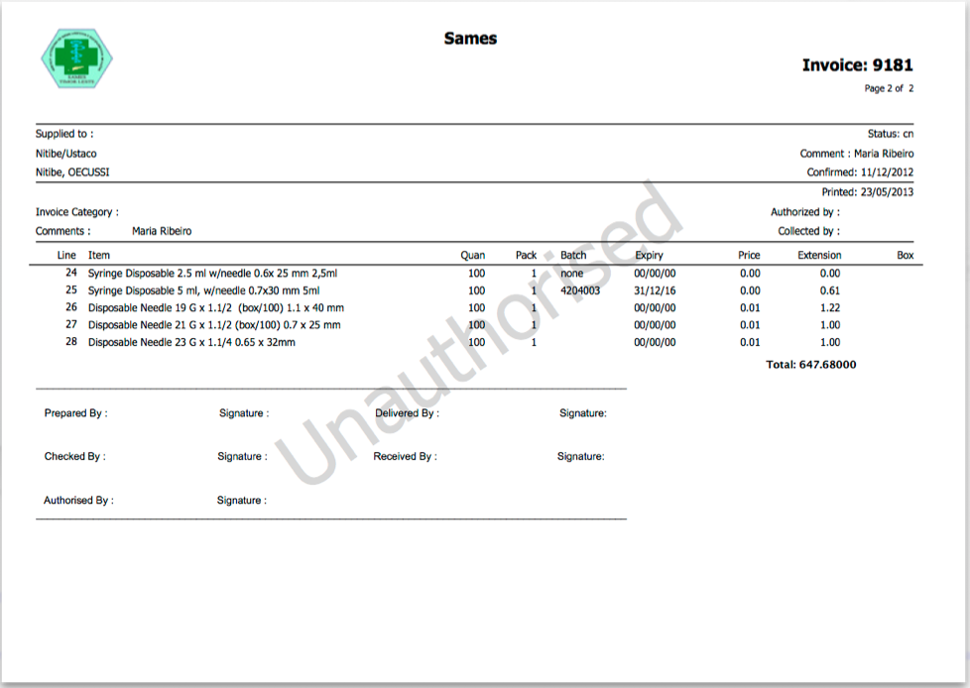
When an invoice is not authorised, it will print with a clear Unauthorised watermark. Authorised invoices will print without the watermark.

Viewing authorisation logs
mSupply records the authorisation and unauthorisation of invoices and creates a record every time the authorisation status of an invoice changes.
To view the records, click the Log tab of an invoice.
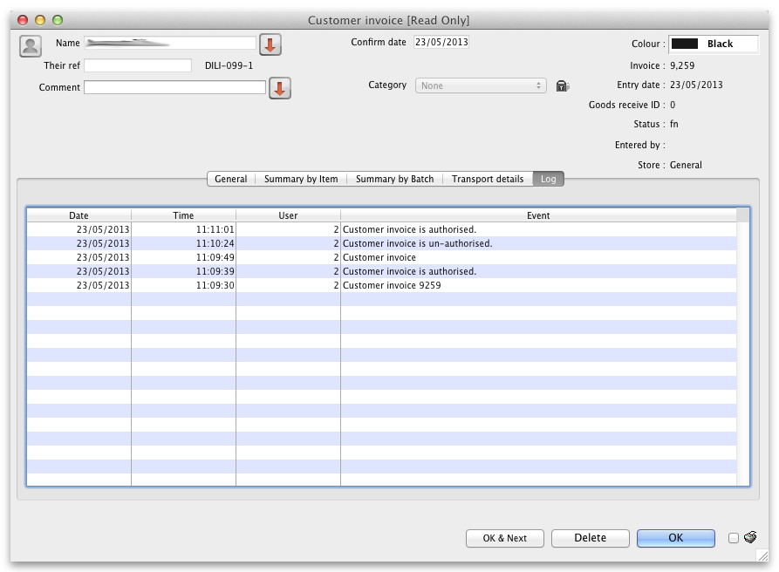
Advanced users can also view all logs by going to Special > View log...

Previous: 26.13. Using the mSupply remote client | | Next: 26.15. Remote authorisation

