26.13. Using the mSupply remote client
As well as using an mSupply client connecting to a local mSupply server, or using a standalone version of mSupply, it is possible to access a copy of mSupply running on a remotely hosted server. In this case, we use remote access software called TSplus (http://www.tsplus.net).

Connecting to mSupply
The first time you run the remote access client, you'll have to enter your TSplus username and password. These correspond to a Windows account on the remote server and are completely separate from your mSupply username and password.
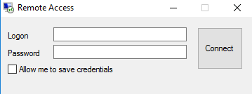
We recommend that you select the “Allow me to save credentials” box so that you don't have to remember it in future.
After clicking Connect, you may get a warning Window similar to this one:
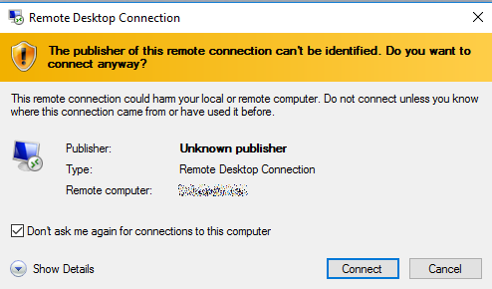
If so, then select the “Don't ask me again for conections to this computer” box to avoid seeing it again in future.
You should then see the normal mSupply login screen - simply login as usual to get to the mSupply navigator, which looks exactly the same as normal except that it is enclosed in a session window:
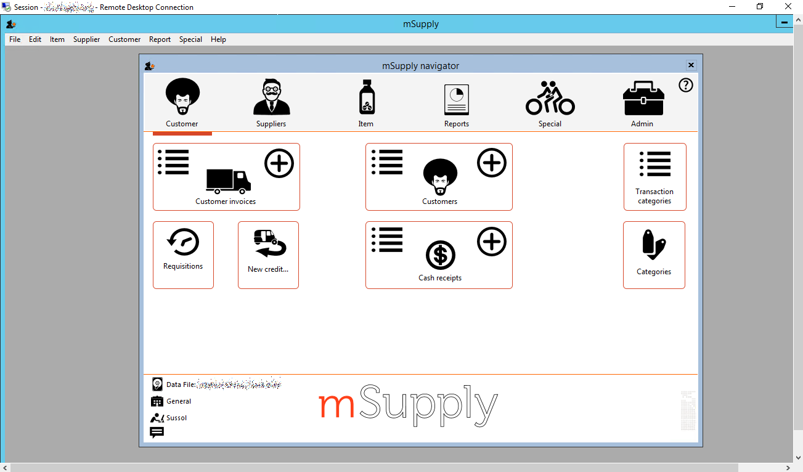
When you're finished, exit mSupply by using the File → Exit mSupply menu item. If you just use the X button at the top right of the session window, it will close the window but mSupply will continue to run on the server, and use a license which may be needed by someone else.
After exiting mSupply, right-click on the empty desktop and click on the Logout button to close your session.

Printing from mSupply
Because mSupply is running on a remote server, printing forms and reports is slightly different as there is an extra step involved to download them to your local computer. There are several ways to do this, depending on which print option you choose e.g. printing a customer invoice:
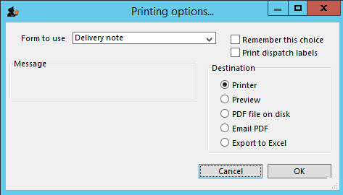

Universal Printer
TSplus comes with a “Universal Printer” driver, and if you select the Printer option and then choose this as your printer, the print job should get downloaded to your local computer and then prompt you to choose one of the printer drivers on your local computer to receive the print job.
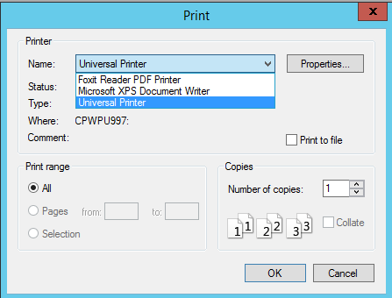

PDF printer
Foxit or some other virtual PDF printer driver will have been installed on the remote server. You can either:
- select the Printer option and choose the virtual PDF printer driver as your printer - this will prompt you for a location to save the PDF file and then open it in the default PDF viewer (you may be prompted to choose either Foxit or Sumatra - the screen shots below use Foxit, but Sumatra is similar)
- select the Preview option - this will generate a PDF file in the default location (C:\mSupply client\Documents\temp) and then open it in the default PDF viewer
- select the PDF file on disk option - this will generate a PDF file in the default location and open that folder, and then you can double-click on the file to open it in the default PDF viewer
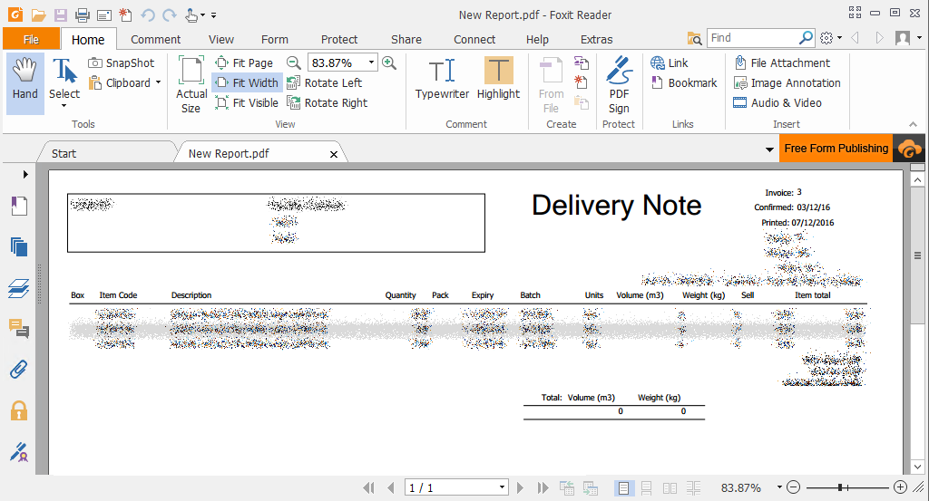
Regardless of which of these you choose, you can use File → Save As to save the PDF file to a folder on your local computer:
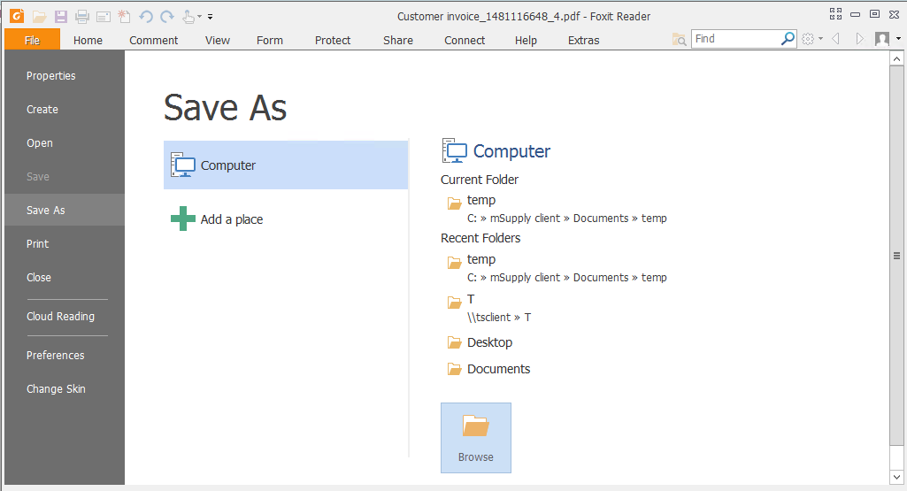
Click on Browse to choose where to save it - This PC includes all of your local drives as well as the ones on the remote server:
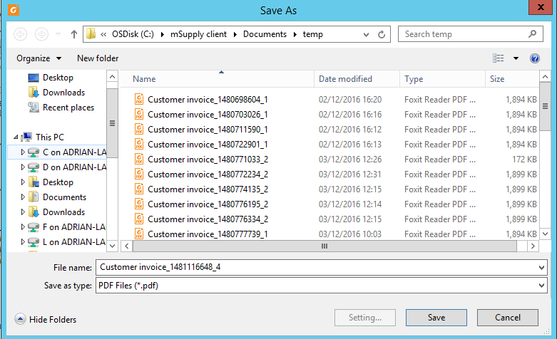

Exporting to Excel
MS Office won't normally have been installed on the remote server, but Open Office will have been. The first time you try to export to Excel, you'll have to choose the location of “Excel” - in this case, it will be something like C:\Program Files(x86)\Open Office 4\program\scalc.exe.
Select the Export to Excel option to open the report/form in Open Office:
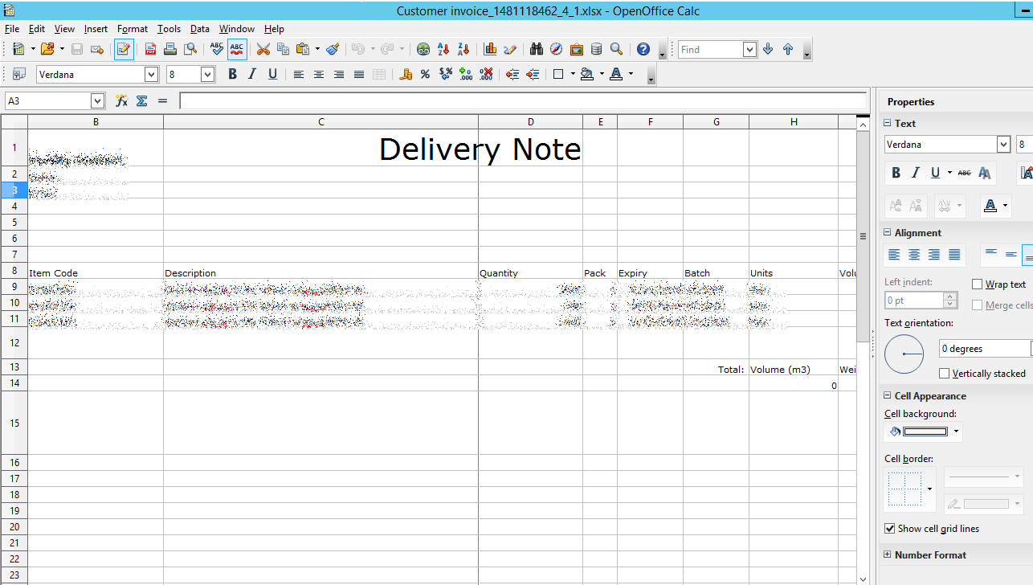
In the same way as for PDFs, you can select a local drive from the File → Save As menu (either as an Open Office .ods document, or an Excel .xls document):
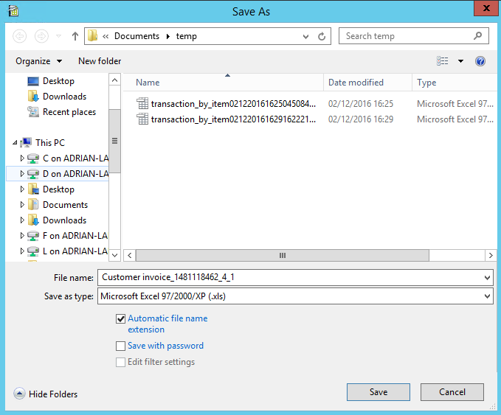

Transferring data
Dropbox will have been installed on the remote server, and can be used to transfer saved reports or other data between the server and any other computer which has access to the Dropbox account.

Previous: 26.12. Product (drug) registration | | Next: 26.14. Authorisation

