13.11. Custom fields
You can create custom fields that appear in different areas in mSupply. These allow you to record additional information and customise mSupply for your needs.
You can create custom fields in the following areas:
- Customer invoice
- Supplier invoice
- Store
- Requisition
- Item
- Item category
- Quote line
- Name (of customers, suppliers, prescribers etc.)
- User
Only edit custom fields if you are confident with the information in this page and fully understand the content. Otherwise you could cause some things to stop working in your copy of mSupply! This is true for all settings, but please be especially careful with custom fields.

Creating custom fields
1. Navigate to the Admin tab and click the Preferences button.
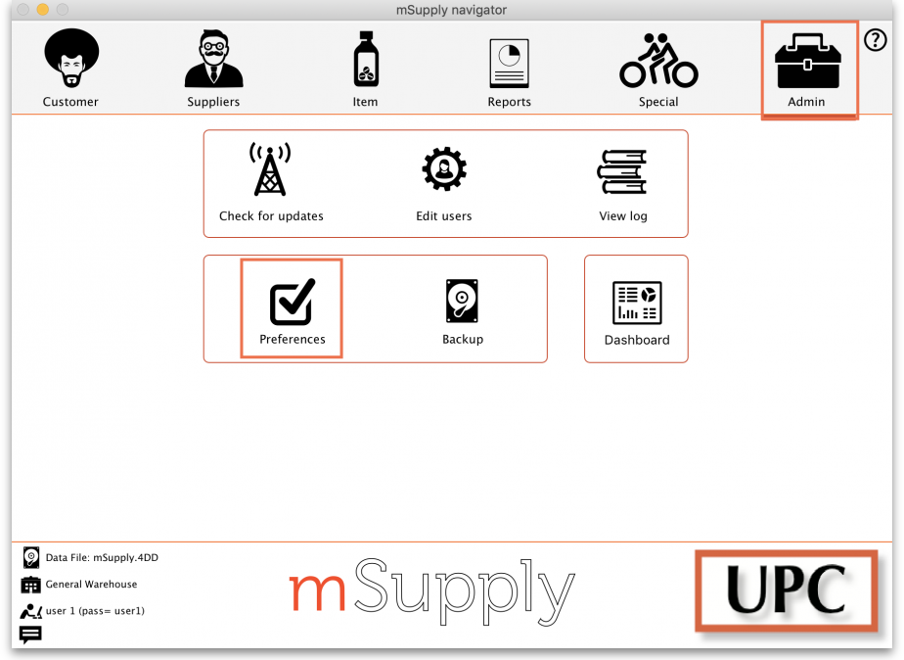
2. Select Custom Fields from the list on the left.
3. Select the screen requiring custom fields from the dropdown list.
4. Click the New Field button.
5. Click on the new line to change the name of the custom field.
6. Click the small arrow in the Field Type column and choose from the drop-down list. The options are:
- Text: User can type free text.
- Number: User can only type a number.
- Boolean: User can tick a checkbox.
- Date: User can only enter a date.
- List: User can only select an option from a list.
6. If you chose a List field type, highlight the line and click Add Item to enter the options that will appear in the list. To delete an option, select the item from the list and click Delete Item(s).
7. Click OK.
If you want to delete a custom field, highlight the line and click Delete field(s).

Using custom fields
This section shows where custom fields appear in each area after they are created.

Customer invoice
When creating a customer invoice:
Click the Custom Data tab. In this example, we added a # custom field.

Supplier invoice
When creating a supplier invoice:
Click the Custom Data tab. In this example, we added a # custom field.

Store
When creating a store:
Click the Custom Fields tab. In this example, we added a # custom field.

Requisition
When creating a requisition:

Item
When creating a new item:

Item category
When creating a new item category:

Quote line
When creating a quote line:

Name
When creating a new name (e.g. customer, supplier, prescriber etc.):

User
When creating a new user:

