Item preferences

Item accounts
- The accounts you enter here will become the default accounts for newly created items.

Assigning item codes automatically
- If you want item codes to be assigned automatically, check the checkbox on the items tab of the preferences (File > Preferences > Items )
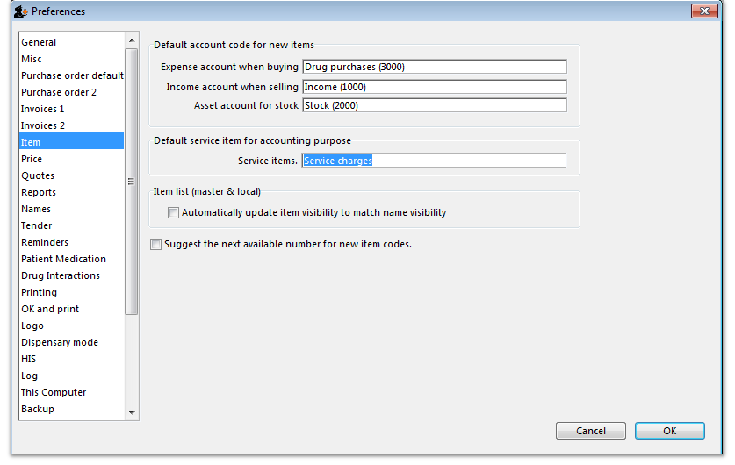Preferences window:item tab
*

