Printing Preferences
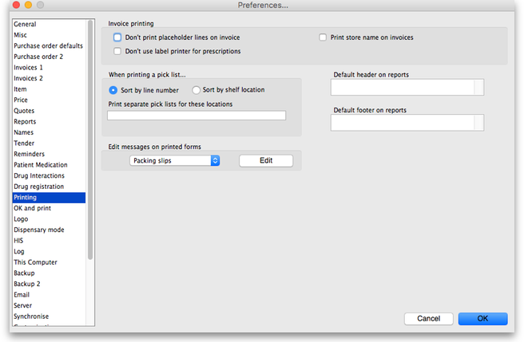
Preferences related to the printing of invoices appear in this window, allowing users to customise the printing of customer invoices.

Don't print placeholder lines on invoice
Check this option if you don't want placeholder lines to appear on your printed invoices.

Don't use label printer for prescriptions
Check this option if you want to use a normal printer (not a label printer) to print prescriptions.

When printing a pick list...

Sort by...
This refers to how the items on the list are ordered. You can choose to sort by
- line number: the order in which they were entered
- shelf location: which will enable a “logical” order for picking goods from the shelves
You can also set a priority for shelf locations, and this will override the default alphabetical ordering i.e. locations with a priority of 1 will come first (in alphabetical order), then those with a priority of 2 etc., with priority 0 locations at the end.

Print separate pick lists for these locations
By default mSupply will print a single pick list for all locations. If, for instance, you need separate pick lists printed for cool store items (whose locations in your store start with “CS”), and for Dangerous drugs (whose locations in your store all start with “DD”), you would enter “CS,DD” (no quotes, each location separated by a comma) in this field. If a pick list being printed contains CS items, they will be printed separately, and the same for items with a ”DD” location.

Edit messages on printed forms
If you would like to print a particular message on one or multiple printed forms you can do that here. Choose the appropriate form from the drop-down list (menu), and then click the Edit button to edit the message that will appear on the bottom of every form of that type. For example, you may use the special invoice for issuing narcotics, and have the following message:
* I have received the above Narcotics.
* Signed:.........................
* Print name:..................
* Position:.......................
* Date:.............................
A message on a pick list might be as follows:
* Packed by:..................
* Date/time:..........................
* Checked by:........................
When you have written the message, click OK and you can either add another message to another form (choose another one from the drop down list) or move on to another preference.

Other

Print customer statement balance on invoices
If this item is checked and you are using the mSupply cash receipts system, the outstanding customer balance will be printed at the bottom of each invoice.

Default header/footer on reports
There are two spaces here. In one you can enter the header that you would like to appear on reports by default. The text will appear on the top left header for most reports. A common use of this space is to include your organisation name.
In the other you can enter the default footer. Text you enter here will appear on the bottom centre space of each page of reports. You might use this space to include a confidentiality clause on your reports.

OK and Print
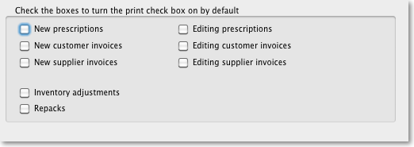
Checking these boxes means that the printing checkbox will be checked by default when the corresponding window is opened.
Note that you can still manually turned the option on or off in a window- these settings just affect the default value.
Back to: General preferences

