Managing outstanding purchase order lines (pipeline stock)
Stock that you have ordered and waiting to be delivered is called your pipeline stock. Sometimes it's helpful and important to monitor this stock so mSupply has functions to help you do that.
Pipeline stock is represented by all the outstanding purchase order lines i.e. purchase order lines which haven't been fully received into mSupply yet. To see all your pipeline stock simply choose Supplier > Show outstanding PO lines… from the menus or click on the Outstanding icon in the Purchase orders section of the Suppliers tab on the navigator. This window will open:
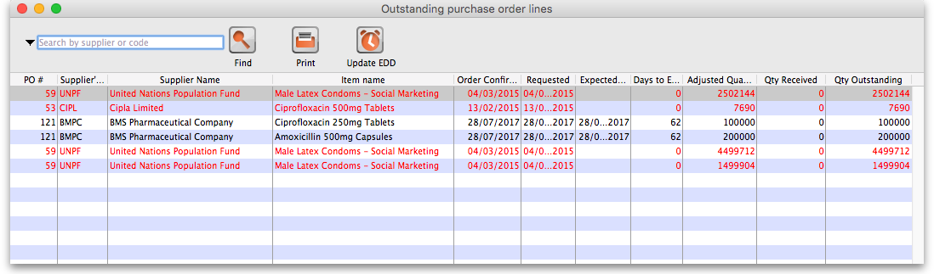
Choosing this menu item displays a list of all lines outstanding on all confirmed Purchase Orders; from the drop down list you can restrict the list displayed to a single supplier, to a single item, or to items whose delivery is expected within a specific number of days.note that the search excludes finalised orders.
Double click on a line to display the Purchase Order containing that line:
Previous: Editing Pack Sizes Next: Managing Donors

