The PagePro Report Editor
*
- As of version 3.03 mSupply includes the PagePro report editor.
- The graphic below shows the standard mSupply pick list being edited in PagePro.
- It gives almost unlimited customisation possibilities for forms and reports.
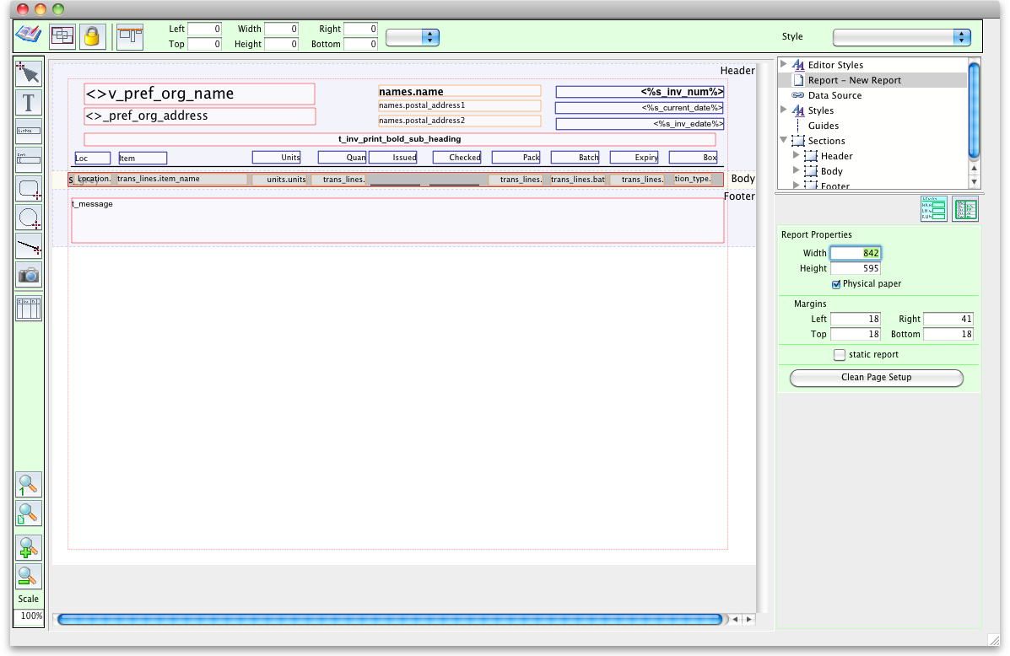
<note>More on Pagepro coming soon</note>

