11.05. Requisition reports
You can report on requisitions in 2 ways:
- grouped by item, showing which customers the item was requisitioned by, what has been sent and what is outstanding or
- grouped by customer, showing which items a customer has requisitioned, what has been sent and what is outstanding.
You can access the reports from the Reports > Requisitions menu option of by clicking on the Requisitions option on the Reports tab of the navigator:
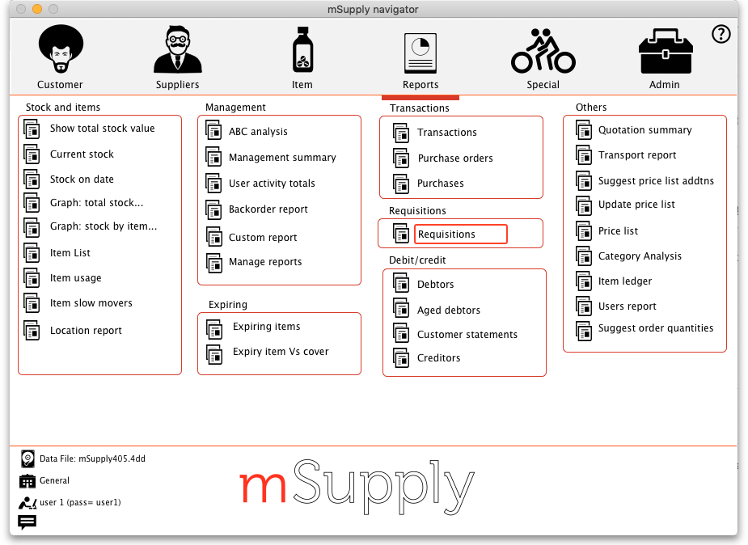
Whichever way you choose, the requisition report options filter is displayed:
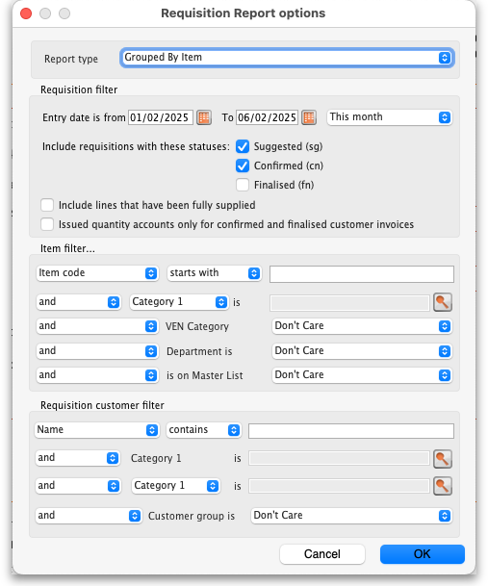
Use the Report type drop down list to select which type of report you would like: Grouped by item or grouped by customer.
The Requisition filter settings enable you to select which requisitions you want to include in the reports, based on their entry date (this month so far is set by default but note the quick date selection drop down list and the date pickers to enable quick selection of reporting dates) or status.
If you leave the Include lines that have been fully supplied checkbox unchecked, the report will only include lines where not all the stock requested has been sent to the customer i.e. outstanding requisition lines only. If you check the checkbox, all requisition lines will be included in the report.
The Item filter section allows you to select which items will appear in the report (only requisition lines for items matching these filters will be included in the report. If you don't set any of these, there will be no filtering by item.
Finally, the Requisition customer filter section allows you to select the customers whose requisitions will be included in the report. If you don't set anything in this section, requisitions for all customers will be included in the report.

Example output
These are examples of what the requisition reports like like:
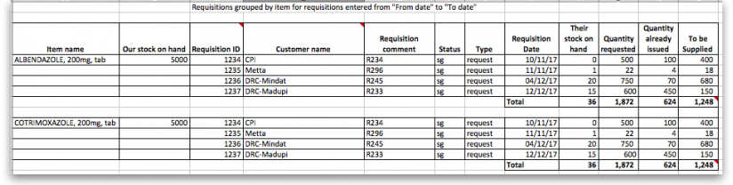
Grouped by item
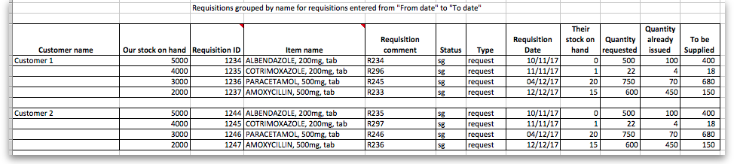
Grouped by customer

Previous: 11.04. Purchasing reports | | Next: 11.06. Customer ordered shortfall report

