29.01. Sync Site Wizard
The sync site wizard is a tool to quickly create a sync site for a particular store. It does all the behind the scenes work for you, making sure that sync settings are updated for the store you are moving as well as for all the stores it has visible.
This Sync site wizard only allows a single store to be created on a sync site. However, after that is done, you can Move a store from one sync site to another.

Before you use it
To use the sync site wizard you must:
- be on the central server machine
- have permission to “add/edit sync sites” (see the 25.15. Managing users page for details on setting user permissions)
If you do not meet these criteria, you will be shown a warning and the wizard will not open.

Using the wizard
Choose Special > Create sync site… from the menus. This winbdow will open:
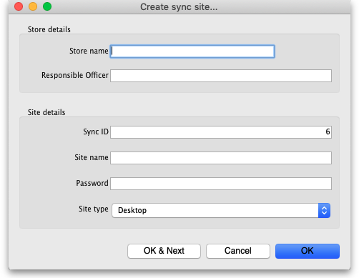
If the sync site is Mobile, then delete any Supplier Requisitions where Status = sg before the store is moved!

Selecting a store
First select a store. You can search in the Store name field by typing the first few characters of the store name and pressing the Tab key on the keyboard. This will present a list of stores starting with names starting with what you typed to choose from, or if there is only one match it will just be selected for you. No matches will prompt “try again”. You can use “@” as a wild card to get all stores available.
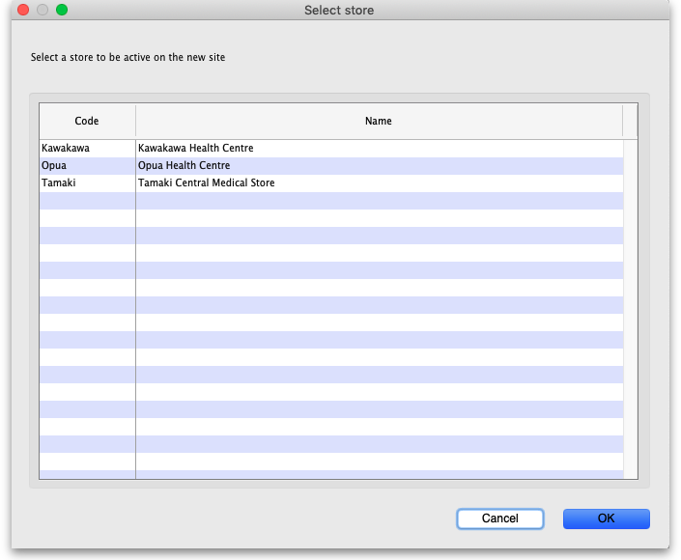
The stores are restricted to those that are Active on the Primary server. This is to prevent accidentally moving stores being used on an existing sync site to a new site unintentionally.

Selecting a responsible officer
Selecting a responsible officer is just like selecting a store. The responsible officer needs to be given permission to:
- Login to desktop
- Login to the store
- Add/edit users in the store
If the store selected already has a responsible officer, this will automatically be selected and cannot be changed from the sync site wizard. If you need to, you can edit the responsible officer through the store editor.

Sync ID
The sync ID is used by the synchronisation system to identify what records go to which sites. It must be unique. This means it must not be one already used by an existing sync site.
It will already be filled with the number after the current largest sync ID used.

Site name
The site name is used for specifying on remote devices what sync site it is operating when configuring synchronisation.
The site name must also be unique. You may enter any text here. You may want to indicate what facility it is based in or what device it is.

Site password
The site password is used along with the site name when configuring a device to use the synchronisation system.
Make sure it is strong and record the password in a secure manner. We recommend a password manager like Bitwarden.
If you would like Sussol to be able to provide support, the site name and password will need to be recorded in Sussol's secure credentials repository. Please consult with Sussol on how to communicate the credentials in a secure manner.
Please don't send the credentials together in an email, this is not secure. At least send them in separate emails but far better is to use an email to send one part and Skype, Telegram or WhatsApp or similar to send the other.

Site type
The site type simply indicates the intent to synchronise the sync site with mSupply Desktop or mSupply Mobile. As of v4.12, this setting has no functionality. Functionality around this is planned for the future.

Reviewing sites
To view and edit sync sites that you've created, you can do so through preferences.
We are continuing to work on accessibility of the synchronisation system. This includes new interfaces for viewing and editing sync sites in the near future.
Previous: 29. Synchronisation | | Next: 29.04. Sync Site Export

