18.08. Tender currencies
You will have noticed that responses from suppliers can be received in any currency in an mSupply tender. For comparison with other tender lines, all lines are converted to the home currency of the datafile using a rate that is defined by the user. These rates are stored and managed separately for each tender so that historical records of the rates used in any particular tender are retained permananetly. The rates used for currency conversion throughout mSupply will change over time to keep up with fluctuations but any such changes will not affect tenders and their historical records.
The conversion rates used for each currency in a tender are shown and managed on the Currencies tab, which looks like this:
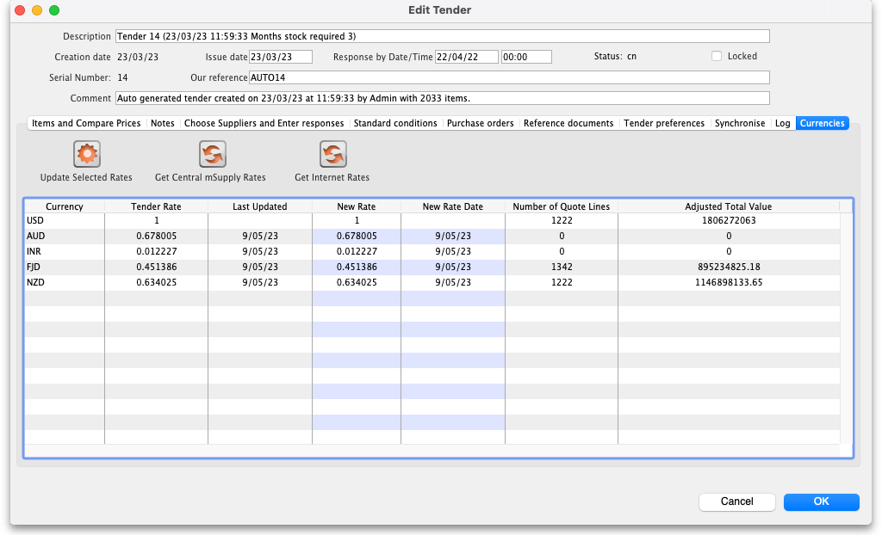
Whenever a tender is created all foreign currencies with their current rates are added to the table. If a new currency is added to mSupply (see the 26.10. Currencies page for details) then it is added to this table. When responses are downloaded from the Health Supply Hub (HSH), any currencies used but not already in this table are added.
The columns in the table display the following:
- Currency: The three letter abbreviation of the currency.
- Tender Rate: The rate used to convert this currency to the home currency of the datafile.
- Last Updated: The date the rate was last updated (empty if it has never been updated in the tender).
- New Rate: The new rate to set the Tender Rate to (doesn't do anything until the Update Selected Rates button is clicked).
- New Rate Date: The date to say the rate was updated on.
- Number of Quote Lines: The number of supplier response lines on this tender that use this currency.
- Adjusted Cost: The total value of the supoplier response lines using this currency in this tender.

Previous: 18.07. Analysing supplier responses and creating purchase orders | | Next: 18.09. Supplier instructions for using tender submission web interface

