18.09. Supplier instructions for using tender submission web interface

Introduction
This user guide explains how to use the web site at https://tenders.msupply.org.nz that is used by mSupply users to publish tenders. It is only relevant if you are a supplier who has been invited to tender by a user of this system. If you have been invited to tender and have questions that are not answered in this document, you may request support by emailing tender_support@msupply.org.nz.
- Save the login credentials. The login credential for the website does not change. Once received, it is the responsibility of the supplier to securely save or note down the login credential for future tender participation.
- Don't wait until the last minute. Many suppliers have left the entry of tender till the last moment, not followed instructions correctly, and bombarded Sustainable Solutions with support requests during the last 24 hours of the tender closing. Please do not do this.
  - Please carry out a dummy run of entering lines and saving. You can change your entries later before finalising the tender. This will allow you learn how the system works without the pressure of a submission deadline.
  - If you choose to populate the tender with an uploaded file, that too should be tried out in advance and not left till the last moment. The instructions need to be followed carefully. - Refer Uploading prices.

How it works - a summary
- The Client prepares tender documents and distributes them by email to suppliers.
- Each Supplier receives details, including a username and password, for accessing the secure website where the tender is to be found.
- The password provided is valid only for the first time the website is accessed, so the supplier’s first action will be to change it.
- During the period between receiving the tender document and the tender’s deadline, the supplier decides on the bids to be submitted, and enters the details on line. This may be done over multiple sessions.
- Before the deadline, the supplier finalises the bid; this action is not reversible and prevents any further changes being made. The status is changed from “SG” (suggested) to “FN” (finalised).
- Once the deadline has passed, the client will access all quotations which have been finalised, evaluate them, and notify successful suppliers.

How it benefits suppliers
- Accuracy: you can be confident that the information entered by you will be accurately transferred. Manual systems are prone to transcription errors in the price, pack size, currency, etc.
- Speed: while the tender process may be slightly slower for the supplier, the time between tender closing and bid evaluation is dropped from weeks to one or two days. This means tender closing dates can be moved closer to the date on which suppliers are notified of winning bids, benefiting all involved.

Costs
- There is no charge to suppliers to use the system. Development and maintenance costs are covered by software support contracts with mSupply users.
- Due to a steady stream of requests for help for issues that are covered in this guide, or issues that are not a system issue (e.g. password reset requests and requests for help with uploading bids where the instructions for formatting the file to be uploaded have not been followed), we will charge for support requests if it relates to such issues.

Security
- We take the security of this module seriously.
- Only https (secure) website access is allowed: observe the closed padlock icon in the corner of your browser. This means that no-one can read the interactions between you and the tender server.
- Automatic disconnection: should there be no activity after a short time, you are required to confirm that you are still working on the website. In the absence of such confirmation you are disconnected and the login screen reappears.
- One-time password: the password provided for the first time you access the website is valid only for that first occasion. You must change it to a password of your own choosing for continued access to the website.
- The server running the Tender Management System is managed by Sustainable Solutions and is accessible by us alone. We know this system will only be successful if we maintain the highest standards of ethical, impartial behaviour and keep your data secure and accessible only to authorised parties.
- Restricted access by IP address: if you wish to limit access to your online account to users within your office, let us know an IP address or subnet that you will use and we will put this restriction in place until you instruct us to remove it.
- We track the IP address of all log on attempts. Repeated attempts from the same IP address will be blocked.
- We have coded the software carefully to ensure that supplier information entered is only available to that supplier and to the customer (obviously once the customer downloads the submitted bids, we can not control the information flows outside of our system).
- All emails sent by the tender module are sent by SSL (Secure Socket Layer) for added security.

First logon
Log on to https://tenders.msupply.org.nz and this is the window which appears when you log on
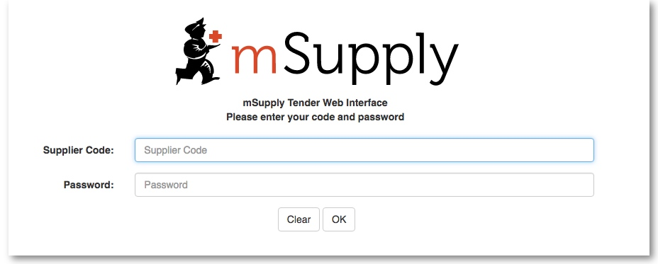
You should enter your supplier code and password, both of which were sent to you by email.
You will immediately be shown the window for changing your password:
In the Old Password field you should enter the password sent to you by email. You must then enter a password of your own in the New Password field, re-entering it in the Confirm Password field; when you have done this, and clicked on OK, the standard log on window appears again, and you should enter your user name and the password which you have just created. You will now be logged on to the system, and these are the details you will use for logging on in future..
Note that the web site uses a large Javascript library, so will take a few moments to load the first time you use it. In return you get a fast and easy-to-use interface.
If you have chosen to do so in the preferences, each time you log in, you will be sent an email saying that you logged in to the web interface - this means if someone else was to log in to your account, you would know about it.

Staying logged on
If no user activity is detected for a few minutes, as a precautionary measure to restrict unauthorised access, a window appears. You need to click Keep Working, otherwise you will be logged out.
Once you have logged on, you will be shown a list of tenders for which you have been invited to submit quotations.
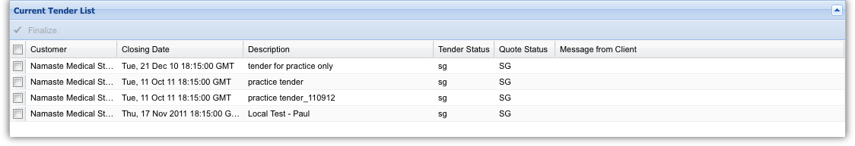
The example shows that 4 tender documents from client Namaste Medical Stores, have been uploaded and await the supplier’s attention.

My Information button
Clicking the My Information button displays this window:
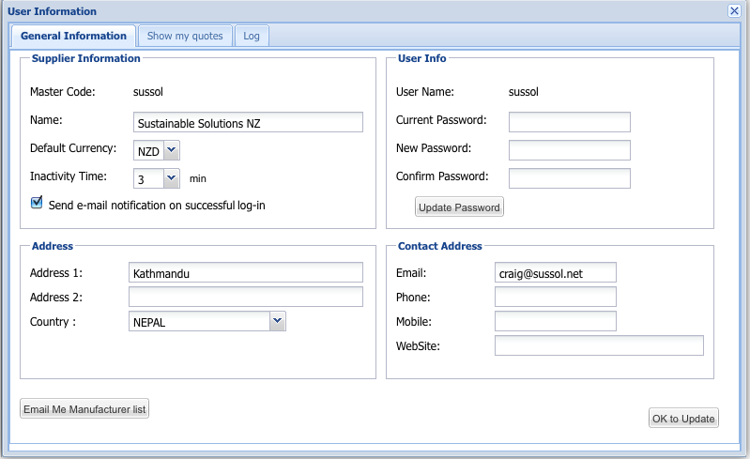
This is where the supplier’s details held on the server are entered and stored, and this is also where they can be edited. Those details include name, address, contact details, and the default currency for this supplier.
Default currency The default currency is that currency in which the you normally supply quotations - in the example shown, it is Singapore dollars, and this will normally remain unchanged for a particular supplier; suppliers located in another country are likely to use their own country’s currency as their default one.. In the case where a supplier submits a quotation with one or more lines quoted in another currency - e.g. Euros or US dollars - the particular currency used is entered on the appropriate line of the quotation Note that changing your default currency will affect new quotations, and won’t have any affect on existing quotations.
Inactivity time This is the length of time in minutes after which you will be logged out if there is no activity. 10 minutes is the default but you can choose from between 1 and 60 minutes.
Email me manufacturer list As the name suggests, this will email an Excel file with the complete list of manufacturer names and their corresponding codes to the email address specified. If you want to take advantage of the new facility to upload a quotation as an Excel file, you will need to use the manufacturer codes specified in this list.
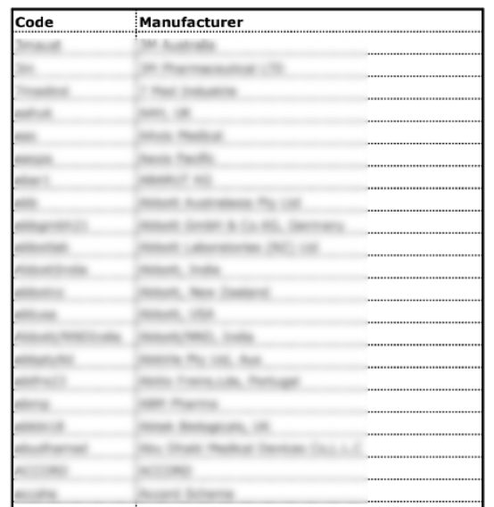Manufacturer List
Saving your settings and closing the window Click the OK to update button to save your settings. Click on the close box in the top right of the window to close it when you are finished.

Viewing the tender list and individual tenders
The window which appears when you log on is the Current Tender List, and it shows all of the tenders for which the supplier has been invited to submit a quotation; it also shows the status of the tender, which is set to SG (= suggested), and should remain at this status until all work has been completed, and the quotation is ready to be finalised. Access to a particular tender document is achieved by double clicking on the line. The tender and the items involved in it are then displayed in a window which looks similar to the following:
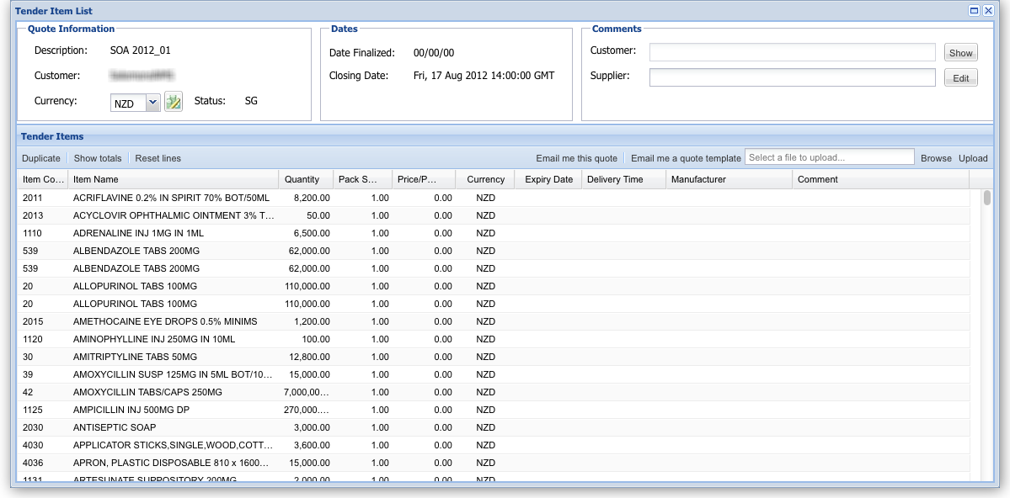
Description: This is the description or title of the tender. Use this whenever you refer to the tender so that everyone knows you're talking about the same one!
Customer: This is the name of the organisation who created and published the tender and then invited you to respond to it.
Currencies drop down list and Set currencies icon: This sets the default currency for your quote. Use the set currencies icon to change the currency for all items currently entered. If you struggle to find the correct currency, type the first letter of the one you want and you will be taken to the first currency beginning with that letter. The list is in alphabetical order so it should make it easier to find.
Show button: displays the whole of the customer's comment if they've entered one. May contain useful information for you.
Edit button: Displays a window to enable you to enter or edit a longer tender comment for the customer (the one who invited you to tender). Any information you want to convey to the customer about your quotes can be put in here. Note: you also have the opportunity to enter comments on individual quote lines. See Entering prices section below.
Duplicate button: Duplicates a selected quote line. Will put the new quote line at the top of the quote. Helpful if you want to enter a quote for the same item but with slightly different details. If you need to do this for many items, use the Upload button mentioned below.
Show totals button: Shows the total value of your quote for each currency you've included in your quote.
Reset lines button: Removes any changes you have made to the selected quote lines.
Email me this quote button: Sends you a copy of your quote as it currently stands. It will be sent to you as Excel file attachment to an email.
Email me a quote template button: Sends you a copy of the tender with all items included with no price or other information added. This is the perfect thing to use as a base for your quote if you are going to create it in a spreadsheet and upload it using the upload button (see below).
Browse button: Allows you to select an Excel file to upload as your quote.
Upload button: Uploads the selected Excel file as your quote (see the Uploading prices section below).

Entering prices
To enter the details for a line, double click on the line.
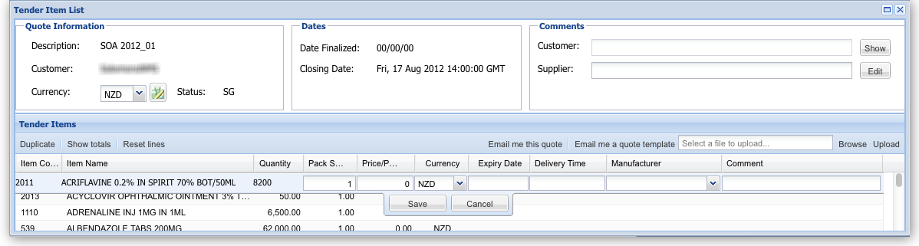
Details should be entered in each of the columns:
Item code, name and quantity These are fixed by the tender and cannot be changed.
Pack size The pack size requested by the customer is already on the form; if needed, it can be changed.
Price per pack The unit price of the pack you are offering to supply in the chosen currency.
Cost Including Freight (CIB): The quoted price should include international freight charges.
Expiry date and delivery time When completing these fields, it is suggested that a series of abbreviations be used:
- min = minimum
- max = maximum
- w = week
- m = month
- y = year
- So for example, if you want to indicate a delivery time of 3 months, enter “3m”
Delivery times should be specified from when you receive the purchase order, so must also include the time for order compilation by the supplier
The tender document is likely to specify minimum expiry dates, but it is important that there should be no misunderstandings. Delivery time is understood to mean the estimated period of time between the consignment leaving the supplier’s premises and delivery to the customer.
Currency: The relevant currency should be selected from the drop down list - it doesn't have to be the same as the default currency. If you're struggling to find the right currency from the list, type the first one or 2 letters of the currency you want - should make it easier to find.
Manufacturer: The name of the manufacturer should be chosen from the drop-down list. Typing the first few characters of the manufacturer's name will show a list of matching manufacturers. Click to select one.
Manufacturers are not linked to suppliers in our system, so multiple suppliers who source goods from the one manufacturer do not cause a problem.
Problems saving entered data ? : Simply entering price and saving is not sufficient. The website will not save the row of data. The Manufacturer column must also be filled with a valid manufacture. If you choose to not to specify a manufacture then simply choose : “Not Specified” as the options.

Adding new manufacturers into the tender module
Due to the desire of mSupply users to collate manufacturer data, you cannot enter manufacturer names yourself. If you want to have a manufacturer added to the list, please email to tender_support@msupply.org.nz and we will add the name(s) within 24 hours.
Please submit Manufacturers in the following manner:
The country where the manufacturer is based must be specified. The address column is optional.
If you have more than 5 manufacturers to add then it may be worth creating and a spreadsheet with the column headings described below, then sending to us as an attachment:
Manufacturer | Country | Address (optional)
John Western Pharmaceutical | US | 32 Obama Road, Virginia
Jürgen Klinsmann Group | Germany | Göppingen, West Germany
Universal Supplies | Great Britain
If you do not want to or cannot specify the manufacturer, choose the entry 'Not specified' from the list. You may wish to add a comment to that quote line to explain your entry. Alternatively you can specify the manufacturer in the comment column if the manufacturer is not in the list provided and if you have run out of time for the manufacturer list to be updated.
Country of Origin: Some tenders require you to specify country of origin instead of manufacturer. Common countries are specified in the Manufacturer list, so you can just choose a country rather than a specific manufacturer if you wish.
Comment: Use this column for entering any comment or note you may wish.
Once you have made all the entries for a row, click Save to update the tender document with the details you have entered. It is quite possible that you will not have all the necessary information to complete a tender document at a single session; this is not a problem - just close the document at the stage you have reached and later, once you have the further information you require, reopen the document and continue with the process.
Submitting multiple quotations for the one item If you wish to do this, then select the line you wish to submit a second (or third) price for and click the 'Duplicate' button in the toolbar. Fill in the details of the second quotation.
Tender conditions Some tenders may have more restrictive conditions than the web site allows for. For example, a tender may specify only one currency, or that multiple quotations for the same item are not allowed. Currently the web site will NOT reflect such conditions, and it is your job to read the tender conditions and respond accordingly.

Uploading prices
This facility allows you to upload an *.xlsx file containing a header line and one or more item lines for your quotation. The template for the *.xlsx spreadsheet is provided with your invitation to tender.
As of August 2019, spreadsheets are now provided and to be uploaded in *.xlsx format.
You can use Microsoft Office or the Free Libre Office.

Preparing the quotation file
You can download a suitable template for your quotation file by clicking the 'Email me a quote template' button on the top-right of the tender items window. This file will have the first four columns pre-filled for your convenience and is the best way to start if you intend to upload your quotes.
The file should be in *.xlsx format, having the following 10 columns:
- Item code
- Item name
- Quantity
- Pack size [Must be number, not words like “each”, “box”..etc ]
- Currency (in 3 letters international code format: e.g. AUD USD EUR )
- Price per pack
- Expiry date
- Delivery time
- Manufacturer code (as per the manufacturer code list you can download from the “My info” button when logged in)
- Comments
Please note:
- The Item Name and Quantity columns are only included for the sake of human readability, and will be ignored
- This table uses the manufacturers code rather than the manufacturers name (the code is shorter so less likely to make mistakes)
- You can download a manufacturer list of names and codes from the 'My information' page (see the 'My Information button' section above)

Uploading the quotation file
First of all, you need to select the file that you wish to upload by using the Browse button on the far right of the tender items window. The selected filename will then be visible in the text field to its left. Then click on the Upload button and you will be presented with the following window:
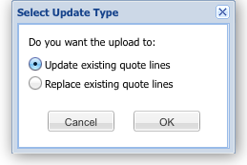
Update existing quote lines: Select this if you want the contents of the file to update quote lines already in the tender. Note that information will only be updated for items in the tender where the current price for the line is 0. If a line in the tender has a non-zero price any line in the file with details for that item will be ignored. So, if you want item lines to be updated by the contents of the file reset their prices to 0 before you carry out the upload. Note also that if there is more than one matching zero-price tender item line with the same item code, then it will select the first match it comes to i.e. the system will cope with multiple quote lines for the same item. Therefore, if you want to upload multiple lines for an item, you need to duplicate that line in the tender first (using the Duplicate button on the toolbar) before uploading the file.
Replace existing quote lines: Select this if you want the contents of the file to replace everything already in the tender. All your existing lines will be deleted from the tender and the contents of the upload file will be entered into the tender. Note that if there are multiple lines in your upload file with the same item code this method will put them all into the tender. This is helpful if you keep your Excel file as a master copy and use it to update your quotes. And also means that you can easily input multiple quotes for the same item (with different pack sizes or manufacturers, for instance - but mSupply won't check so the multiple lines could be identical if you wish).
Click on the Cancel button to cancel the upload or the OK button to continue.
Having clicked on the OK button you will, after a short while, get a confirmation that the upload was successful and the list of displayed tender items will be updated to reflect the data that has just been uploaded.
Please note the following points regarding the file upload process:
- Only Excel files (extension of '.xlsx') smaller than 1Mb are accepted.
- Currently, the only web browsers which fully support file upload are Firefox and Chrome. The next versions of Safari and Opera are also planned to include support for this new HTML5 feature.
- A successful upload message does NOT imply that the contents of the file are valid, simply that it has been processed. An email will be sent to your email address, with two attachments:
  - A text file which contains the output generated from the upload process i.e. the number of records which were successfully processed, and any error messages generated during the upload process.
  - An Excel file in the same format as produced by the 'Email me this quote' button, which will include the updated tender items - you should check that this reflects the changes you are expecting.
- Any blank lines in the uploaded file will be ignored.
- Any lines which do not contain the expected number of columns, or with data in the wrong format will generate an error message and will not be imported.
- Any lines with an invalid item code or an invalid currency code will generate an error message and will not be imported. We use the standard 3-character currency codes - see here for a complete list.
- Any lines with an invalid manufacturer code will still be imported but will be given a manufacturer of 'Not specified'.
Note also that it is possible to perform as many file uploads as you like.

Finalising a tender
- Firstly, be warned: Finalising means exactly that. It can not be undone.
- Only when you are satisfied that you have completed the details on all the lines for which you are quoting should you finalise your tender entry.

Email it to yourself first
We strongly recommend you use the button in the tender window to email yourself the tender, and then check that the entries in the online tender module match your intended entries.
To email a quotation to yourself, open the tender your wish to email, and then click the “Email it to me” button at the top-right of the window.

What finalising does
Clicking on Finalise does two things:
- It locks the tender document, changing its status to FN (finalised) and you can make no further changes to it.
- It makes the finalised tender submission accessible to the customer once the tender has closed. Only finalised quotations will be accepted by the customer.
Finalising the tender submission, therefore, must be performed before the closing date as specified by the customer.

How to finalise
- You need to be viewing the list of tenders, not the particular tender you have just entered.
  - If you are not logged in: Log in and you will be shown the list
  - If you are editing your tender, close it to return to the list of tenders.
- Check the checkbox in the left-hand column next to the tender you have completed
- Click on the Finalise button.
- You're done
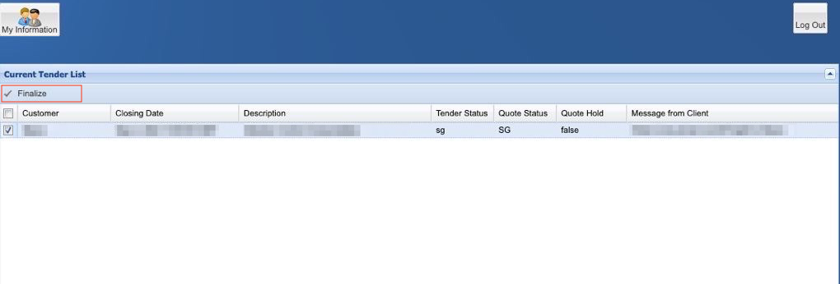

Closing date and time
Note that closing date and time is specified as GMT (Greenwich Mean Time). This is NOT likely to be the same as your local time. Please take this into account when planning for when you will finalise your prices.

Results notification
The client will notify successful suppliers directly by submission of a purchase order. The web site will not show you any information about you or any other supplier’s success or otherwise

Obtaining support
Please email tender_support@msupply.org.nz if you have any problems. We are based in Nepal, but provide support 18 hours per day Monday to Friday while there are open tenders in the system.
Note that you should only communicate with us regarding technical matters. For all matters relating to tender conditions, pricing, etc., communicate directly with the client who published the tender.

The future
- We hope you appreciate both the concept and the hard work we’ve put into making this system work for both clients and suppliers.
- The system is used by several mSupply users, and is being taken up by more each year.
- We have lots of our own ideas on how to improve the system, and we’d love to hear your criticisms, compliments or ideas as well. Use the email address above.

Warranty
There is none. Our software is provided “as is”. We take the responsibility to act fairly and carefully very seriously. We are replacing manual systems that are prone to gross errors, so even when our system experiences the odd (very rare) issue, it remains a vast improvement on what has gone before.

Infrequently asked questions
- Q: What if your server failed just before a tender closed.
  - A: Our advice is: This isn’t an auction. There is no need to submit at the last minute. However, if there was more than a few minutes of downtime in the last 24 hours of a tender, we would ask the customer's permission to extend the closing date. Also, our server has been running for several months. Should the tender module prove popular we will transfer it to a data centre.
- Q: Can we phone you for support.
  - A: Yes. But, if your question relates to issues that are explained in this document, we reserve the right to charge you for our time. (This includes the resetting of passwords which we have supplied in the past).
    - Nepal: +977 1 5548021
    - New Zealand: +64 22 519 0499

Thanks
Thanks to the staff of Republic of Kiribati’s Ministry of Health & Medical Services Pharmacy Department who pioneered the use of this feature!
Previous: 18.08. Tender currencies | | Next: 18.10. Using web tenders

