

Training Handout: receiving goods, supplier invoice

7.01. Supplier invoices

Introduction
All received goods should be recorded in mSupply either by:
- Manually creating a supplier invoice
- Working with a supplier invoice that has been created automatically as a result of a stock transfer from another store in your mSupply system.
- Using the purchase order system, which leads to the automatic creation of a supplier invoice when you finalise a goods receipt associated with that purchase order (PO).
In some countries a supplier invoice is called a “bill”, a “creditor invoice” or a “purchase invoice”
Goods are only entered into stock once a supplier invoice is confirmed
Confirming the supplier invoice also calculates the selling price based on the margin you have chosen for that supplier or for that item, depending on how you have set your mSupply preferences.
You will notice there is a Prices tab in the supplier invoice window - this is for use with invoices received in foreign currencies, which will usually be done via the goods receipt system.
Each line received on a supplier invoice will be treated as a separate line in your stock. You can manually consolidate these later, or set a preference to automatically consolidate items with the same batch, expiry date, pack size, location, donor, cost and sell price.

Creating a new supplier invoice
STOP! Don't proceed with creation of a new supplier invoice if the stock came as a result of:
- Your store created a Purchase order to a supplier, in which case you should be following the procedures described under Ordering items from suppliers
- Your store created an internal order to an 'internal' supplier (a virtual store in mSupply), in which case they should have followed the procedure for handling Response requisitions. Provided that they have finalised their customer invoice, a new supplier invoice will be created automatically in your store, populated with the stock lines that they are sending to you.
- A stock transfer to your store from another store in mSupply (and they are not responding to a purchase order or internal order from your store), in which case they should have followed the procedure for transferring goods to another store. Provided that they have finalised their customer invoice, a new supplier invoice will be created automatically in your store, populated with the stock lines that they are sending to you.
In these cases, you should NOT create a new Supplier invoice, and can skip most of the following section.
Search for these automatically created invoice using Suppliers>Show invoices…
Depending on the store preferences, the supplier invoice may be finalised. If not, you will be able to add, edit or delete lines on the supplier invoice if what you actually received is different to what the supplier invoice states…
To create a new supplier invoice, navigate to the Suppliers tab and click the New Supplier Invoice button.
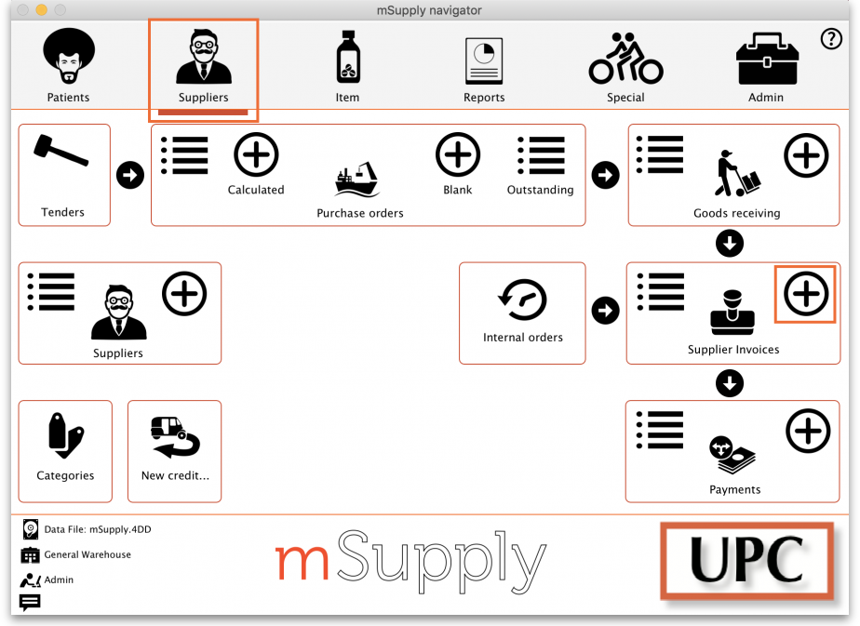
The supplier invoice entry window will open:
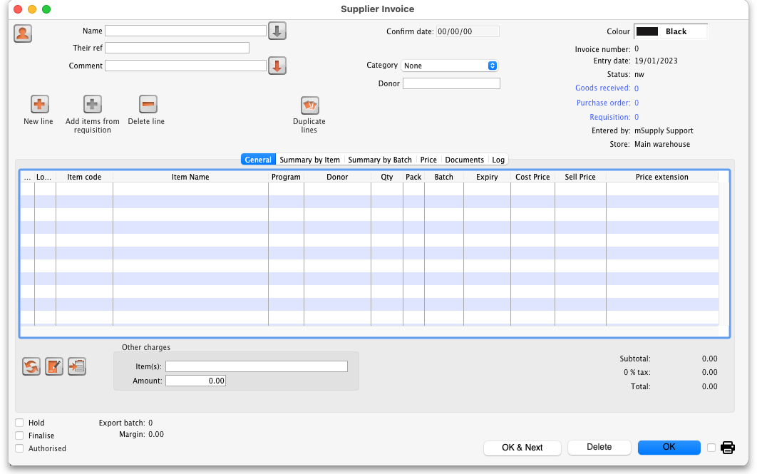
If you have turned on any of the custom stock fields in store preferences they will be displayed as columns (between the Batch and Expiry columns) in the list of invoice lines and the information you entered for these fields will be shown in the appropriate cells.

Information to enter in the main window
Name: The first thing to do is enter the Supplier's name in the Name field. Type the first few characters of the supplier's name or code, and then press the Tab key. If only one supplier name matches the entry, the supplier's name will be filled in. Otherwise, a list will be displayed:
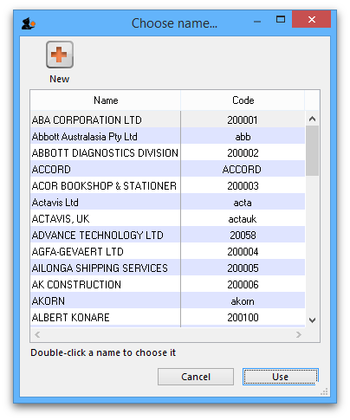
Double-click the appropriate entry, or click Cancel to try again. You can also use the up and down arrow keys or the “u” and “d” keys on the keyboard to move the highlighted item up or down, then click the Use button or use the Enter key to choose the highlighted item.
At this point the supplier's name will normally just appear in the Name field (and their code will appear at the end of the Their ref field) and you can continue as below. However, if the Can manually link requisition to supplier invoice preference is turned on for this store (see Store preferences), a list of requisitions the store previously made to that supplier will appear. Select a requisition to associate with this supplier invoice, then click OK:
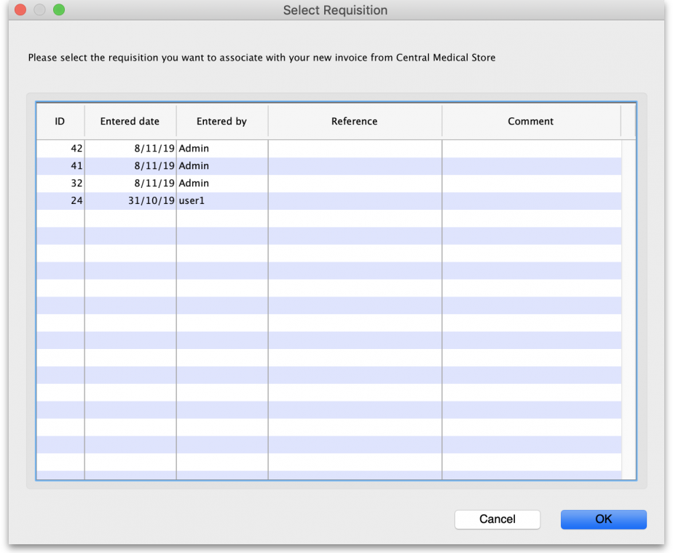
The supplier invoice window will appear with the name of the supplier you have chosen in the Name field:
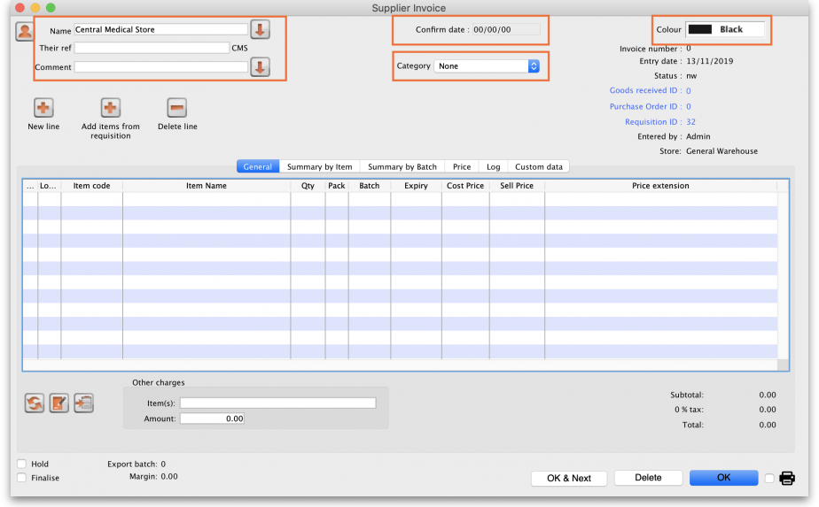
The arrow next to the Name field takes you directly to the Edit Customer/Supplier window, giving access to all the information relating to the supplier entered.
Their ref: Enter the serial number or delivery note number on the bill the supplier gave you.
Comment: Enter anything that needs to be remembered about this invoice. If you need more room, click on the arrow next to the Comment field to give a large area for entering the comment.
Category: Categories created for supplier invoices in File > Preferences > Invoices 1 are listed here.
Colour: Clicking the colour box presents you with a selection of eight colours. When the list of supplier invoices is displayed, the text of this particular supplier invoice will appear in your chosen colour. The colour does not appear on the supplier invoice itself.
Confirm date: This is normally read only but will be editable if the Allow entry of dates on invoices preference is turned on (see the Invoice preferences page for details).

Read-only information at the top of the invoice
There is some information at the top of the invoice that is read-only and cannot be edited:
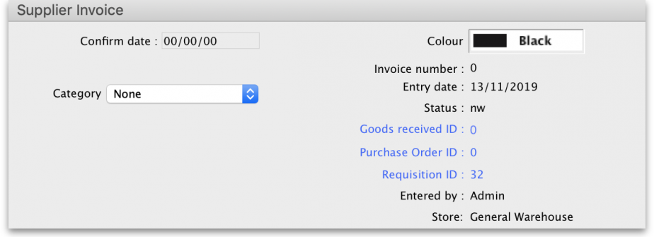
Invoice number: This is the invoice number. The number is automatically incremented and assigned when the invoice is first saved (which actually occurs when the first line is added to it) and is unique within a store. Note that supplier invoices in different stores could have the same invoice number.
Entry date: The date the invoice was created.
Confirm date: The date the invoice was confirmed. Will be “00/00/00” if the invoice has not been confirmed.
Status: The current status of the supplier invoice:
- nw = new (just created, can still be edited, stock not yet added to mSupply)
- cn = confirmed (stock has been added to mSupply but invoice is still editable)
- fn = finalised (stock has been added to mSupply and the invoice is no longer editable)
Goods received ID: If the supplier invoice was created automatically when a goods received note was finalised then the goods received note's ID will appear here in blue, indicating that it is a link and, if clicked, will open the goods received note. A 0 here indicates there is no linked goods received note.
Purchase order ID: Again, if the supplier invoice was created automatically when a goods received note was finalised then the ID of the purchase order which the goods were ordered on will appear here in blue, indicating that it is a link and, if clicked, will open the purchase order. A 0 here indicates there is no linked purchase order.
Requisition ID: If the supplier invoice was linked to a requisition, the requisition number appears here. You can click on it to be taken directly to the requisition. A 0 here indicates there is no linked requisition.
Entered by: The user name of the user who created the invoice.
Store: The name of the store the invoice belongs to.

Buttons in the supplier invoice window
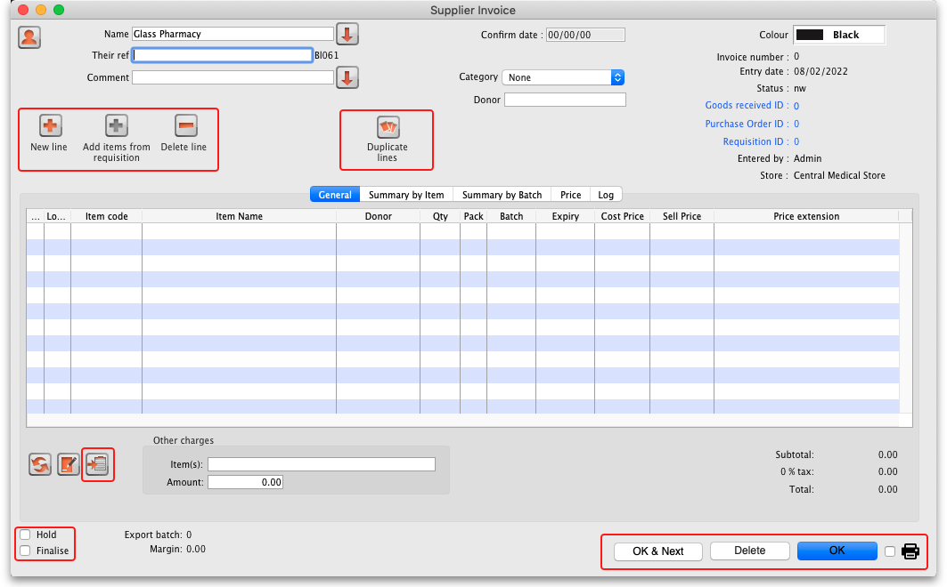
New line: Add an item to the invoice. See Adding lines to an invoice below for more details. To edit a line, double-click on it.
Add items from requisition: Only visible if the supplier invoice is linked to a requisition. Displays a list of items from the linked requisition, which you can add to the supplier invoice. You can add one or more items by highlighting them and clicking OK. To edit a line, double-click on it.
Delete line: Delete item(s) from an invoice. Highlight the line(s), then click this button. Multiple lines can be deleted simultaneously.
Duplicate lines: Select one or more lines on the invoice and click this button to add duplicates of those lines. Great time saver when receiving large quantities of the same item with similar batches into different shelf locations, for example.
Hold checkbox: If checked, the invoice status cannot be changed.
Items on a supplier invoice with new (nw) status have not been entered into the system yet. Putting a new invoice on hold allows you to enter the supplier invoice, but not allow the stock to be available for issuing until all the details have been checked.
Finalise check box: If checked, clicking the OK button will finalise the supplier invoice. Once finalised, the invoice can no longer be edited so be sure first that all the details are correct. Only users with the Can finalise individual invoices permission can check this box. Other users will be warned if they try to turn it on, and the check box will automatically uncheck.
When the OK button is clicked, you will be asked to Confirm invoice and enter into stock now?
- If you click Later the invoice will still have a new (nw) status
- If you click Confirm and the Finalise box was not checked, the invoice will be confirmed (cn)
- If you click Confirm and the Finalise box was checked, the invoice will be confirmed (cn) and finalised (fn)
A finalised invoice cannot be edited.
Should a finalised invoice need to be changed, the entire invoice may be cancelled, and the correct data may be entered as a replacement.
In order to maintain the accuracy of any subsequent audit trail, mSupply creates a transaction which reverses all the stock movements on the invoice being cancelled, having due regard to all appropriate details, such as batch numbers, etc. See Cancelling finalised invoices
If Confirm supplier invoices without asking is checked in the “Invoices 1” tab of the Preferences window, then all invoices will be finalised automatically.
If you have the store preferences set to force supplier invoice authorisation, you will not be able to confirm supplier invoices until they have been authorised. See here for details.
Copy: Copies the invoice details to the clipboard, allowing you to paste them into a spreadsheet or email message.
Delete: Deletes the entire invoice. When deleted, there will be no trace of your entry and the invoice number assigned will be reused.
Unless the invoice has a new (nw) status, if you have added lines to an invoice, you must manually delete each line using the Delete line button before deleting the invoice. This is intentional, to save the “Oops, I just deleted my invoice with 100 lines on it” feeling.
Invoice status | Description
nw | The invoice has just been created - clicking Delete will automatically delete each line and the entire invoice
sg | The Delete button will only delete the invoice if you have first deleted all lines using the Delete line button
cn | Same as for suggested (sg) status
fn | No changes or deletions can be made and the Delete button will be disabled
Print checkbox: If checked, the supplier invoice or packing slip will be printed when the OK button is clicked. If the supplier invoice has a suggested (sg) status, a packing slip will be printed; otherwise an invoice will be printed.
OK: Saves the changes you have made and exits the window.
OK and Next: Saves the changes you have made and opens a new supplier invoice.

Tabs in the supplier invoice window

General tab
This shows a detailed view of each line on the invoice. This is the tab you see when you first open or create a supplier invoice.

Summary by item tab
Displays a summary of each item's requested quantity, sent quantity and received quantity. Different batch numbers of the same item are consolidated into a single line.
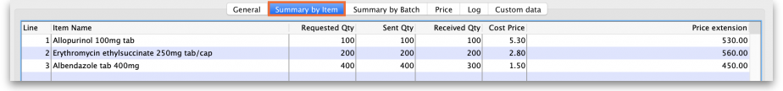

Summary by batch tab
This tab shows each batch but grouped by item and showing summary price information for each batch.
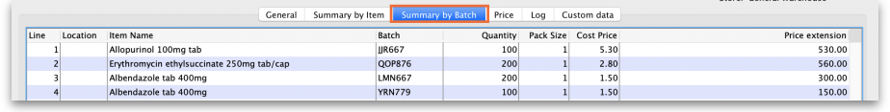

Price tab
There can be a lot of information on this tab! It is all detailed in the Price tab section below.

Unsupplied items tab
This tab is only shown if this supplier invoice is the result of a stock transfer from another mSupply store and the supplying store has the Use EDD placeholder lines in supplier invoices from this store store preference turned on (see the 26.08. Virtual stores page for details).
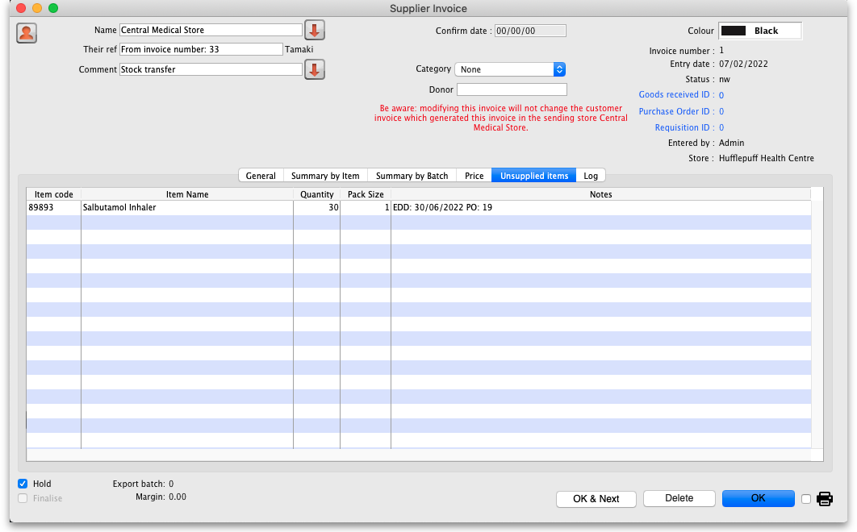
The table on this tab shows all placeholder lines that were present on the customer invoice in the supplying store (they represent the quantities of items that could not be supplied). If the item is also present on a purchase order in the supplying store then the Notes column contains the Expected Delivery Date of the item and the purchase order this date is taken from. Note: this is the expected date the item will be delivered to the supplying store, not your store.

Documents tab
The Documents tab on a supplier invoice enables you to save documents and other files relating to the invoice. The tab looks like this:
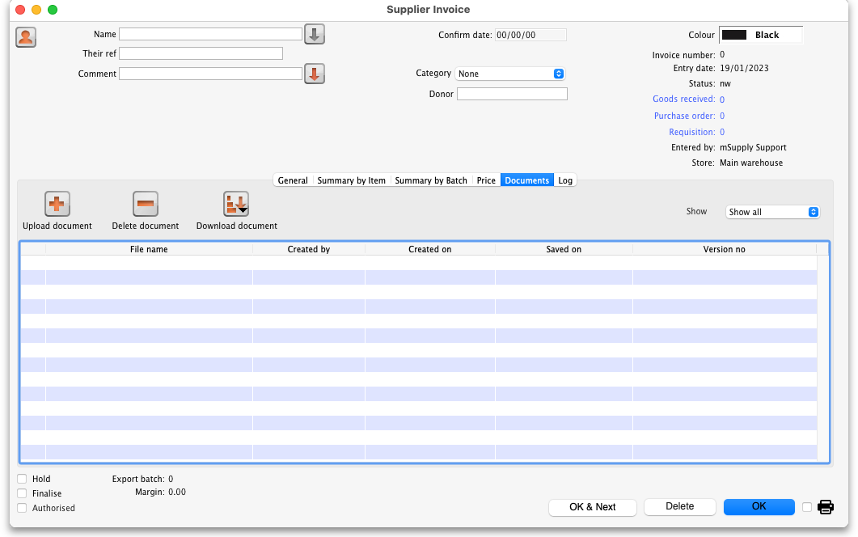
The table shows you all the files currently uploaded to this invoice.
- Upload document button: Click this to upload a document to the invoice. This will open a window enabling you to search for and select the file on your computer. After you've selected it, click on the Open button to upload it. If you upload a file with the same name as one already uploaded, mSupply will upload it as a new version of the already uploaded file.
- Delete document button: Select a file in the table by clicking on it and click this button to remove it from the invoice.
- Download document button: When you click on this button you are presented with two options:
  - Download: this will download the file to a location you select on your computer.
  - Download and open: this will download the file to a location you select on your computer and then attempt to open it using the default application on your computer for that file type. If there is no application associated with the file type on your computer then mSupply will tell you that the file could not be opened.

Log tab
The log tab displays all the log entries that have been made regarding this invoice. All log entries are stored in the mSupply log and this tab will display all the log entries in there which were made for this invoice.

Custom data tab
This tab shows the custom fields that have been set up for supplier invoices.
All custom data will be saved with the invoice (i.e. when you click the OK or OK & Next button).

Adding new lines to a supplier invoice
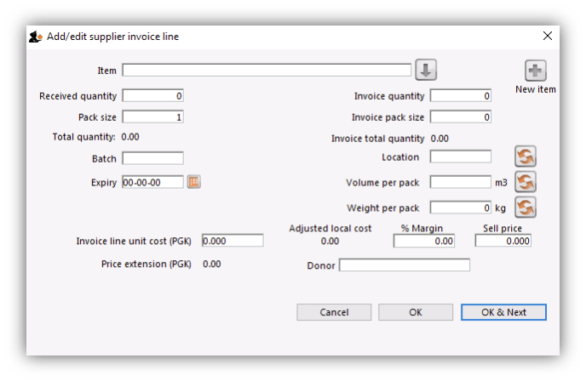
Click the New line button to add a line to the invoice. This window appears: The cursor will be in the field ready for you to enter the item name.
Item: Enter as much of the item name (or code) as you know, then press the Tab key. As usual, if only one entry matches, it will be filled in. More than one matching entry will present you with a list from you should double-clicking on the required item. The text you type will be matched against both the item name and the code. A match for either will display the item.
To query for an item name or code that contains, rather than starts with, a string of text, use the asperand (@) wild character. So, for example, to search for “250mg” within an item, enter @250mg in the search field.
Hint: you can use the “up” and “down” arrow keys to change the highlighted item (You can also press u to move up and d to move down!) . Pressing the enter key will choose the highlighted item.
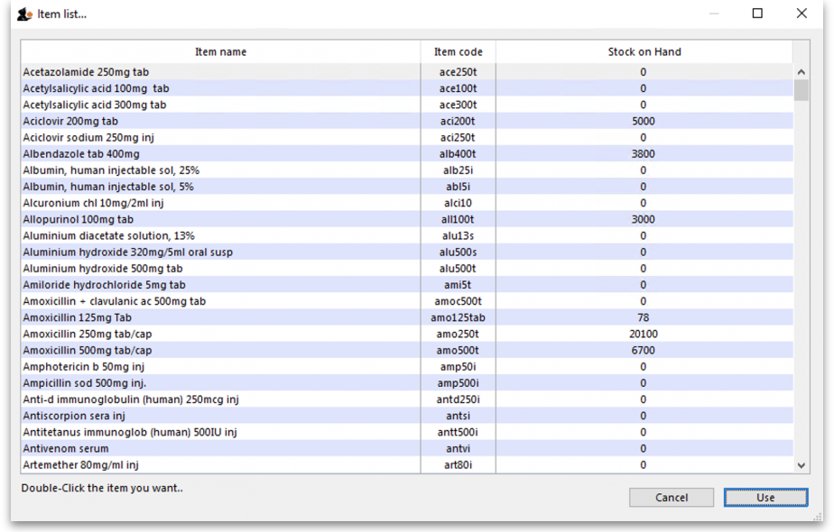
If you did wish to apply a different margin to the whole invoice, click the cancel button, and edit the margin for that supplier by choosing Supplier >Edit supplier and change the margin. If you wish to apply a different margin to just some lines, you can do this as you enter the lines, as long as Editing margins is enabled in the Preferences.
If the the item you are entering is not listed, you can click New item to add it.
Note: it is a good idea to agree upon a standard form for entering items. For example, will you enter an “infant feeding tube” as:
- “infant feeding tube”
- “feeding tube, infant”
- “tube, infant feeding”
Duplicated items can later be merged, but it is better to get it right first time!
If you need to see the full details of the item itself after selecting it, click on the down arrow icon () to the right of the item name field and you will be taken to the item's details window.
Now there are a series of fields to enter to fill in the basic information for the line
Received quantity: How many packs did you receive?
Pack size: How many units are in each pack? Once the item has been selected the item's unit will be displayed after this field. If you also want to enter the number of packs in a carton (the “inner” pack size) and the number of cartons on a pallet (the “outer” pack size) then you can turn on a preference, as described on the 16.03. Invoice preferences page.
Total quantity: mSupply will automatically calculate the total quantity of individual units (received quantity x pack size).
Say you receive 50 boxes of amoxycillin caps, each box containing 10 strips of 10 caps. You would normally enter 50 in the received quantity field and 100 in the pack size field. However, if you normally issue the capsules in strips of 10 to customers (e.g. you allow them to order 20 or 30 capsules), then it will be more convenient to enter a quantity of 500 and a pack size 10.
Pack to one: Clicking this button will automatically change the pack size to 1 and update the Received quantity to match. If the Convert pack to one when receiving option is turned on for this item (see the 4.01.01. Items - General tab page for details) then this button will not be present but will be replaced with a warning that the pack size will automatically be changed to 1 (and the Received quantity updated accordingly) when the OK button is clicked or a cost price is entered. If you are using barcoding then the barcode for this batch will automatically be updated to a barcode matching the pack size (1) and manufacturer (if selected). If there is no matching barcode then the barcode selection will be changed to Remove barcode and, when the OK button is clicked, the barcode will be removed from the batch (you can of course use the Add one option to add an appropriate barcode before clicking on the OK button).
Invoice quantity: How many packs did the supplier claim to have sent? (Sometimes this is different to the quantity received!)
Invoice pack size: What is the pack size stated on the supplier invoice? It should match the received pack size, but if Pack-to-one has been applied to the received quantity (see above), this value will show the original pack size on the supplier invoice.
Invoice total quantity: mSupply will automatically calculate the total quantity of individual units stated on the supplier invoice (Invoice quantity x Invoice pack size).
Batch: The batch number or other identifying information. The batch appears on the invoice, so you can use this field to differentiate between brands if you need to (eg you operate using generic names, but occasionally want to give a specific brand- you can put an abbreviation for the brand name here as well as the batch).
Expiry: You can use “/” or “.” to separate the day/month/year.
Use whichever date format you have set in your computer (dd/mm/yy or mm/dd/yy or yy/mm/dd). You can enter the year as 2 digits, which will be understood as a date between 1961 and 2060. This should cover the expiry date on most things you receive in the next 52 years!
Location: The location of the item should be entered in this field. Type the first few characters of the location's code and press the Tab key on the keyboard to select the correct location. If there is only one location that matches what you typed mSupply will select it for you, otherwise this window will open to allow you to select the right location:
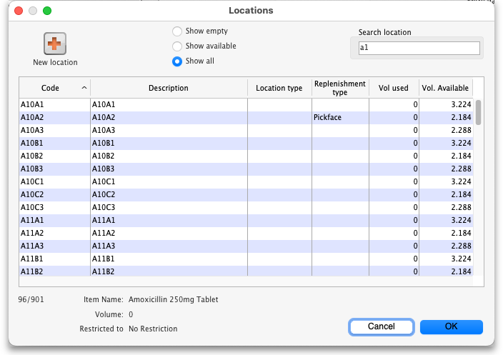
Double-click on the location in the table to select it. You can refine the list by selecting the Show available or Show empty radio buttons:
- Show available: If this is selected the list will only show those locations that have enough volume left in them to accepot the volume in this line. For this to be useful, the locations must have a volume entered and the stock you are receiving must have a volume per pack value.
- Show empty: If this is selected the list will only show those locations that have nothing in them at all (this does not use volume, it uses the presence of stock in that location).
Volume per pack: How much space the pack occupies in metres cubed (m3).
Weight per pack: The weight of the pack in kilograms (kg).
Invoice line unit cost: Enter your cost price for one pack of the pack size you entered above. If your supplier's currency is different to that of mSupply the cost price will appears in the supplier's currency.
If you have set a default selling price for this item, if you set the Invoice line unit cost to zero after setting it to some value, you will be asked to confirm whether you want to zero the cost price. If you confirm the change, the Sell price and Price extension will be set to zero.
Adjusted local cost: Displays the cost of a single unit of the item in local currency.
% Margin and sell price: If you have allowed editing of these fields in Preferences, you can adjust the margin (and the sell price will adjust automatically), or you can adjust the sell price (and the margin will adjust automatically).
If you do not set it to something else, the sell price will be set to the item's default sell price.
Manufacturer: This field displays the name of the manufacturer of the item. It will only be shown if you have turned the Able to specify manufacturer when receiving, ordering or quoting for items preference on in the store preferences.
Entering a manufacturer follows the same pattern as entering an item or supplier - type the first few letters of the manufacturer's name or code, and press the Tab key. Choose the required manufacturer from the list if more than one is displayed.
You can add a new manufacturer by clicking on the New button.
Donor: The donor of the item can be entered to this field. A valid donor should be entered, type the wildcard character '@' and press the TAB button to view your list of donors.
Price extension: This information field provides the cost price in local currency for the total quantity of the item you have entered.
Custom fields 1-8: The appearance of these fields is controlled by the Custom stock field preferences. Any information you enter in these fields will be displayed wherever stock information is displayed (e.g. when issuing stock on a customer invoice or when viewing the stock of an item on the stock tab of the item details window). The fields can also be reported on so they are an important and powerful way of tracking different categories of stock. For full details please see Custom stock fields.
Click OK if you are finished, or OK & next to add another line. (The invoice lines added will be displayed in Items Display Field.)Click Cancel to exit to the main screen without saving any of the details.
mSupply provides the feature of receiving service items into stock. Service items are items that are not normally held in stock and are called non-stock items in mSupply. See here for more information on those. You might be tempted to use service items to manage assets - if you are you might find the mSupply asset management functionality better. See the 21.02. Asset management page for details.
If the Convert pack to 1 when receiving preference is turned on for the item (see the 4.01.01. Items - General tab page for details), the Pack size field will be changed to 1 and the Cost price, Volume per pack and Weight per pack field values will all be re-calculated when you enter the Cost price field value or click on the OK button. A warning in red text will be displayed on the window if the preference is turned on so that you don't get any nasty surprises when the values suddenly change!
PLEASE NOTE: There is a preference to prevent the adding of expired stock to supplier invoices. See the 26.07. Virtual stores page for details.

Editing lines on a supplier invoice
Supplier invoice lines can be edited at any time until the invoice is finalised.
If the SI has been finalised, it needs to be un-finalised in order to edit lines. Contact support on support@msupply.org.nz
To edit a line, simply double-click on the line you wish to edit.

Editing lines if stock has been issued
If you have already issued stock of this line to a customer, you will be warned with a window like this:
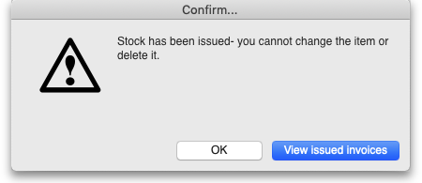
Clicking View issued invoices will show you a list of customer invoices containing stock entered on this particular line:
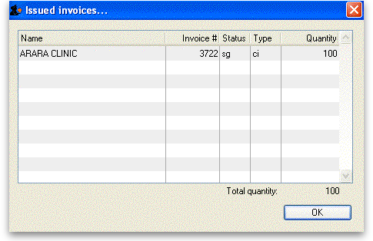
Clicking OK will take you to the item issue window:
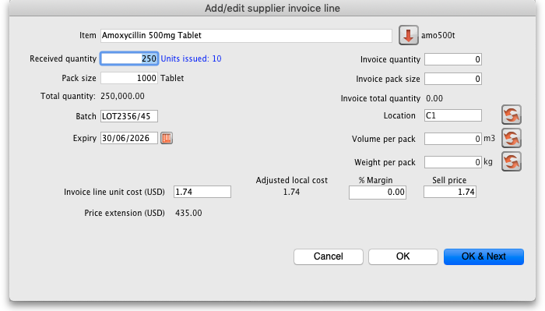
The item and pack size fields will not be editable and you may not reduce the received quantity to a figure lower than the quantity already issued. However, if you have the Update pack size, cost and sell price preference turned on (see the 24.15 Managing users page for details) you will also be able to edit the pack size field. There is a caveat; if the stock has been involved in a repack or a split, the pack size field will always remain uneditable.
In the screenshot above you will notice the “units issued: 10” text in blue to the right of the Quantity field. This will only be present if stock has already be issued to customers. You can click on that text to display a list of issued invoices as described above with the View issued invoices button.
Note that the OK & Next button is very useful for editing a whole invoice. Simply double-click the first line of the invoice, then use the OK & Next button to go from line to line.

Vaccines
There is extra functionality for vaccines to enable you to record the VVM status. To turn it on, you must turn on the Able to specify VVM status when receiving items store preference; see the 26.07. Virtual stores page for details.
When this preference is turned on, the field appears on the supplier invoice line entry/edit window here:
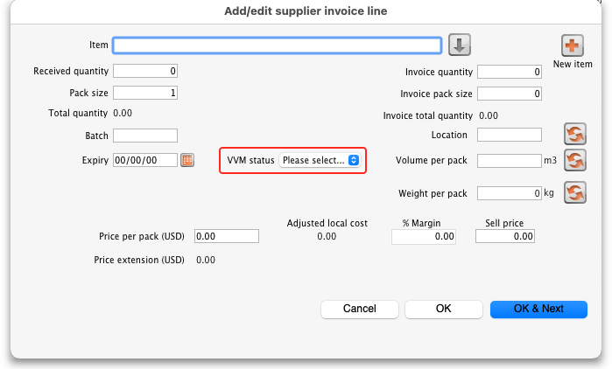
The VVM status field is populated with the statuses set up in the system. See the 20.01. Vaccine Vial Monitoring (VVM) page for details on how to do that.
If you are editing an existing line on the supplier invoice then the VVM status field will display the status selected for the invoice line or Please select… if it doesn't have one set already.

Working with the list of invoice lines
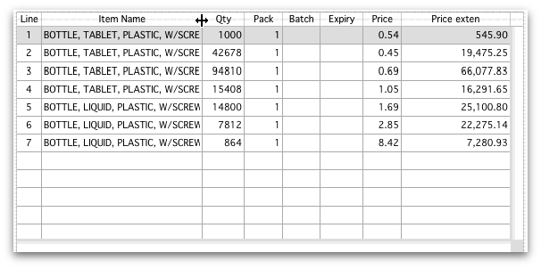
Resizing columns: These columns are resizable. If any of the column data is cut-off or remains hidden, the column width can be increased or decreased by positioning the mouse at the borders of the column. The cursor changes to a cross with arrowheads on the horizontal bar. Click and drag the cursor to the left or right.
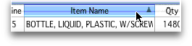
Sorting columns: Columns may be sorted either in ascending or descending order by clicking on the header.
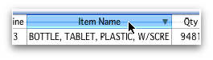
The order of the columns can be re-arranged by clicking on the header and dragging it to the new position.

Deleting a line on a supplier invoice
To delete a line, do one of the following:
- Click on the line you wish to delete, then click on the Delete line button
- Double-click the line to edit it (see above) and set its quantity to zero.
Click the OK button. You will be asked for confirmation. Click OK to proceed.
You cannot delete a line from a supplier invoice that has been finalised.

Selling price calculations in mSupply
mSupply uses a number of items of information to calculate the selling price of an item. This enables you to have the price calculated just the way you like it.
Here's the logic mSupply uses:
- Does the item have a selling price specified? If it does, this price will be used regardless of any other information. Note that the price entered for the item is for one unit. The price will be multiplied by the pack size to get the selling price for the line.
- If either the supplier margin or the item margin is specified as zero, then the other (non-zero) value will be used?
- If a margin is specified for both the supplier and the item, the Preference Item margin overrides supplier margin will be examined to see if it is on or off. If it is set, the item margin will be used, if not the supplier margin will be used.
For example: <HTML>
</HTML>
Cost price | Pack size | Supplier margin | Item margin | Preference set for Item margin overriding Supplier margin | Item price | Price used
100 | 100 | 6 | 10 | yes | 1.15 | 115
100 | 100 | 6 | 10 | no | 1.15 | 115
100 | 100 | 6 | 10 | yes | 0 | 110
100 | 100 | 6 | 10 | no | 0 | 106
100 | 100 | 0 | 10 | no | 0 | 110
100 | 100 | 6 | 0 | yes | 0 | 106
<HTML>
</HTML>
Note that if you have turned on “allow editing margins and sell prices on supplier invoices” in the Preferences you will be able to over-ride the prices mSupply calculates.

Price tab
This tab provides functions for applying discounts and apportioning different charges to items.

Applying a discount to the whole invoice
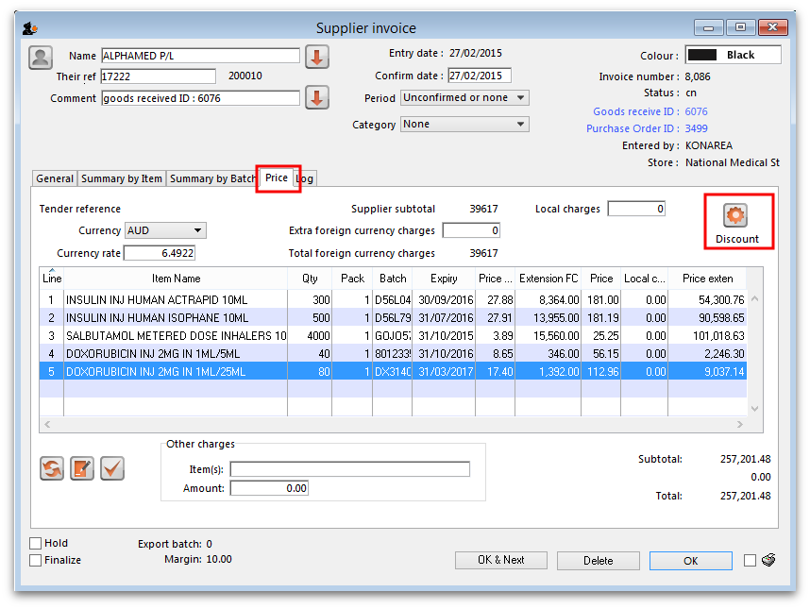
If a supplier gives a discount at the bottom of the invoice rather than adjusting the price of each invoice line, you can use the discount button.
This window will be shown:
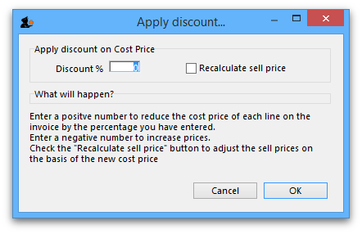
If you enter “5” the cost price of each line will be reduced by 5%, and the invoice total will be recalculated. It should then match the amount the supplier is actually charging you.
If you want the sell price calculated based on the new cost price, check the “Recalculate sell price” checkbox. The selling price rules as described above will still apply.
When a discount is applied to the invoice, a log entry containing the discount percentage is also made. The log entry can be seen on the Log tab (see the Log tab section above).

Applying local charges
Local charges are any charges you want to add to the cost of individual items on this invoice in your data file's local currency (i.e. the default currency used in your data file - this might not be the same as the currency you use when you visit a local shop!). These could be administration charges, local freight charges, handling charges etc.
You can either enter the amount of local charge to apply to each invoice line or the total amount of charges to apply to the invoice.

Entering local charge amounts on each invoice line
You do this by directly entering the amounts to apply to each line in the cells of the Local charge column in the table. As you do this, mSupply will automatically increase the sell price per pack by the amount you have entered divided by the number of packs for the line and will add the amount you entered to the current value in the Local charges field above the table.

Entering the total amount to apply to the whole invoice
To do this, you simply enter the total amount in the Local charges field above the table. When you do that, mSupply will automatically apply a portion of the local charges to each invoice line's sell price, according to the ratio of that line's Price extension to the sum of all the Price extensions of all lines on the invoice. You can see how much mSupply added to each line in the Local charge column. If you wish, you can edit the local charges applied to each line after this by simply clicking on the appropriate Local charge cell in the table and typing in the cost to apply. As you do that, mSupply will keep track of the total local charges applied to all lines in the Local charges field.

Applying foreign currency charges
These charges are applied in the currency selected in the currency selected in the Currency drop down list, following the rate displayed in the Currency rate field (which you can manually adjust if the default shown by mSupply is not what you require). The charges could be, for example, international freight charges or administration charges.
Simply type the amount of foreign currency charges to apply to the whole invoice in the Extra foreign currency charges field and mSupply will apply a portion of the whole amount to each line, according to the ratio of the line's Price extension to the sum of the Price extensions of all lines. mSupply will automatically update the sell price value for each item.

Applying other charges
These charges will NOT be added to the sell or cost prices of the items on the invoice. You enter them in the Other charges section below the table of items:
- Item(s) field: Enter what the charges are for in this field.
- Amount field: Enter the total amount of the other charges in here. When you do this, you will see the amount added directly to the Subtotal and Total amounts and none of it will be added to the sell or cost prices of the individual items in the table.

Applying tax to the invoice
Tax, like other charges, will not be added to the sell or cost prices of the individual items. To add tax, click on the % tax rate below the Subtotal field on the right hand side below the table of items and enter the rate you wish to use. mSupply will calculate the amount of tax (the % you entered of the Subtotal value) and automatically add it to the Subtotal value to give you the new Total.
If you have set a default tax rate in the preferences (see General preferences) you will see it applied as soon as you open the invoice. Also, you will only be able to edit the tax rate if the Allow editing tax rate and amount on invoices preference is turned on (see Invoices preferences).

Viewing supplier invoices
To view or edit any supplier invoice, choose Supplier>Show invoices. The details of how this works is virtually identical to that of viewing customer invoices.
Rapid access to Goods Received note from Supplier invoice, and vice versa
If the Supplier Invoice came from a Goods Receipt, (which in turn came from a Purchase Order), Supplier invoices show the Goods Received transaction number in the upper right area of the window. By clicking on that, the Goods received transaction will be displayed. Similarly, the Edit goods received list has a link Click here to open Supplier inv ……. which will display the required invoice.

Processing supplier invoices
In order to bring the stock on a supplier invoice in to your store, you will need to confirm it.
If the supplier invoice was created by mSupply, then depending on the store preferences, the supplier invoice may or may not be on Hold or Finalised:
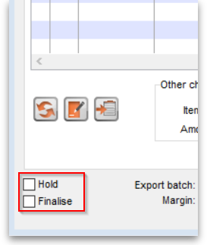
- If the supplier invoice is On hold, then the supplier invoice can not be processed (moved from one status to another). You will need to take the supplier invoice off Hold in order to process it.
- To toggle the supplier invoice between on and off Hold, click on the Hold checkbox.
- You can print the supplier invoice even if it is on Hold.
- If the supplier invoice was finalised when you first opened it, then the stock has already been (logically) brought in to your store, and you don't need to do any processing! (In fact, you can't do any processing of it, even if you wanted to.)
- If the supplier invoice status is nw, then the stock as described on the supplier invoice has not been brought in to your store yet.
- To close the supplier invoice, click on the OK button. If the supplier invoice is not on Hold, then you should be prompted with the pop-up message below.
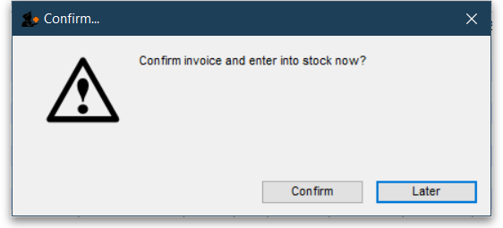
- If you click Later, the supplier invoice will close, the supplier invoice status will stay at nw, and the stock will not be brought in to your store.
- :Once you are happy with the details of the stock as described on the supplier invoice (taking special notice of the Cost Prices), and you are ready to bring the stock in to your store, click on the OK button, and then click Confirm. The supplier invoice will close, the stock will be brought in to your store, and the supplier invoice status will change to cn.
- Depending on your user permissions, you may be able to edit details of the stock even after it has been brought in to your store - provided that the status remains at cn
- If you click on the Finalise tick-box, then the status will change to fn and you will no longer be able to edit any details on the supplier invoice.

Printing supplier invoices
There are 2 ways to print a supplier invoice but both require it to be open. The first way is to check the print checkbox in the bottom right hand corner of the supplier invoice window:
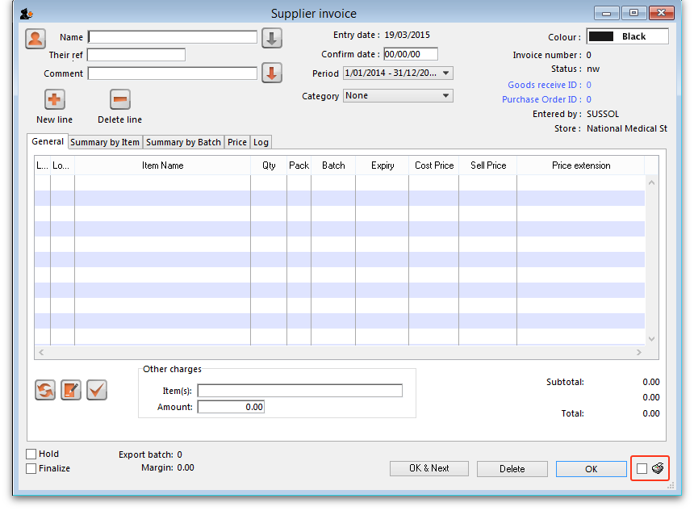
When the checkbox is checked and you click on the OK button, the printing options window is displayed. The invoice will be closed after printing.
The second way is to hold down the Shift key on the keyboard and click on the printer icon in the bottom right hand corner instead of checking it. This will also open the printing options window but the invoice will stay open after printing.
This is the printing options window:
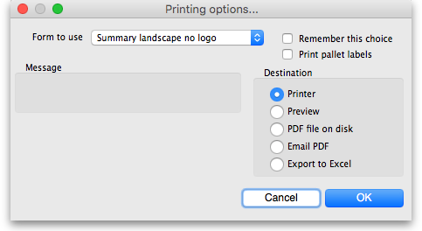
- Form to use drop down list: Select the form you want to use to print the invoice. There may be several in the list. There is also a None option if you don't want to print the invoice but just want to print pallet labels.
- Remember this choice checkbox: The form you choose in the Form to use drop down list will be selected (and everyone else!) next time the supplier invoice printing options window is opened if this checkbox is checked.
- Print pallet labels checkbox: Check this if you want 100x150mm pallet labels in a specific format to be printed out from a label printer. A label will be printed for each line on the supplier invoice. Note: the label printer has to be installed and configured in mSupply before this option will work - see Label printer installation and Printing preferences (setup) for details.
- Destination radio buttons:
  - Printer: the invoice will be printed out straight away.
  - Preview: a preview of what the invoice will look like when it is printed will be displayed in your installed PDF file reader. You might be able to print the invoice from the PDF reader, depending on its features.
  - PDF file on disk: the invoice will be saved to disk in PDF format.
  - Email PDF: the invoice will be created as a PDF file and attached to an email for you to send. You can double-click the email attachment to see a preview of the invoice. The email preferences in File > Preferences should be setup correctly before using this feature.
  - Export to Excel: the invoice will be exported as a spreadsheet file and opened for you (provided you have a spreadsheet application installed).
When you click on the OK button the invoice will be printed in the form you have chosen.
Previous: 7. Receiving Goods | | Next: 7.02. Goods receipt

