3.08. Enter incoming goods (supplier invoices)
In some countries an invoice for incoming goods is referred to as a “bill” - in mSupply we use “supplier invoice” to mean the same thing.
Let's suppose we have just received a shipment containing two items from Acme Pharmaceuticals, and we want to enter these goods into stock. The invoice looks like this: <HTML>
</HTML>
From: Acme PharmaceuticalsBill no.:A939
Item | Quan | Pack | Batch | Expiry | Price | Extension
Amoxycillin Caps 250mg | 1000 | 100 | b93333 | 31/12/2015 | 344 | 344,000.00
Cotrimoxazole 240mg/5mL susp | 65 | 60 | bb23d | 31/10/2015 | 21 | 1,365.00
Cotrimoxazole 240mg/5mL susp | 100 | 60 | bb22d | 31/01/2016 | 21 | 2,100.00
Total: |  |  |  |  |  | 347,465.00
<HTML>
</HTML>
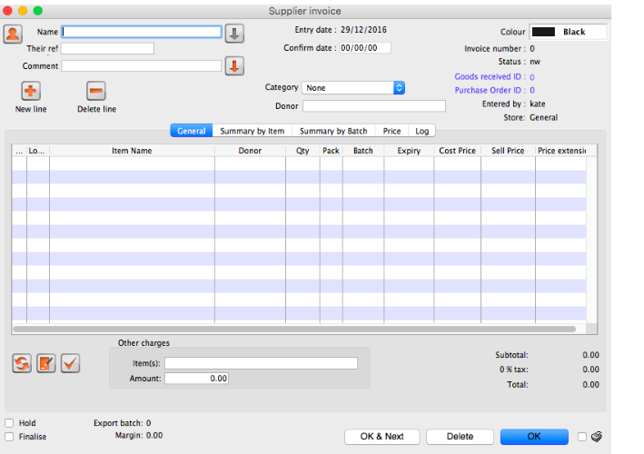
Choose Supplier > New invoice from the menu or navigator.
The cursor will be positioned in the Name field. Type “a” and then press the tab key. If there is only one supplier whose name starts with “a”, the details will automatically be filled in.
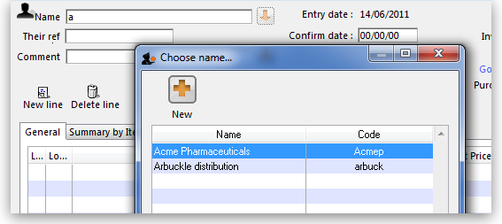
In our case the supplier “Arbuckle distribution” was already present, so you are presented with a window listing the suppliers starting with “a”. Double-click the line containing “Acme Pharmaceuticals” to choose them for this invoice. The insertion point will jump to the Their ref. field.
Type “A939” into the Their ref. field. Press the Tab key to advance to the Comment field.
In the Comment field you can type a comment or information to identify the invoice.
Note that the margin is showing as 10 percent (the percentage that will be added to your cost price to obtain the selling price).
Click the New line button to add the first invoice line. You will be presented with the window for adding invoice lines.
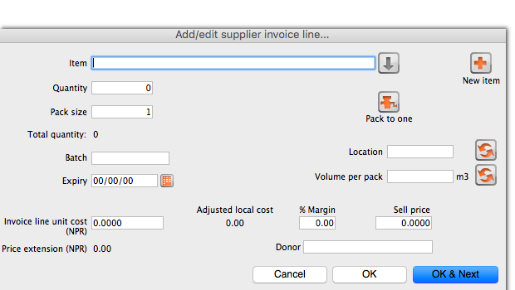
- The cursor will be positioned in the Item field. Type “a”, then press the Tab key. You will be presented with a window listing all items whose name starts with “a”. Double-click the “Amoxycillin 250mg tab/cap” entry to choose it. The cursor will now be positioned in the “Quantity” field.
- Enter the number of packs received in the Quantity field: “1000” (Note that this is the number of packs, not the total quantity of capsules). Press Tab to advance to the next field.
- Enter the pack size: “100.” Press Tab to advance to the next field.
- The cursor will now be in the location field. Ignore this for now and press Tab again.
- You can also ignore the Volume per pack field and press Tab to keep going.
- Enter the batch number: “b93333.” Press Tab to advance to the next field.
- Enter the expiry date: “31/12/2014” (Presuming you have dates set up to enter as dd/mm/yy. If your dates are set to the USA's mm/dd/yy format, enter “12/31/14”). You only have to enter 2 digits for the year, as long as the year is in the range 1961 to 2060. Dates outside this range must have the year entered as four digits. Press Tab to advance to the next field.
- In the “Invoice line cost” field enter the pack cost price: “344”
- The table shown in the picture at the bottom appears if you have Show previous purchases checked in your preferences. It will show purchases you have made of this item in the past.
- Donor is the donor who provided funds for the goods on this invoice. You can create donors by activating donor tracking in File/Preferences/Suppliers/New Supplier and then check the donor check box.
As we have another line to add, click the OK and Next button. The entry is recorded, and the window is now blank to accept your second invoice line.
- Enter “c” into the item name field and press tab. In the list of items showing, you will find “Cotrimoxazole 240mg/5mL susp”. Double-click the entry.
- Enter the remaining invoice details for “Cotrimoxazole 240mg/5mL susp”:
- num units: “65”
- pack size: “60” (Note that it is better to record the actual volume of most packs, unless the volume is not important- for example with an eye-drop, where you could record the pack as “1”)
- batch: “bb23d”
- expiry: “31/12/2013”
- price: “21.00” (You can just enter “21”)
Click the OK & Next button to save the details and start to enter another item.
Now enter the third item on the supplier invoice from the example invoice from Acme Pharmaceuticals example invoice above.
When you have finished, click the OK button to take you back to the main list of invoices.
Our invoice will now have 3 items added to it. The invoice total should read “347,465”, and should appear like this:
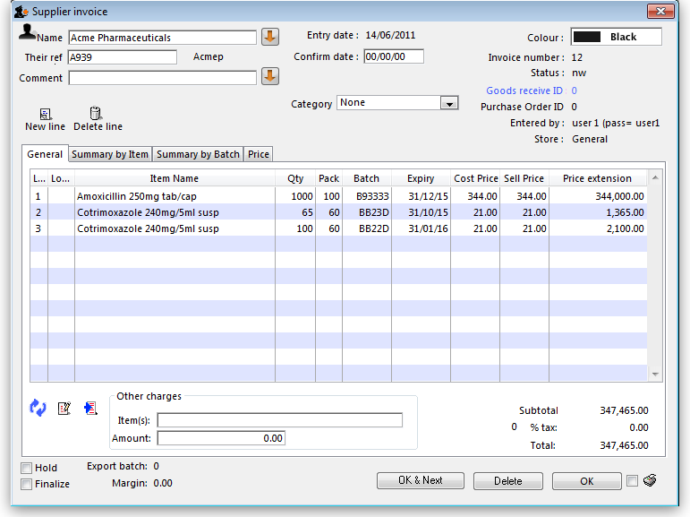
If you have made a mistake, click on the relevant line , which will now be highlighted; double-clicking on it allows you to edit it. You will be shown the line details again, and you can then make corrections and click the OK button to save your changes. There are 3 icons in the lower left corner of the invoice window.
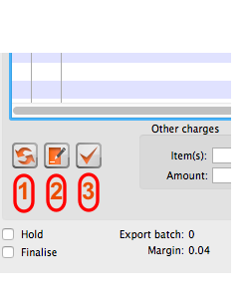
- This allows you to rearrange the order in which the lines are shown on the invoice
- Here you can make a note of anything relevant to this invoice
- This will copy the details of the invoice to the clipboard
Now click the OK button. As long as you have left the “print” check box (bottom right corner) checked, you will be asked if you want to print the invoice (you may do so). Note that when you print, you are shown two windows. The first window is the page setup for your printer, the second window allows you to specify how many copies to print, etc. (The second window also has “preview” check box, where you can preview the print job).
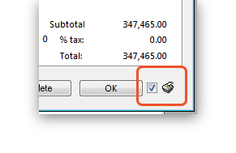
As this invoice is a “supplier invoice” it has been “confirmed” when you clicked the OK button in the invoice entry window. You can view and edit the invoice details until the invoice is finalised. Note that if you issue some of the stock you have just entered to a customer, some fields relating to that stock will no longer be edit-able.
NOTE - As of mSupply® v190, a more precise alternative for entering received goods has been implemented. See Viewing and editing supplier invoices created via Goods Receipts
Previous: 3.07. Viewing location in Google Maps | | Next: 3.09. Entering outgoing goods (customer invoices)

