3.09. Enter outgoing goods (customer invoices)
Now let's suppose we have just received an order as follows: <HTML>
</HTML>
From: | Blue Cross Hospital
Order number: | PO882
Delivery: Express courier please
Item | Quan
Amoxycillin 250mg tab/caps | 10,000
Cotrimoxazole 240mg/5mL susp | 120
<HTML>
</HTML>
Choose New Invoice from the Customer menu, and the following window appears:
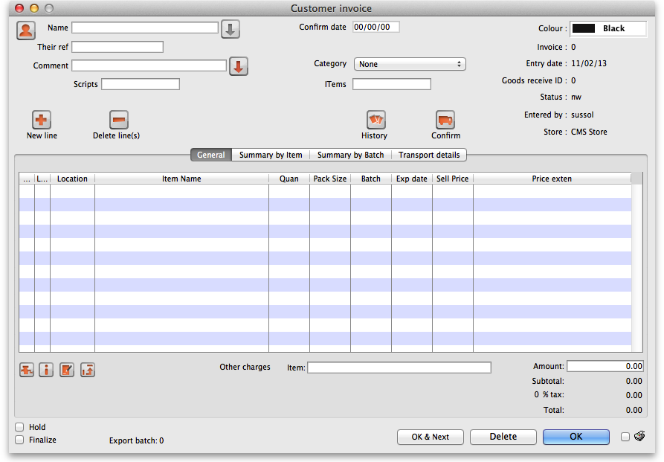
Type “b” into the Name field, and press the Tab key. You will be presented with a list of customers whose name starts with “b”. Double-click the “Blue Cross Hospital” entry to select it.
- In the Their ref field enter “PO882”.
- In the Comment field enter “This afternoon by courier”
- Click the New line button to add a line to the invoice. You are presented with the “Add item” window.
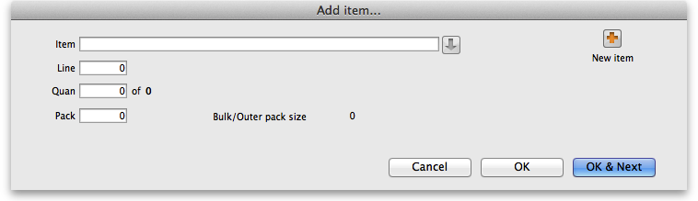
Enter the following details:
- Type “a” into the Name field then press the Tab key. In the list you are presented with, double-click the “Amoxycillin 250mg tab/cap” entry.
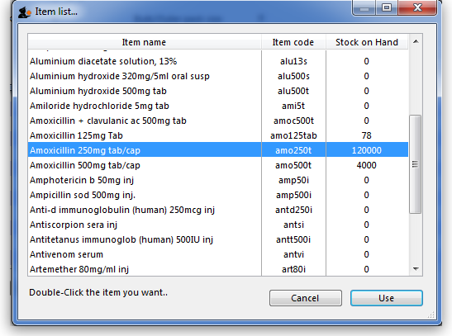
- You will see that a list of available stock has appeared in the window, and the cursor has moved to the Line number field. Enter “2” to choose line 2. (The list is sorted so batches with the shortest expiry date are at the top - usually you would choose the shortest expiry batch, but today we're being different!).
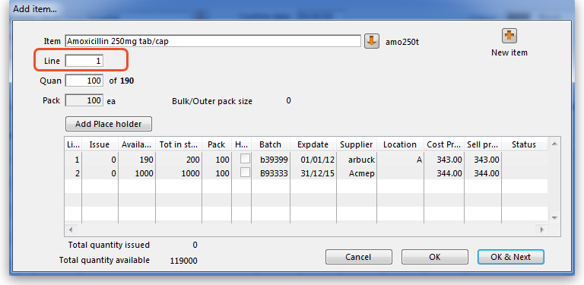
- Quantity field - the line we have chosen has a pack size of “100”, so we need to enter a quantity of “100” to make a total of 10,000
Click the OK & next button to add the second line of the order.
This time enter “c” and press the tab key. Double-click the “Cotrimoxazole 240mg/5mL susp” entry. The window will close and the list of available batches and quantities will be completed.
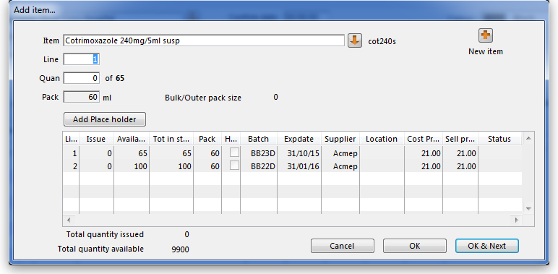
Note that in the list of available stock, the second line we entered from “Acme pharmaceuticals” is now at the top of the list - this is because the list is sorted so that the item with the shortest expiry date comes to the top of the list.
Line 1 is selected, despite the fact that there is insufficient stock of line 1 to meet the order of 120. Nevertheless, you should enter “120” in the Quantity field, press Tab, and the following message will appear:
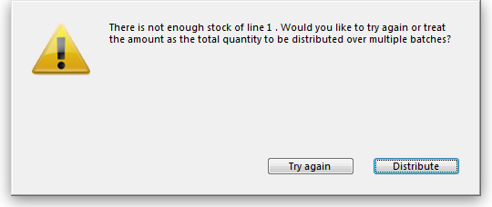
For this tutorial, choose Distribute (which is likely to be your normal choice), and the necessary stock to complete the order will be drawn from another batch/other batches, starting with the batch which will be the first to expire. There will be occasions, however, when you wish to override this automatic means of distribution, and in this event you would select Try Again and manually select the batches from which you wish to meet the order.
Click the OK & Next button
Because the invoice has not been confirmed, the “available” amount for the line has been reduced, but the “total stc” (total stock) is still showing as “100”. mSupply® includes these lines in the list so you can see stock that has been allocated to an invoice but has not yet left your store. You can then edit the other invoice if stock is urgently needed on the current invoice.
Click OK as we are finished entering lines. You will be returned to the main Customer invoice window.
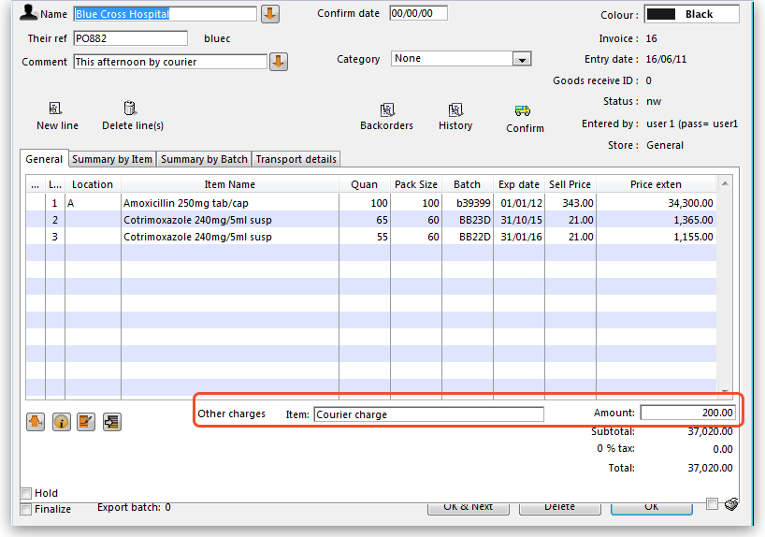
At the bottom right of the invoice you will see the invoice total.
- As the customer has requested an express courier, we will charge them Rs200 for the service (Rs = “rupees” the currency in our tutorial). At the bottom of the window you will see the Other charges field:
- There, enter “Courier charge” and press the Tab key
- In the “amount” field enter “200” and press the Tab key. The new total should be “37,020.00”
Now we are ready to print a packing slip. Make sure that Print is checked in the bottom right corner, and click OK; a window appears displaying your print options:
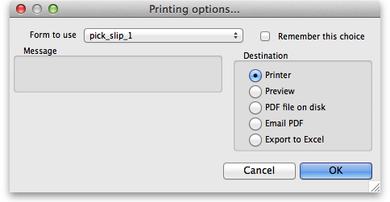
We want to print a packing slip, so the default settings suit our purpose. You will notice the packing slip printed has a column where you can write down the actual quantity packed.

Confirming the invoice
Let's suppose the order was successfully packed according to the packing slip, and you now want to confirm the order and print an invoice to pack with the goods. (We're in a hurry - the express courier is on her way!)
First, we need to look up the invoice. Here's an easy way to look up the last invoice you have entered:
- Choose Show invoices.. from the Customer menu.
- If you know the invoice number (printed on the packing slip) you can enter it. To bring a list of the most recent invoices, you enter the number of invoices to view. As we know the invoice we want is the last one to be entered, we just type “1” and click OK - you will be taken straight to the invoice.
Click the Confirm truck icon,
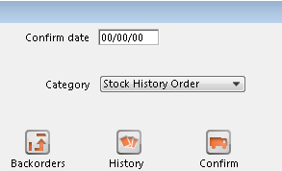
and today's date will appear in the Confirm date field. Click OK to confirm you want to proceed.
The invoice is confirmed, and you are given the opportunity to print an invoice.

Previous: 3.1. Logging in | | Next: 3.3. Working with lists

