3.10. Entering quotations
mSupply allows you to keep a record of prices that suppliers have quoted to you. Let's assume that you have just received 2 quotations for Amoxycillin 250mg capsules; one of the companies has used US dollars for their quotation, and the other has used British pounds, so before entering the details of the quotations, it is necessary that both of these currencies are recognised. To achieve this, choose the menu item Special > Currencies, and this window appears:
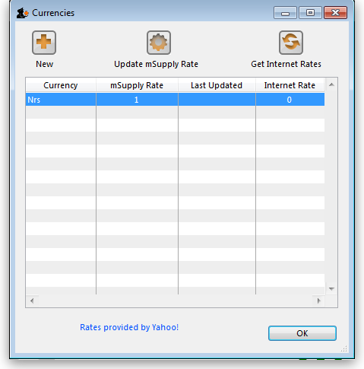
Click on the New button, and a window appears which allows you to enter another currency:
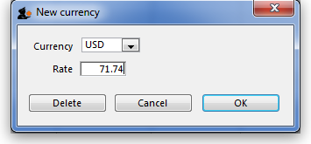
Enter “USD” in the Currency field; in the Rate field you should enter the number of units of the default currency - in this case Nepali Rupees - equivalent to 1 US dollar; at the time of compiling this tutorial, the rate was 71.74 N.Rs. to US $1, so “71.74” is entered in the Rate field. Click on the OK button, and repeat the exercise for British pounds, the rate presently being 116.36.
Once you have performed this, the Currencies window should look like this:
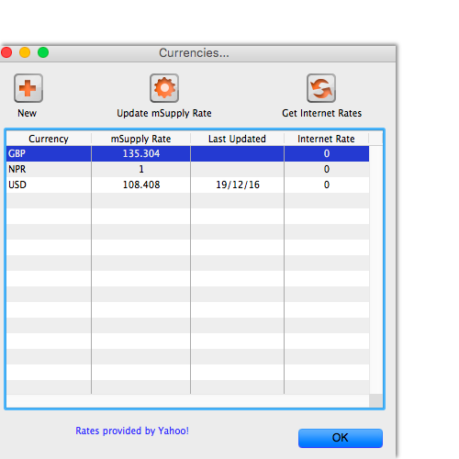
We're now ready to proceed.
To enter a quotation:
- Choose Items > Show items
- Type “Amox” then press Enter.
- Double-click the “Amoxycillin 250mg caps” entry from the list.
- The item view window, on the left, has vertical content list (General, Usage, Quotes). Click the Quotes line.
- Click the “New Quote” button.
- Note that the item is entered for us. We need to choose a supplier and enter their price details.
- Enter “Arb” in the supplier field and press tab. Arbuckle distribution is automatically chosen. They have quoted in US dollars, so choose “USD” from the currency menu.
- Their price is US $3.50 per 100 capsules, so enter “3.5” in the price field and “100” in the pack size field.
- Click OK to save the entry
- Now click “new quote” again and enter the following details:
<HTML>
</HTML>
Supplier | Gold Medical Supplies
Currency | Sterling [GBP]
Price | 20.00
Pack size | 1000
<HTML>
</HTML>
Click OK when you are done.
Now we can see the list of quotes, which should look like this:
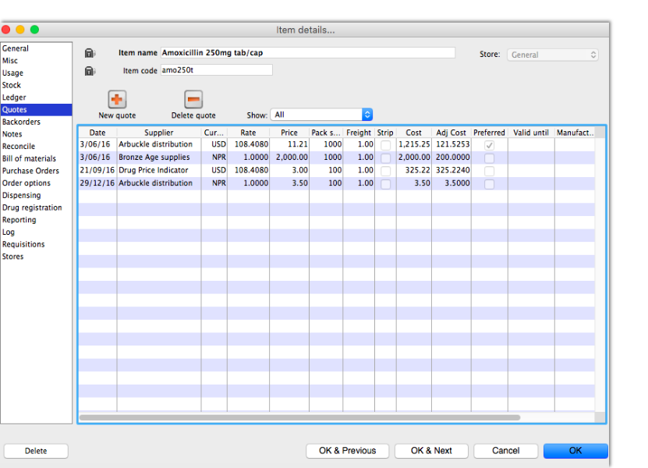
Notice how the adjusted price takes into account differences in pack size and currency, so you can easily compare suppliers.
Thanks for working through the tutorial. We hope you learnt something useful, and now feel confident to start using mSupply!

Previous: 3.1. Logging in | | Next: 3.3. Working with lists

