mSupply Mobile (browser) Users Guide - legacy version
* *

What is it?
mSupply Mobile (browser) is a simplified web interface which allows you to communicate over the internet with a store in your mSupply server from browsers on any mobile devices (smartphones, tablets, net-books, etc.).
While smaller screen devices will function, it is generally impractical to use devices smaller than a tablet.

Features and Limitations
mSupply Mobile (browser) is simplified because it is designed for 'lower level' stores that do not need the full functionality afforded by mSupply Desktop. Conversely, mSupply Mobile (browser) is generally not suitable for 'higher level' stores which require the features of mSupply Desktop.
In particular, mSupply Mobile (browser)'s features are:
- Customers: Display a list of existing Customers and the Billing Address of any selected Customer. There is no facility to add, delete or edit Customer data; this can only be done with mSupply Desktop.
- Customer Invoices: Display a list of existing Customer Invoices and details of any selected Customer Invoice. Customer Invoices can be added and edited (lines can be added or deleted). Once created, Customer Invoices cannot be deleted.
- Supplier Invoices: Display a list of existing Supplier Invoices and details of any selected Supplier Invoice. Supplier Invoices cannot be created with mSupply Mobile (browser). Supplier Invoices to a Virtual Store will generally be Stock Transfers from a higher level store, coming from a Customer Invoice in that store. Supplier Invoices that have been finalised cannot be edited. Supplier Invoices cannot be deleted.
- Items: Display a list of Items and simplified details of any selected Item Line, including, of course, stock on hand. Inventory adjustments are carried out through a stocktake process - refer below.
- Stocktakes: Display a list of Stocktakes and details of any selected Stocktake. Stocktakes can be added, deleted and edited (lines can be added, deleted and edited).
- Reports: A selection of reports can be emailed (by the mSupply server) to pre-specified email addresses.
Note: There is no facility to display, add, delete, or edit Supplier data; this can only be done with mSupply Desktop.
Batch number and expiry date are not displayed, selectable or editable in mSupply Mobile (browser). These details are recorded, maintained and reported for the store by the mSupply Server on the basis of the assumption that the store is being managed in accordance with FEFO (First Expiry First Out).
Removing the need to handle batch and expiry date information dramatically simplifies the management of stock in the store.

A word of caution
If like us, you've got a long history of drug medicine dealing, it's easy to get confused when a tablet can now refer to something you swallow, and also to something you use to run mSupply. To avoid confusion, we've provided this handy chart
Instruction | Applies to Medicines | Applies to computing device
Crush, then swallow
Swipe | (Don't! You'll get fired for this!)
Dissolve in water
Plug into USB charger
Keep in a dry place

Setting up mSupply Mobile (browser)
Your mSupply server needs to be set up for mSupply Mobile (browser) use. Follow these simple steps to get started:
- Create a virtual store to hold the remote facility's stock.
- Create new users for the store or give some existing users permission to login to it. Note: Make sure that only the users who will use the mobile interface have permission to login to this store.
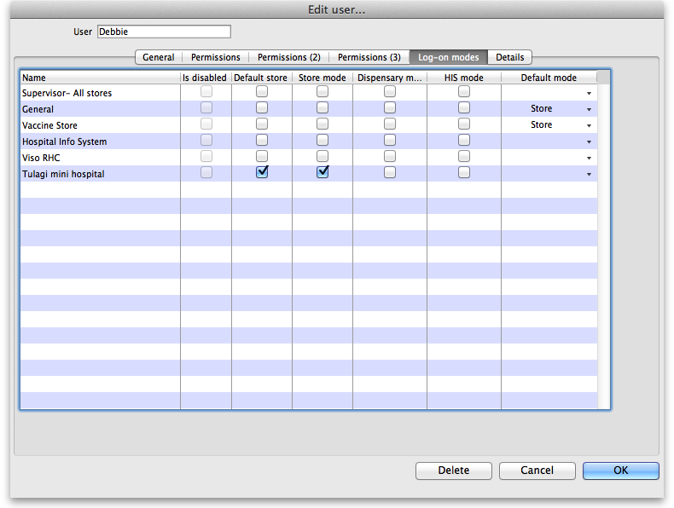
  - Note that the important setting for mobile access is the “Default store.” You'll need to turn on “store mode” for the store too, else you can't turn on “Default store.” For example, here's user Debbie set up so that when she logs into mSupply Mobile (browser) she'll be logged into Tulagi Mini Hospital:
  - Note that other user permissions (on the Permissions, Permissions(2) and Permissions(3) tabs) only apply to desktop users, not to mobile.
- For the steps below, refer to the chapter on Virtual stores for detailed instructions
  - Make only the items which the remote facility will use visible in the new store.
  - Make only the names which the remote facility will use visible in the new store.
  - Ensure the store can receive transfers from the store that will be supplying it (This is done by ensuring that the receiving store's name record is visible to the sending store)
  - Ensure “Pack to one” is turned on for visible items in each store.
Now you're ready - have fun!

Some general information before you start

When you ask the interface to do something it will mostly need to communicate with your mSupply server over your internet connection. We have done our very best to make the communication as fast and smooth as possible but we're still limited by your internet connection (we're good but we can't perform the impossible yet!). When mSupply Mobile (browser) is doing something and you need to wait you'll see this small icon appear: When the icon goes away this means that mSupply Mobile (browser) has successfully finished its communication and what you asked it to do has been successful (it won't specifically tell you that it was successful). If there was a problem doing what you asked it to do then the interface will show you an error message (which will usually be caused by a problem with the internet connection).

Accessing mSupply Mobile (browser)
To access mSupply Mobile (browser), open a browser on the device you will use and type in the address of your mobile store. The address will look like http://xxx.xxx.xxx.xxx:xxxx/mobile. e.g. http://192.168.10.3/mobile. Tap the return key and after a few moments the login screen will appear.
You can add a web page to your home screen. If you're using Safari® then it's tap 1, then 2 in the following screenshot:
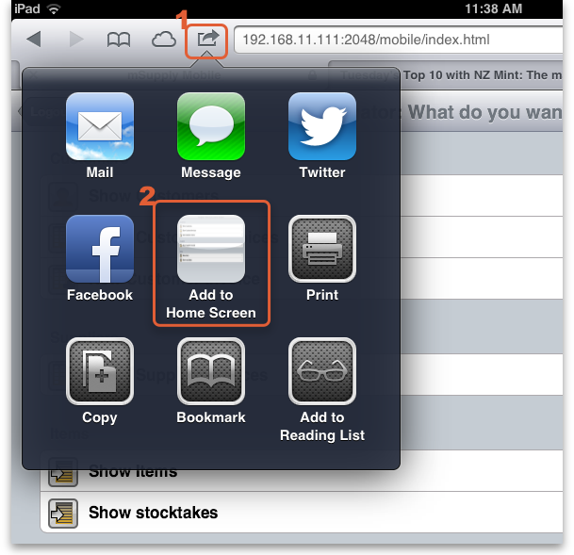

Using mmSupply Mobile (browser)

Logging in
You can't do anything in mSupply Mobile (browser) until you've logged in and this is where you do it. The credentials that you enter must already have been set up on the mSupply server through a Desktop client. Once you've entered your username and password, tap the login button and you'll be taken to the navigator.
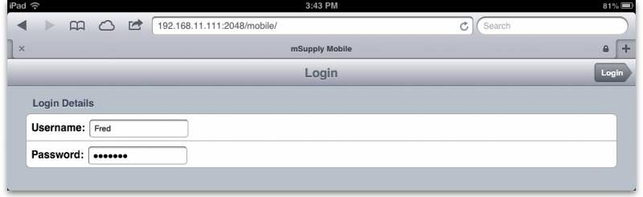

The navigator
This is where you see all the things you can do in mSupply Mobile (browser). Tapping on a row in the navigator will take you to that function. This is what it looks like:
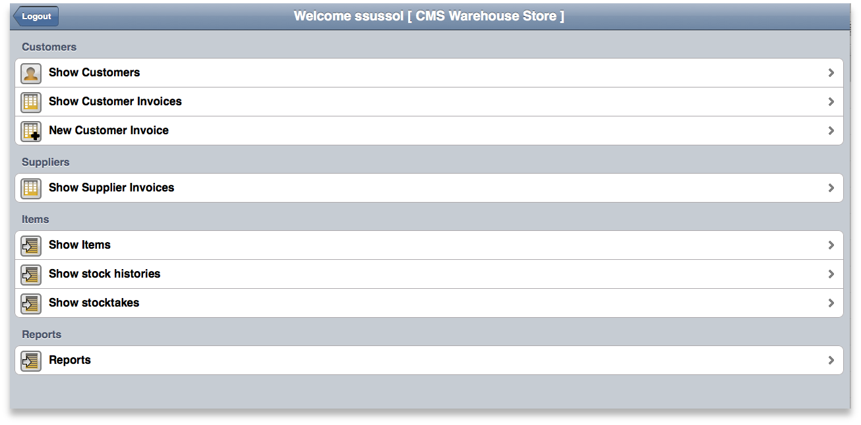
Tap on:
- Show Customers to see information about your customers.
- Show Customer Invoices to see and edit your customer invoices.
- New Customer Invoice to create a new customer invoice.
- Show Supplier Invoices to see and edit your supplier invoices.
- Show Items to see information on the items in your store.
- Show stock histories to view and comment on upcoming supply issuing.
- Show Stocktakes to view, create and delete stocktakes.
- Reports to have reports emailed to you.

Viewing a customer
(Back up to The navigator)
Tapping on Show Customers displays this list of all your customers (Note: If you have more customers than will display on the screen you can scroll the list to see the others):
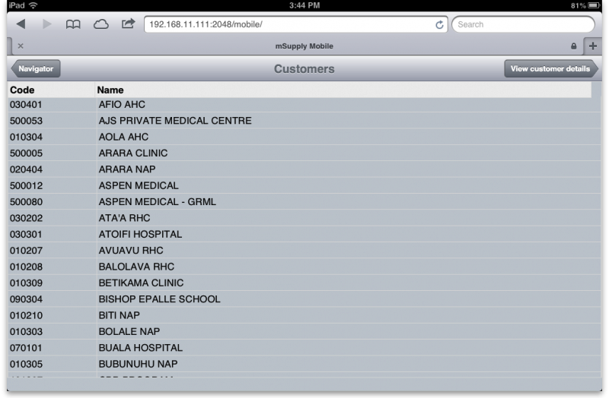
To see the details of a single customer tap on them to select their row in the grid then tap on the View customer details button. You will be taken to the details screen which looks like this:
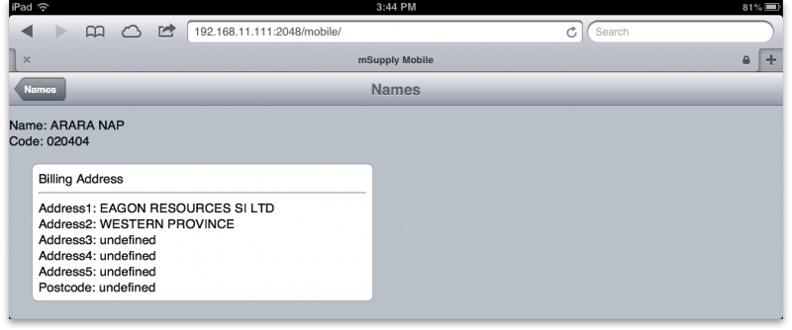

The customer invoice list
(Back up to The navigator)

Transaction Status Codes
Before we go further we need to quickly discuss what is meant by transaction status. See Transaction Codes#transaction_status for a full list of codes used in mSupply. In mSupply Mobile (browser) (for both invoices and stocktakes), you'll see the following codes used:
Status Code | Meaning | Explanation
sg | Suggested | The transaction or stocktake is editable, and stock has not been updated
cn | Confirmed | The transaction or stocktake is still editable, but stock has been updated
fn | Finalised | The transaction or stocktake is not editable, and stock has been updated
When you first arrive at this screen you will see a list of your 15 most recent customer invoices, just like in mSupply Desktop:
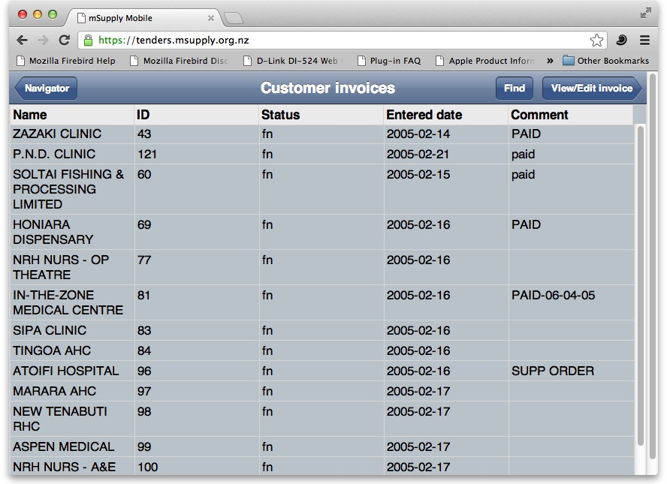
To see other invoices you can tap on the Find button to search for other invoices (see Searching for invoices here) or, to see more details for one of the invoices shown, tap on it to select its row and then tap the View/Edit invoice button. You will be taken to the customer invoice detail screen which looks like this (for a non-finalised invoice):
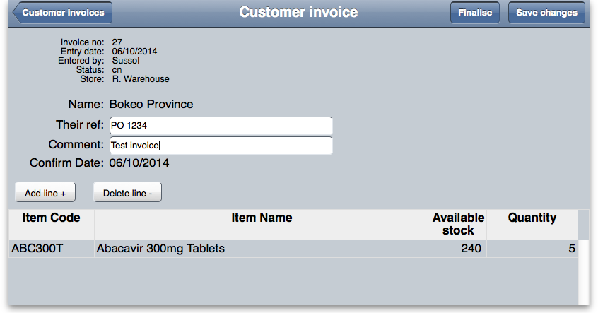
If the invoice is finalised you won't be able to edit it (just as in desktop mSupply) but if it's not finalised you can edit it as follows:
- Their ref Tap the Their ref text box to edit or enter a value. Handy for recording a customer's purchase order number for example.
- Comment Tap the Comment text box to enter or edit a comment or anything additional you want noted about the invoice.
- Add line Tap on the Add line button to add a line to the invoice - it will take you to the Add item screen as described below.
- Delete line Tap on one of the invoice's lines to select it and tap this button to remove it from the invoice. Be careful: once it's gone, it's gone!
- Quantity field You can directly edit the quantity of an item on the invoice by tapping the quantity field of the line. Immediately the field changes to a text box and you can enter the new quantity.
- Finalise it If you've finished editing the invoice and you want to make sure it can't be edited by anybody you can finalise the invoice by tapping on the Finalise button. You'll be asked to confirm that you really want to because once you've done it, it can't be undone and the invoice will be un-editable.
Adding an item line to the invoice
If you click on the Add line + button you'll be taken to this screen to select the item and quantity to add:
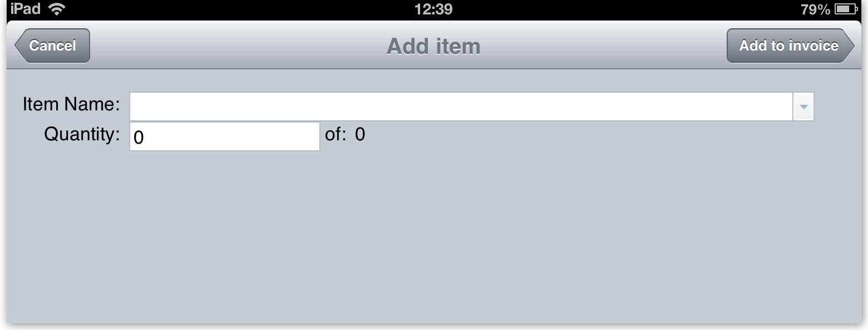
Tap the item field and an alphabetically sorted list of all the items in your store will appear. Type the first few letters of the item name and the list will reduce to those entries which start with what you typed. Now choose the item you want from the list of matching entries. If the list is too long, keep typing. The more letters you type the shorter the list of matching items will become:
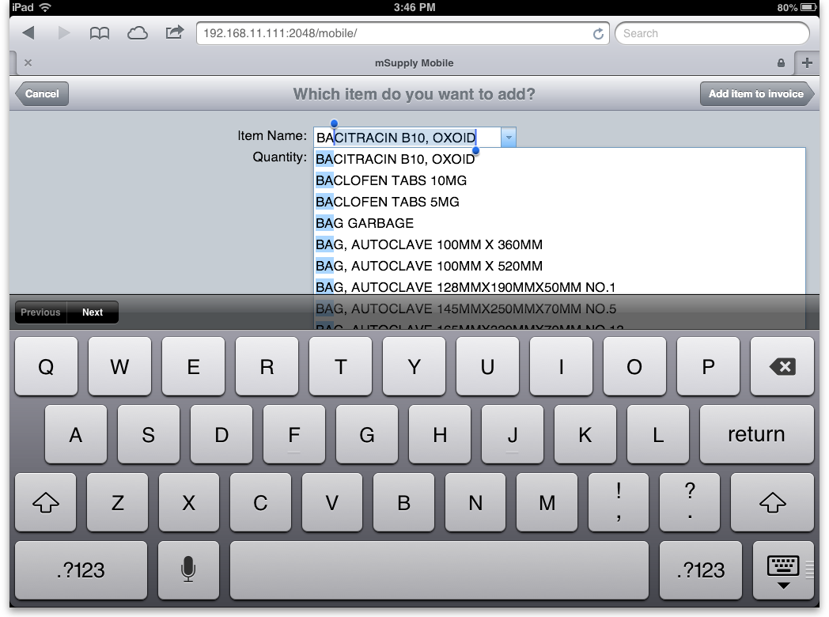
Note that after each item name (in brackets) is the quantity you have in stock of each item. Now you've selected the item its available stock appears next to the quantity text box (after the word 'of:'):
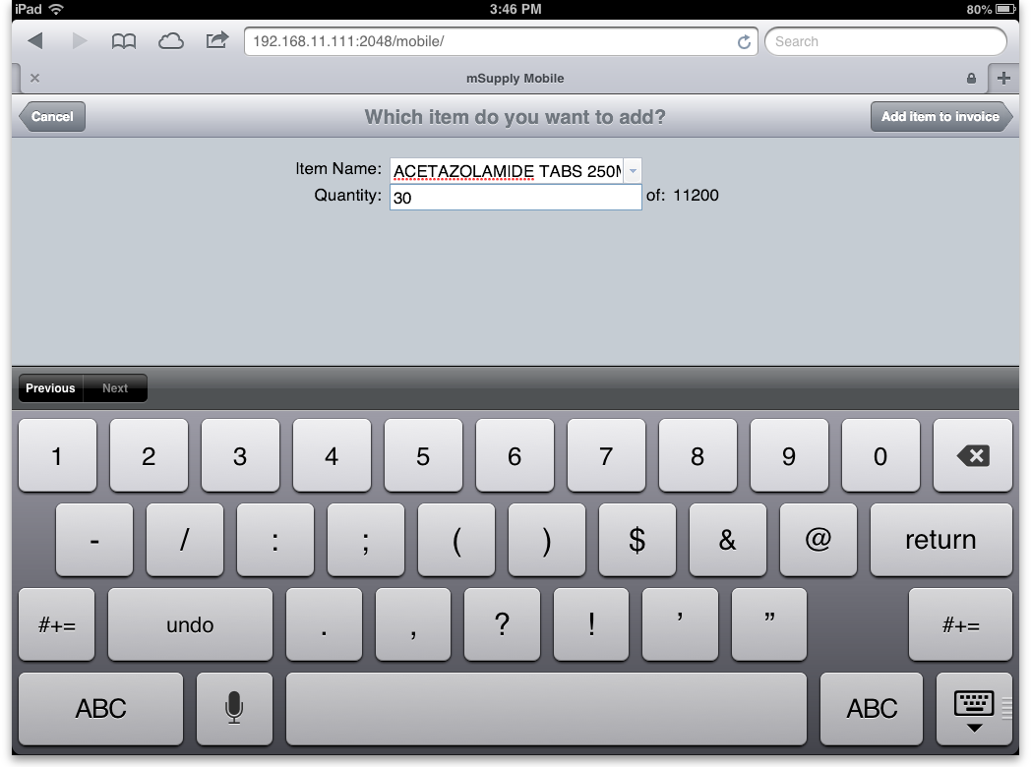
Tap the quantity text box and enter the amount of the item you want to add. When you're done, tap the Add item button and you'll be taken back to your invoice with the new line added to the bottom of those already there (or according to the sort order of the items list if you've previously sorted the list by clicking on one of the column headers).
When you've finished viewing or editing the invoice tap on the Customer invoices button to go back to the list of customer invoices.

Adding a customer invoice
(Back up to The navigator)
Just as in desktop mSupply, customer invoices are for giving stock to a customer (e.g. a hospital ward or a patient) and, when confirmed, result in stock being taken off what's available in your store. To create a new customer invoice tap New Customer Invoice in the navigator and you'll be shown this screen:
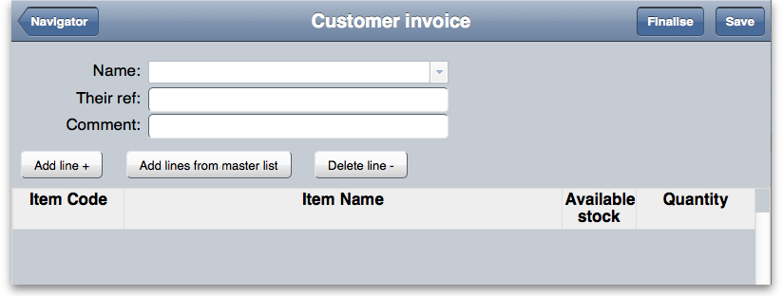
From this point, there are two possible ways to add items.
- Line by line (next), or
- Adding from a master list

Adding lines to an invoice individually
Tap on the Name text box and, enter the first few letters of the customer you're going to supply goods to and then tap on the matching entry from the list:
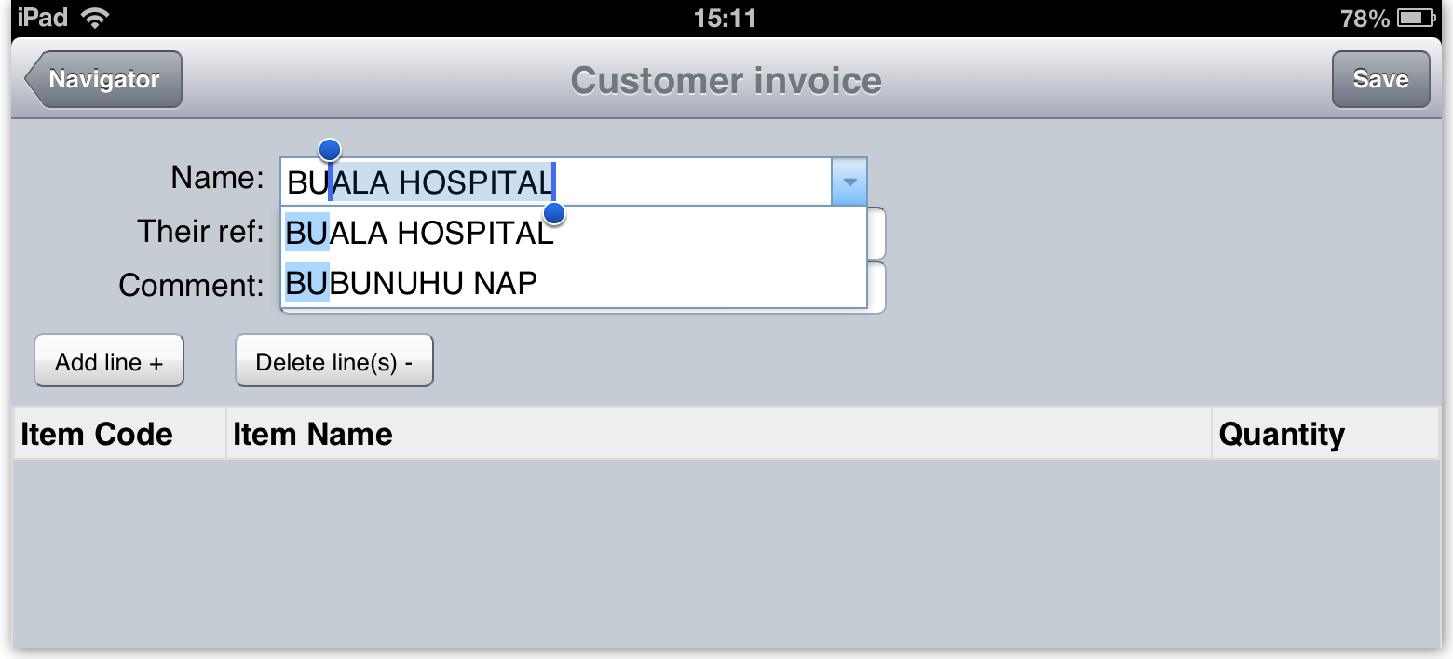
If you want to, enter the customer's reference for this transaction (their purchase order number for example) or enter a comment such as Regular monthly order or Emergency order (these are optional). Now tap the Add line button to add a line to the invoice. This will take you to the Add item screen to select the item and quantity to add:
Tap the item field and an alphabetically sorted list of all the items in your store will appear. Type the first few letters of the item name and the list will reduce to those entries which start with what you typed. Now choose the item you want from the list of matching entries: if the list is too long keep typing, the more letters you type the shorter the list of matching items will become:
Now you've selected the item its available stock appears next to the quantity text box (after the word 'of:'):
Tap the quantity text box and enter the amount of the item you want to add. When you're done, tap the Add item button and you'll be taken back to your invoice with the new line added to the bottom of those already there (or according to the sort order of the items list if you've previously sorted the list by clicking on one of the column headers).
Repeat adding more lines until you've finished. Here's an example after a second line has been added:
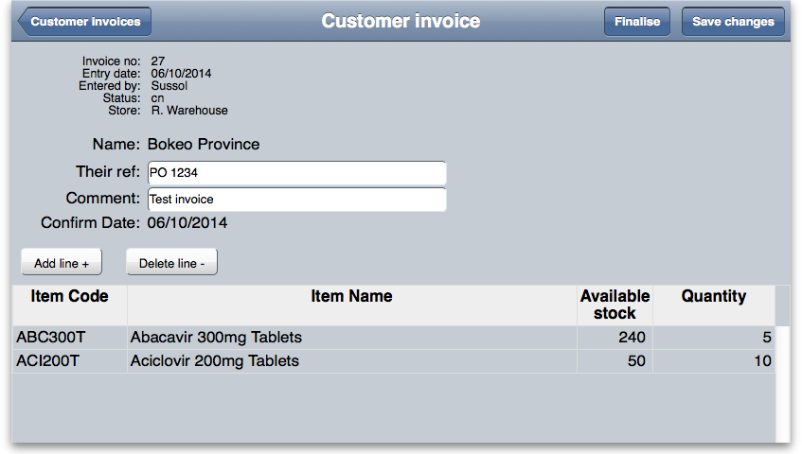
If you need to alter the quantities of any item on the customer invoice just tap on the quantity field and it will change to a text box and allow you to enter a new quantity.
Don't forget to save your invoice by tapping on the Save button but don't worry if you do forget, as mSupply Mobile (browser) will prompt you. Also, if you need to finalise the invoice (to prevent any further changes to it) then tap on the Finalise button. You will be asked to confirm the finalisation because you can't undo it and no changes to your invoice will be possible afterwards.

Adding lines to an invoice from a master list
Firstly, this function will only work if you have assigned a master list to the customer you are issuing to. To do this, see these instructions
Assuming your customer has a master list assigned, then simply tap Add lines from master list and the invoice will be filled with one row for each item. You can tap the button at any time - whether you've already added items to the invoice or whether it's still empty. Only items from the master that you haven't already added to the invoice will be added to it. And the quantities you've added won't be changed either. To alter the quantities of any item on the customer invoice just tap on the quantity field and it will change to a text box and allow you to enter a new quantity.
When you're finished editing, save the invoice.
Note that items that have zero quantity will be deleted when you leave the 'new invoice' screen. This means that:
- You don't have to delete them yourself
- Once you return to the navigator, if you then edit the invoice (via Show customer invoices) you won't see the whole master list - just the items whose quantity was set to greater than zero. Note that using the save button while you have the invoice open on the 'new invoice' screen won't affect your invoice, the 0 quantity lines will remain (so you can still save frequently and not lose the zero quantity lines you still have to edit).
An important thing to note is that when you do save your customer invoice for the first time it is automatically confirmed which means that the stock is allocated to the customer immediately and taken off what is available in your store.
When you're finished, you can tap the Navigator button at top left to return to the Navigator.

Show Supplier Invoices
(Back up to The navigator)
Supplier invoices are for receiving goods into your store.
mSupply Mobile (browser) can only process stock transfers from another store within your mSupply system. Supplier invoices from outside your mSupply system must be received using mSupply Desktop.
Depending on the mSupply preferences, Stock Transfers may need to be finalised in the supplying store before they are visible in the receiving store through mSupply Mobile (browser).
If you tap on the Show Supplier Invoices item in the navigator you'll be taken to this screen, which shows your 15 most recent supplier invoices by default (just like desktop mSupply):
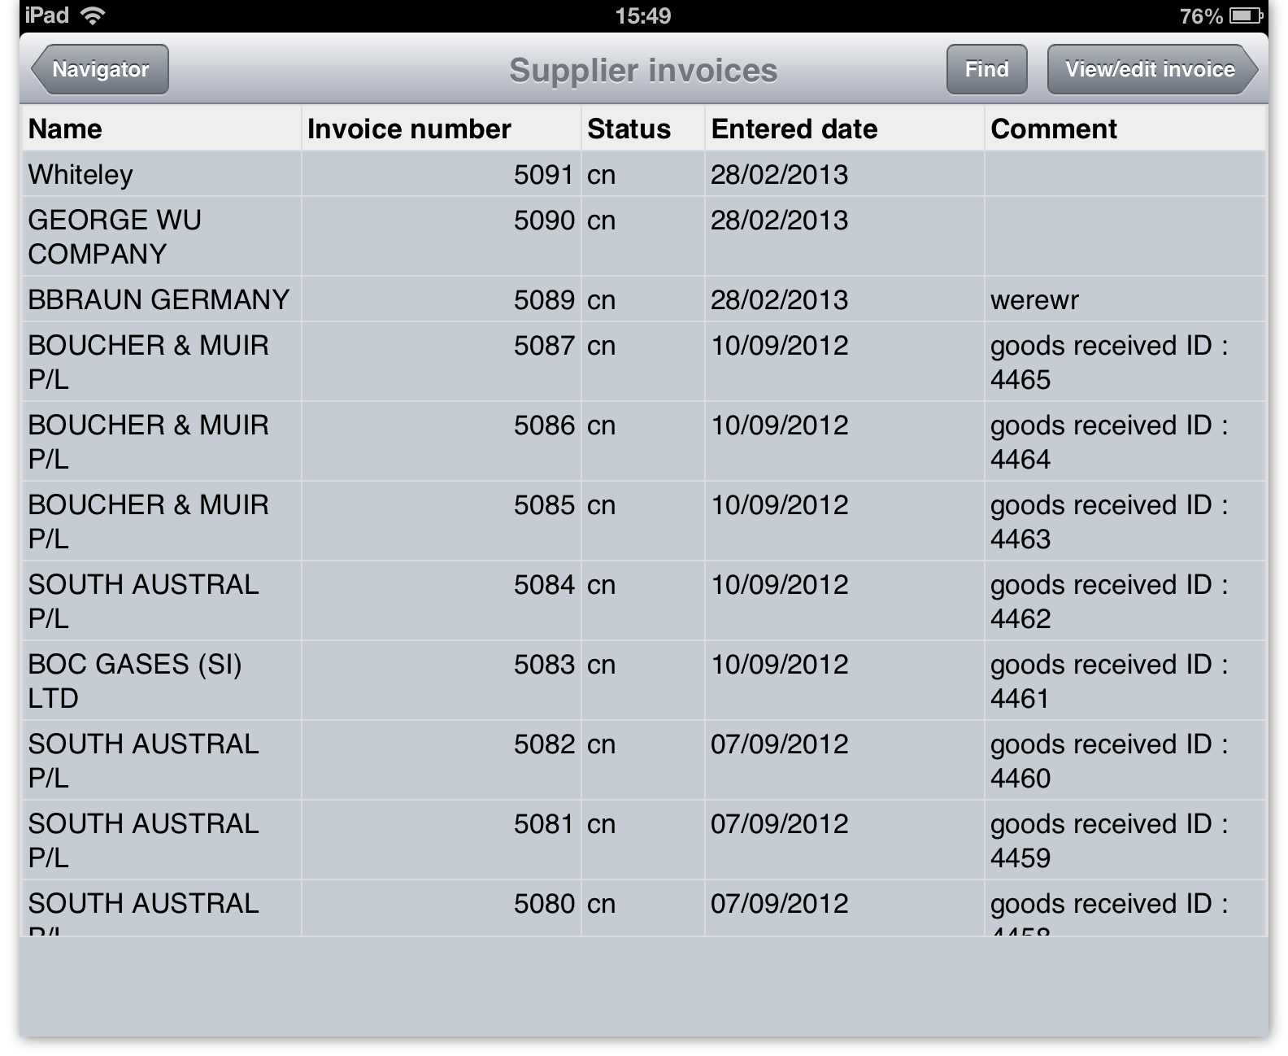
If you tap the Find button you'll be taken to the search for transactions screen, detailed here. If you tap on an invoice's row and tap the View/Edit invoice button you'll be take to the supplier invoice detail screen which looks something like this:
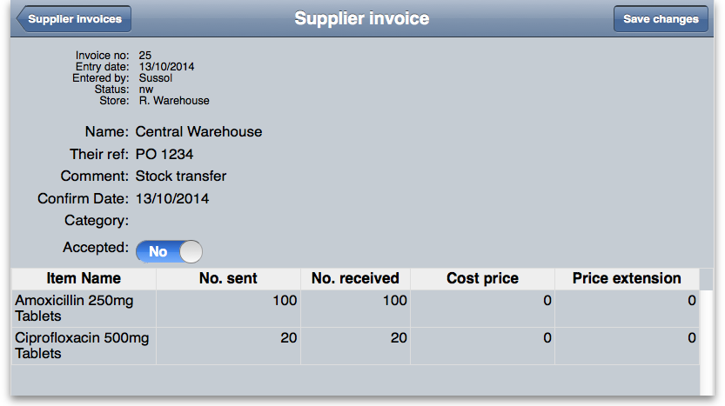
There are two things you can edit on a supplier invoice:
- The Accepted status. If an invoice has been accepted before (status is cn or fn) then it cannot be 'unaccepted' so, if this is the case, instead of a slideable switch you will see the word 'Yes' in the accepted field. An accepted status of 'No' means that the invoice is on hold and the stock has not been added to the stock in your store. As soon as you change an invoice's accept field to 'Yes' and save it (by tapping the Save changes button), the invoice will be confirmed and the stock on it will be added to your store.
- The quantities in the No. received column. This column is for capturing exactly what you received from the supplier, so after a delivery you should go through the invoice and make sure that this column contains exactly the quantity you received for each item. When you are sure that the quantities are correct you should change the invoice's accepted status to 'Yes'. Note that the quantities in this column are set to those that the supplier sent you (displayed in the No. sent column) by default.
Don't forget to save any changes to your supplier invoice. Don't worry if you forget, because mSupply Mobile (browser) will prompt you to save or discard the changes.

Items
(Back up to The navigator)
Tap the Show items row in the Navigator to view items. You'll be shown a screen where you can find items by name or code or SMS code etc. (just spin the wheels to change the criteria used to find the items you're interested in):
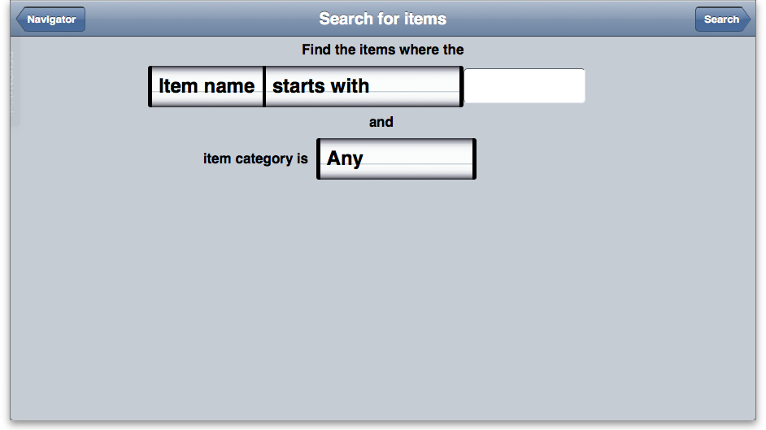
Tapping the Search button will show you a list of results:
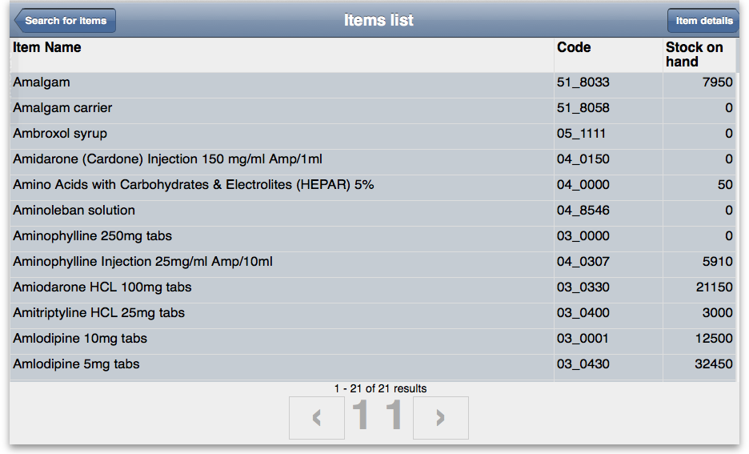
To view more details about a single item, tap on it's row to select it, then tap the Item details button.
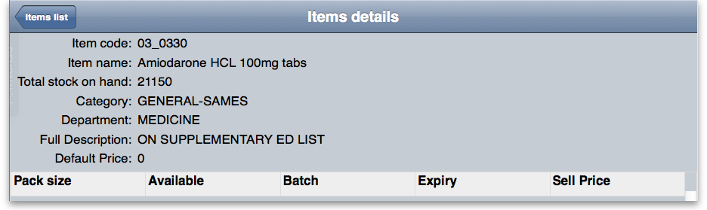
At the moment you can't edit an item's details. If an item needs editing, inform the users of mSupply desktop where your server is located so that they can log in to the desktop version and make the necessary changes.

Stock Based Orders
This feature allows the viewing of and commenting on recommended supply quantities generated by a central store using the mSupply Stock Histories feature. Quantities calculated using the records of previous quantities sent and adjusted using stock take information for your store allows the generation of recommended quantities to be issued.
Clicking on Show Stock Based Orders displays a list of central store generated drug quantity issues.
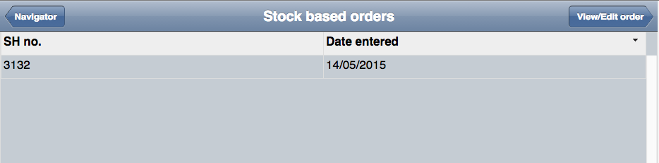
Clicking on the SH no. and then “View/Edit” allows you to drill down and comment on the individual record.
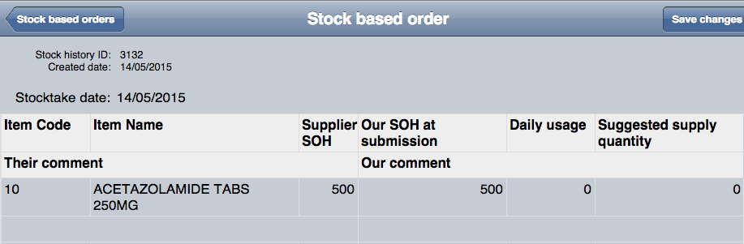
Supplier SOH shows the amount of available stock on hand at the central store.
Our SOH at submission shows the stock on hand available at your store.
Previous usage history is used to calculate the amount to be sent to you in the final column.
The only editable field is the Your comment field where you may enter feedback to the central store.

Stocktakes
(Back up to The navigator)
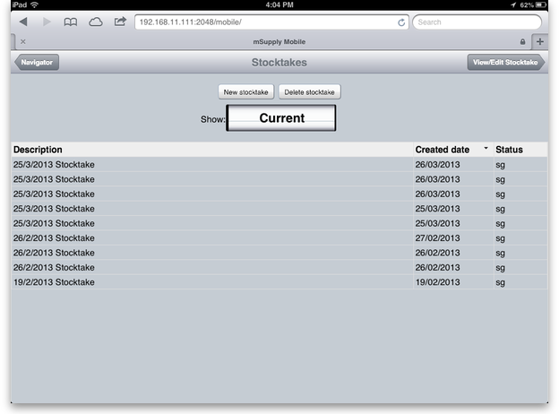
Tapping the Show Stocktakes row will show you a list of in-progress stocktakes:
To create a new stocktake, tap the New Stocktake button.
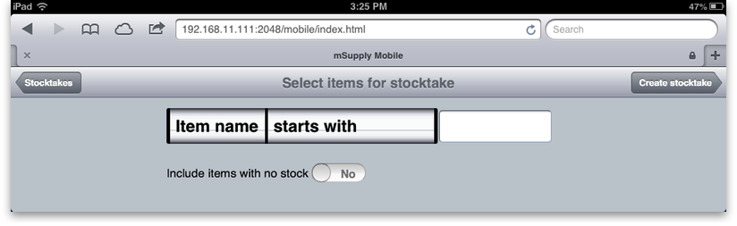
In the example above we're going to create a stocktake for all items whose name begins with “A”. To create a stocktake for all items, leave this field blank.
Include items with no stock Usually you'll want to leave this switched to no but if you are doing an initial stocktake for a new store you have just set up, you might want a list of all items, not just the ones with stock (which will be none for a new store). In that case slide the switch to yes before creating the stocktake.
To proceed, tap the Create stocktake button at top-right. The wheels will spin (you might hear a whirring sound from your tablet) if you want to use other criteria to select the items to go into your stocktake.
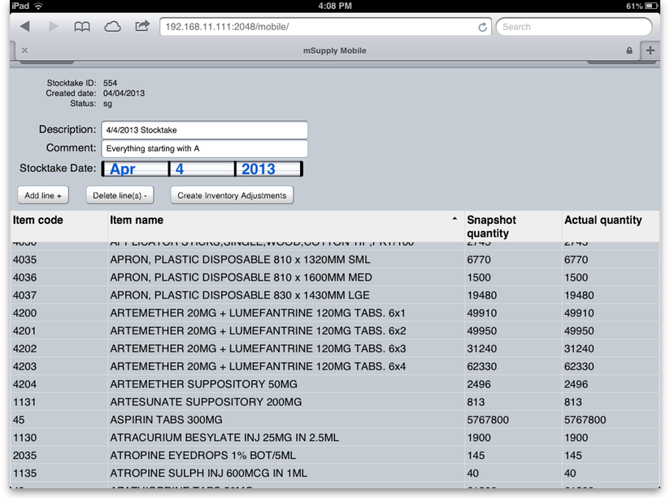
Now the stocktake is created, you can edit lines by tapping on the value in the actual quantity column of the row you wish to edit. In the example below we've counted the Azathioprine and we're 100 tablets short:
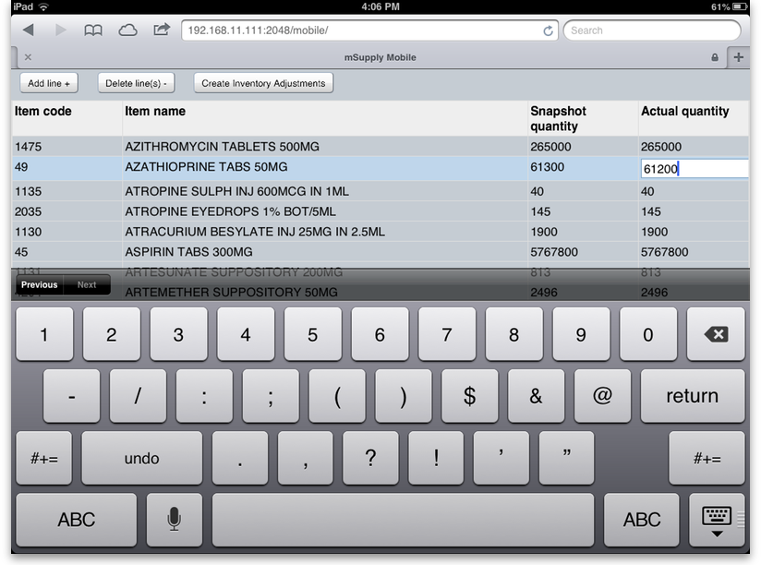
As you stocktake a store you might find items on the shelf that are not in your stocktake. To add an item, tap the Add line + button. You'll be shown this screen, where you find the item, and enter the stocktake quantity for that line: Tap Add to stocktake once you've entered the item and quantity.
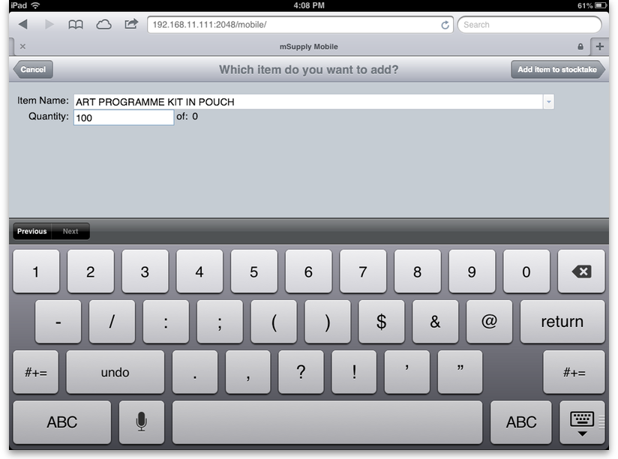

Finalising the stocktake
(Back up to The navigator)
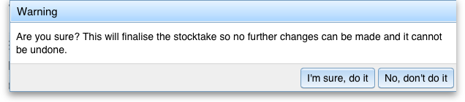
Once your stocktake accurately reflects your actual store stock, tap on Create inventory adjustments You'll be shown this warning:
If you tap I'm sure, do it the necessary adjustments will be made in mSupply.
You do not have to delete rows where the stock is already correct. mSupply will just ignore these when creating inventory adjustments.
Once inventory adjustments are created, the stocktake will have a status of “FN” (finalised) so it will not show up in the list of current (or pending) stocktakes.
Deleting a stocktake You can delete a stocktake by tapping on the row you want to delete, then tapping the delete stocktake button. You'll be warned of impending doom:
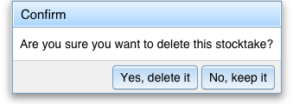

Searching for invoices
(Back up to The navigator)
If you tap the Find button when viewing a list of invoices you will be taken to this screen:
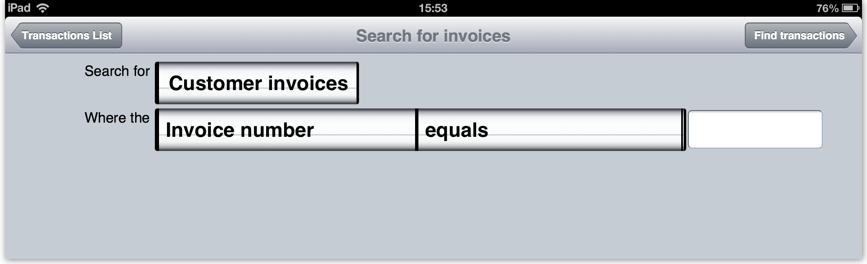
Move the spinwheels until the search matches what you want, enter your search value in the text box then click on the Find transactions button. When the search is complete you will be taken back to the customer or supplier invoice list (depending on which type of transaction you were searching for) with all the transactions matching your search criteria displayed in the list.

Reports
(Back up to The navigator)
mSupply Mobile (browser) can email three different reports to you. Tapping the Reports row on the navigator will take you to the reports page:
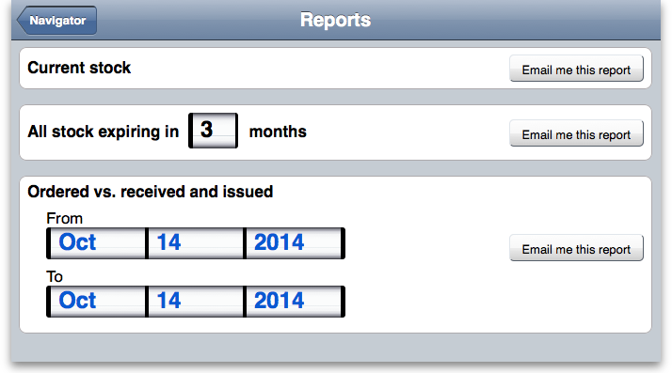600
Tapping on any of the Email me this report buttons will make mSupply email you the corresponding report as an Excel spreadsheet using the values you select. Obviously, it needs to know your email address to do this so remember to set this up in your user preferences in desktop mSupply first - see here for instructions on doing this.

Tips and Tricks

You get a message "You haven't edited anything" when you have
This happens when you change a field (e.g. the description of a stocktake) and then tap Save without first tapping in another field. This only happens on iPads (iPhones too we guess), not Android devices Solution: tap in another field before tapping save.
Previous: The mSupply Web Server Next: The Web Stocktake module

