19.07. Online catalogue
The online catalogue is a searchable list of items you stock, driven by data in mSupply. The information can easily be updated and items added to or removed from the catalogue. By giving users access to the online catalogue you can, for example, replace the expensive printing of hard copy catalogues.

Setup

1. Tell mSupply which columns to display in the catalogue
This is done in the mSupply preferences. Choose File > Preferences… from the menus and go to the Web catalogue tab. For the details of the settings and what they do, see the 16.01. General preferences page for details.

2. Tell mSupply which store to run the catalogue from
Choose File > Preferences… from the menus, and on the Web server tab select the store in the Default store for web interface drop down list. If the mSupply web server isn't already running you'll also need to click on the Start web server button. More information about these options can be found here.

3. Tell mSupply which items are to be included in the catalogue
To do this, from the menus choose Item > Show items…, click on the Find button and double click on an item you want to appear in the catalogue. This will open up the Item's details window. Click on the Misc tab on the left hand side and the screen will look like this:
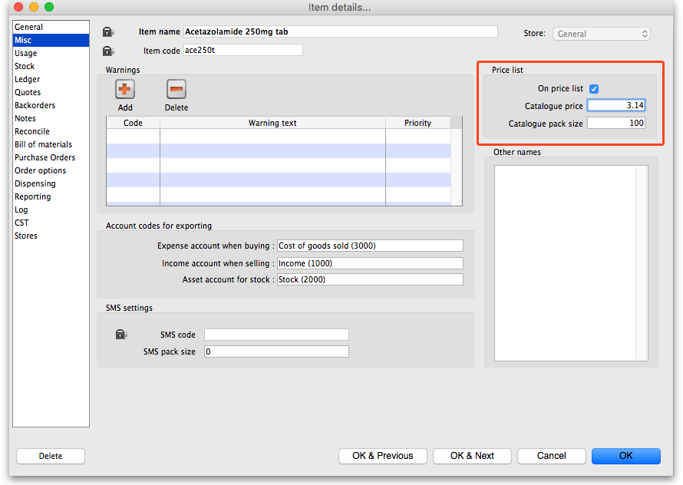
In the Price list section:
- Check the On price list checkbox (any item with this checked will appear in the catalogue)
- Enter the pack size of this item that is going to appear in the catalogue in the Catalogue pack size textbox
- Enter the price for this pack size in the Catalogue price textbox. This is optional and can be left at 0 if you don't want the price included in your catalogue.
Repeat these steps for each item you want to appear in your catalogue. As with many repetitive tasks in mSupply, the OK & Next and OK & Previous buttons are your friends here.
And that's it. Setup is complete and you are now ready for users to view your catalogue.

Operation
Once the mSupply web server is running users access the catalogue using a browser. The address to visit is
https://example.com/catalogue/
where example.com is the domain of your web server.
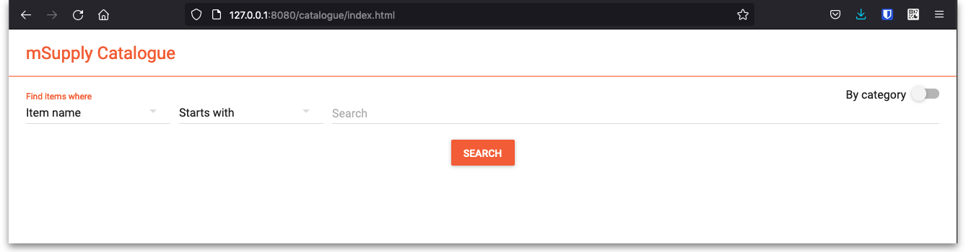
This is what the user will see:
The catalogue can be searched by either item name (the top section) or the categories that items belong to (bottom section).

Searching by item name
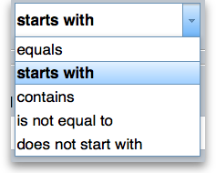
To search by item name enter something in the top textbox and select the comparator in the drop down list next to it. These are the options you can choose from:
Then click on the top Search button and mSupply will search for items with names matching the options you have entered. When the search is complete the item detail screen (shown below) will be displayed and you can browse the items found.

Searching by category
The category used to search for items in the catalogue is item category 1. This category is hierarchical and has 3 levels. For more details about this category, including setting it up and assigning it to items, see here. Note that in the catalogue, Top level corresponds to level 1 of category 1, Mid level to level 2 and Bottom level to level 3.
To search by category, click on one of the 3 Search buttons in the lower section of the search screen. When you do that, mSupply will search for items belonging to the category of the level of category 1 you selected in the corresponding drop down list. If the All option is selected then mSupply will search for items belonging to all the corresponding categories at that level of category 1.
When you select an option other than All in the Top level category drop down list, the options in the Mid level drop down list are changed to be all the children of the top level category you selected. And when you select a Mid level category, the options in the Bottom level drop down list change to be the children of that mid level category.
The Bottom level category drop down list has an additional “None” option. Using this option will search for all items which are not assigned to a category 1 category.

Item detail screen
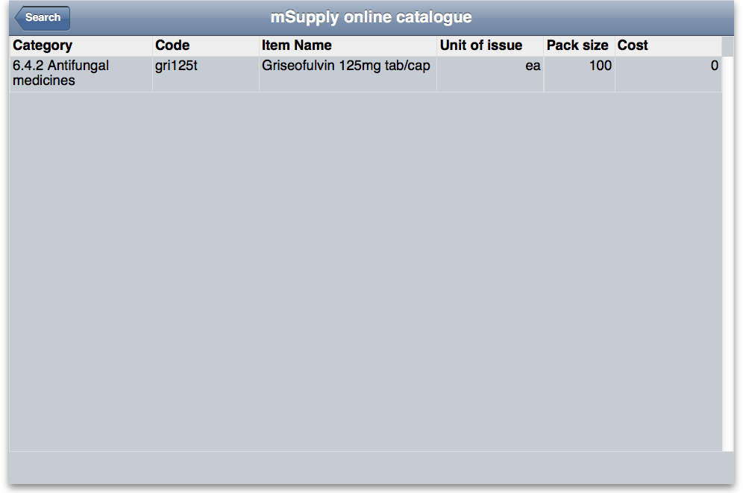
The screen looks like this: When you've finished browsing the items displayed you can click on the Search button on the top left hand side to return to the search screen, where you can perform another search if required.
Previous: 19.06. Mobile Dashboard set up (after v4.0) | | Next: 19.08. Stock web app

