Stock Web App Setup
You can use the Stock Web App to look up your stock information.
- Login to https://yourserver.msupply.org:2048/stock
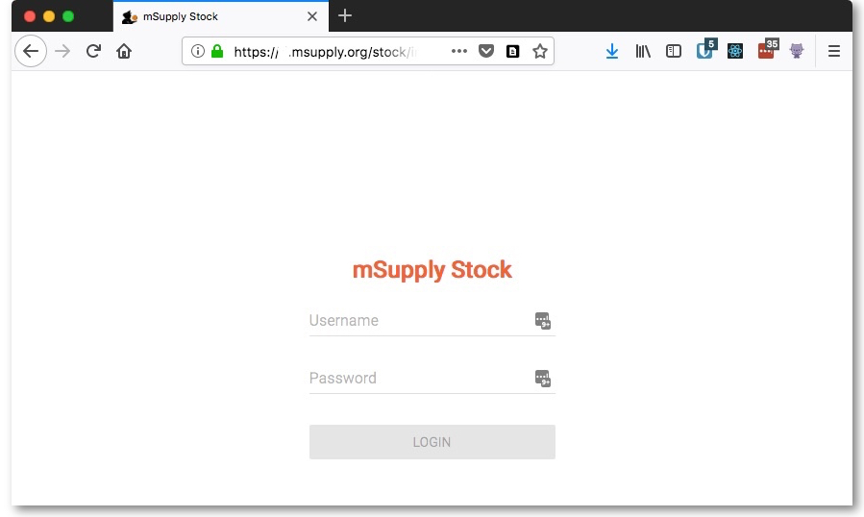
- Enter an item or location to search for
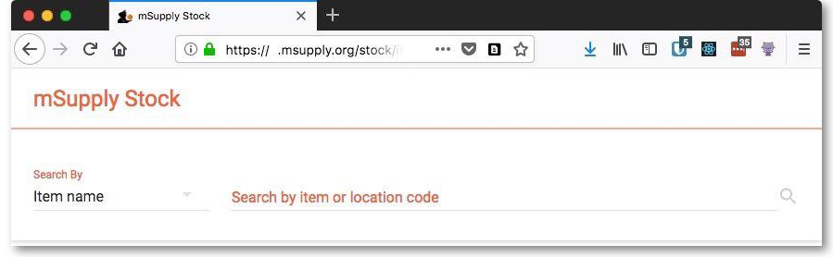
- The search results display


